Brownhills Ormiston Academy
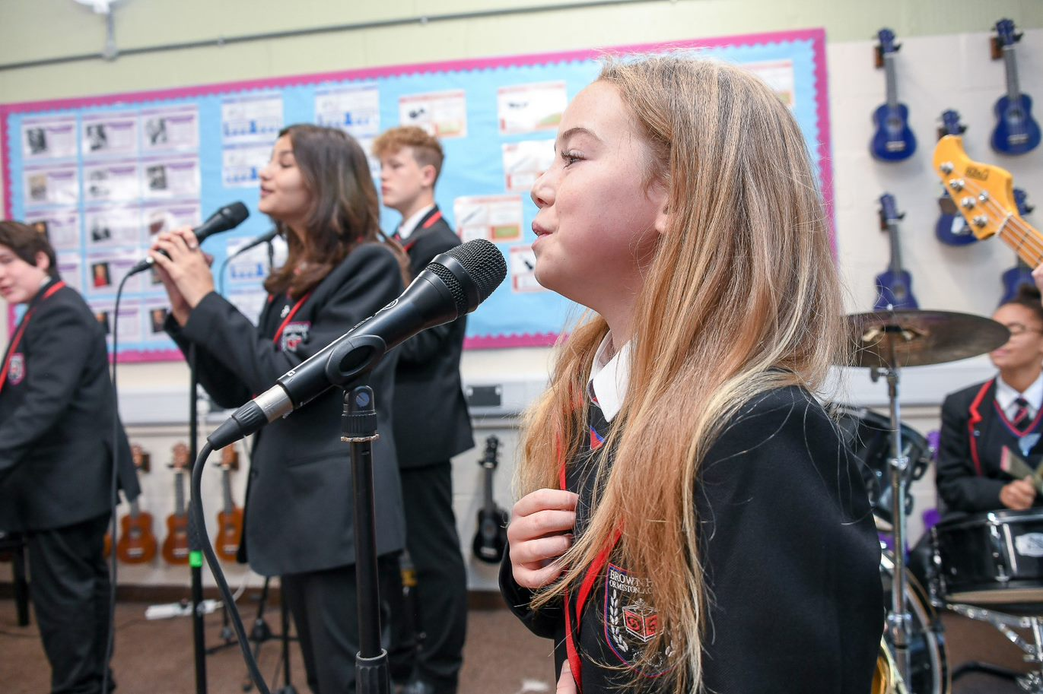
Year 9 curriculum 2023-2024
Year 9 Art

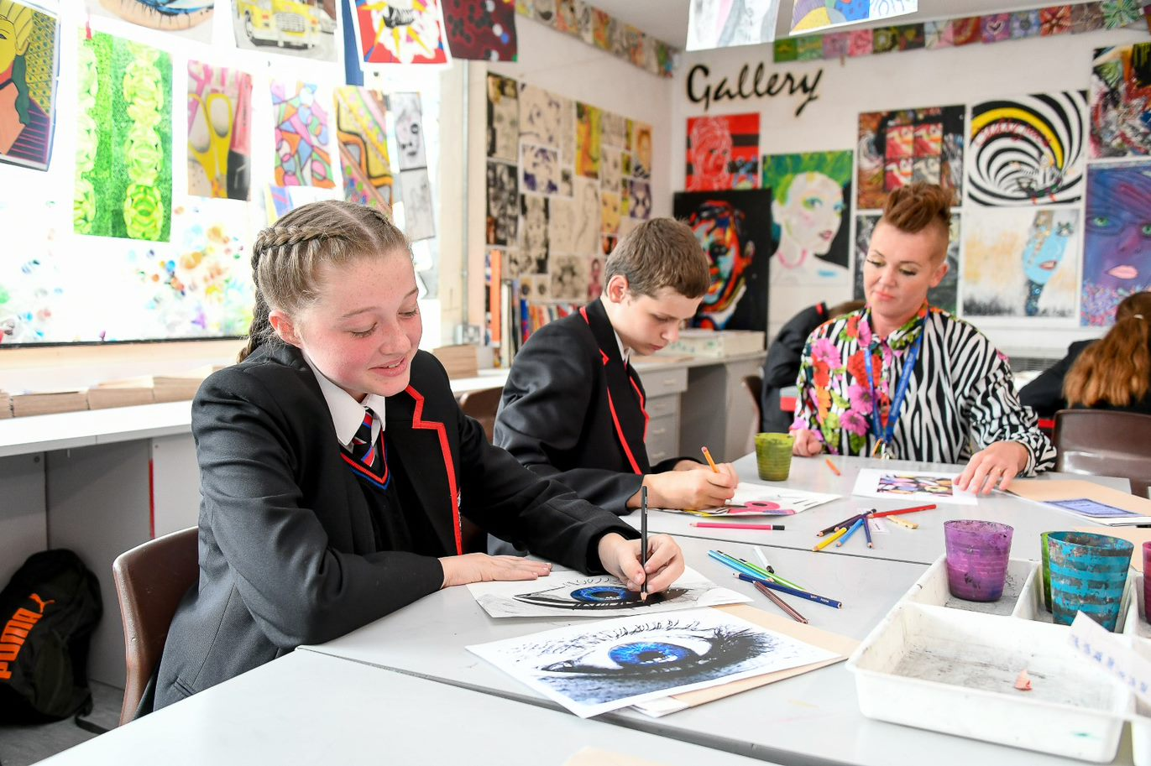
Year 9 Art
 | Autumn Term 1 |  | Autumn Term 2 |  |  | Spring Term 1 |  | Spring Term 2 |  | Summer Term 1 |  |  | Summer Term 2
 | Popular Culture |  | Popular Culture |  |  | Still Life |  | Still Life |  | Natural form | Natural form
➢ | Assessment (drawing | ➢ | Contextual |  | ➢ | Assessment | ➢ | Advanced scale, | ➢ | Assessment | ➢ |  | Contextual
 | and use of materials) |  | references: Peter |  |  | (Contextual and use |  | detail and use of |  | (Development of final |  |  | references: Georgia
➢ | Contextual |  | Blake, Andy Warhol) |  |  | of materials) |  | pencil tone in |  | piece). |  |  | O’Keefe, Henry
 | references: Peter | ➢ | Advanced |  | ➢ | Advanced scale, |  | drawing. | ➢ | Contextual |  |  | Rousseau, Marcia
 | Blake, Andy Warhol) |  | watercolour paint, |  |  | detail and use of | ➢ | Advanced paint |  | references: Georgia |  |  | Baldwin.
➢ | Advanced |  | layering, blending |  |  | pencil tone in |  | techniques and |  | O’Keefe, Henry | ➢ |  | Oil pastel blending.
 | watercolour paint, |  | showing shadow and |  |  | drawing. |  | application. Texture. |  | Rousseau, Marcia |  |  | Acrylic paint
 | layering, blending |  | light. Crayon. Colour |  | ➢ | Advanced paint |  | Sharpie pens and |  | Baldwin. |  |  | introduced. Advanced
 | showing shadow and |  | theory, advanced |  |  | techniques and |  | crayon. | ➢ | Oil pastel blending. |  |  | pencil techniques-
 | light. Crayon. Colour |  | enlargement and |  |  | application. Texture. | ➢ | Advanced use of |  | Acrylic paint |  |  | light, shade, texture,
 | theory, advanced |  | scale. |  |  | Sharpie pens and |  | colour theory. |  | introduced. Advanced |  |  | crayon, refined detail.
 | enlargement and | ➢ | Basic contextual |  |  | crayon. | ➢ | Development of |  | pencil techniques- | ➢ |  | Extended writing.
 | scale. |  | references and links |  | ➢ | Advanced use of |  | contextual references |  | light, shade, texture, |  |  | Contextual
 |  |  | to artists explaining |  |  | colour theory. |  | and links to artists |  | crayon, refined detail. |  |  | references and links
Basic contextual references and links to artists explaining development of ideas and elements used from the work of others.  Key Concepts  ➢ (KS3 ref 1,2,3,4,5)  ➢ Use a range of techniques to explore ideas.  ➢ Use a range of media including paint.  ➢ Increase proficiency in handling materials.  ➢ Analyse and evaluate own work and that of others.  ➢ Learn about art from different eras and styles. |  | Development of ideas and elements used from the work of others.  ➢ Evaluation.  Key Concepts  ➢ (KS3 ref 1,2,3,4,5)  ➢ Use a range of techniques to explore ideas.  ➢ Use a range of media including paint.  ➢ Increase proficiency in handling materials.  ➢ Analyse and evaluate own work and that of others.  ➢ Learn about art from different eras and styles. |  | Development of contextual references and links to artists explaining development of ideas. Analysing the work of others.  Key Concepts  ➢ (KS3 ref 1,2,3,4,5)  ➢ Use a range of techniques to explore ideas.  ➢ Use a range of media including paint.  ➢ Increase proficiency in handling materials.  ➢ Analyse and evaluate own work and that of others.  ➢ Learn about art from different eras and styles. |  |  | Explaining development of ideas. Analysing the work of others.  ➢ Evaluation.  Key Concepts  ➢ (KS3 ref 1,2,3,4,5)  ➢ Use a range of techniques to explore ideas.  ➢ Use a range of media including paint.  ➢ Increase proficiency in handling materials.  ➢ Analyse and evaluate own work and that of others.  ➢ Learn about art from different eras and styles. |  | Extended writing. Contextual references and links to artists explaining in detail what elements have been taken from their work and how they have been applied to own ideas.  Key Concepts  ➢ (KS3 ref 1,2,3,4,5)  ➢ Use a range of techniques to explore ideas.  ➢ Use a range of media including paint.  ➢ Increase proficiency in handling materials.  ➢ Analyse and evaluate own work and that of others.  ➢ Learn about art from different eras and styles. |  |  | To artists explaining in detail what elements have been taken from their work and how they have been applied to own ideas.  ➢ Evaluation.  Key Concepts  ➢ (KS3 ref 1,2,3,4,5)  ➢ Use a range of techniques to explore ideas.  ➢ Use a range of media including paint.  ➢Increase proficiency in handling materials.  ➢ Analyse and evaluate own work and that of others.  ➢ Learn about art from different eras and styles.
Year 9 Computer science

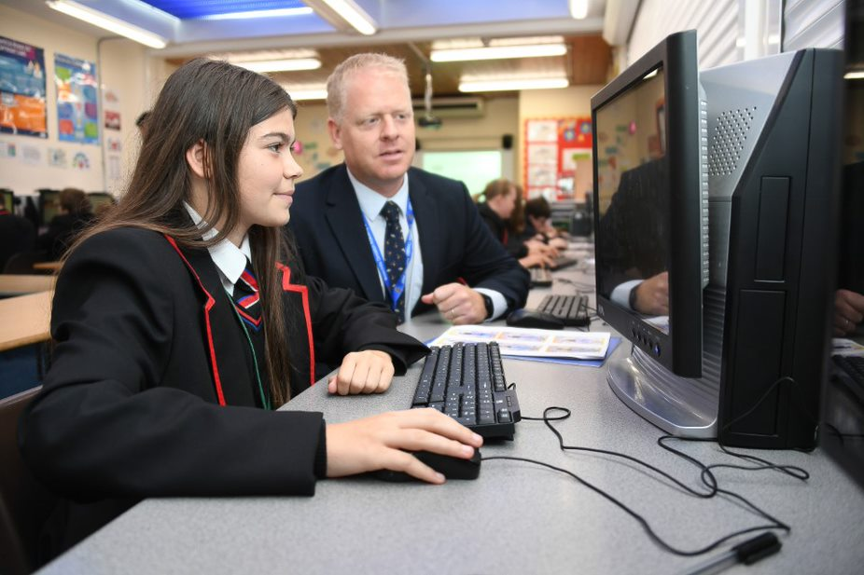
Year 9 Computer science

Autumn Term 1 | Autumn Term 2 | Spring Term 1 | Spring Term 2 | Summer Term 1 | Summer Term 2
Using media with Publisher  - DTP basics  - Using templates  - Applying text  - Using shapes  - Inserting pictures  Key Concepts  (KS3 ref 7, 8) | Understanding computers  - Elements of a computer  - The CPU  - Understanding binary  - Storage device  - New technologies  Key Concepts  (KS3 ref 4, 5, 6, 7) | Cyber Security  - Email scams  - Hacking and malware  - Protecting personal data  - Copyright  - Health and safety  Key Concepts  (KS3 ref 9) | Graphic design  - 2D software basics  - Functions and tools  - Rendering  - Bitmaps  - Vector images  - Adding text  Key Concepts  (KS3 ref 7, 8, 9) | Modelling data: Spreadsheets  - Basic terms and structure  - Columns of data  - Functions used in Excel  - Tools and techniques  - Charts  Key Concepts  (KS3 ref 1, 7) | Introduction to Small Basic  - Introduction to Small basic  - Making decisions  - Repetition  - Graphics  - Turtle Graphics  - Subroutines and Arrays  Key Concepts  (KS3 ref 1, 2, 3)

Year 9 Design Technology
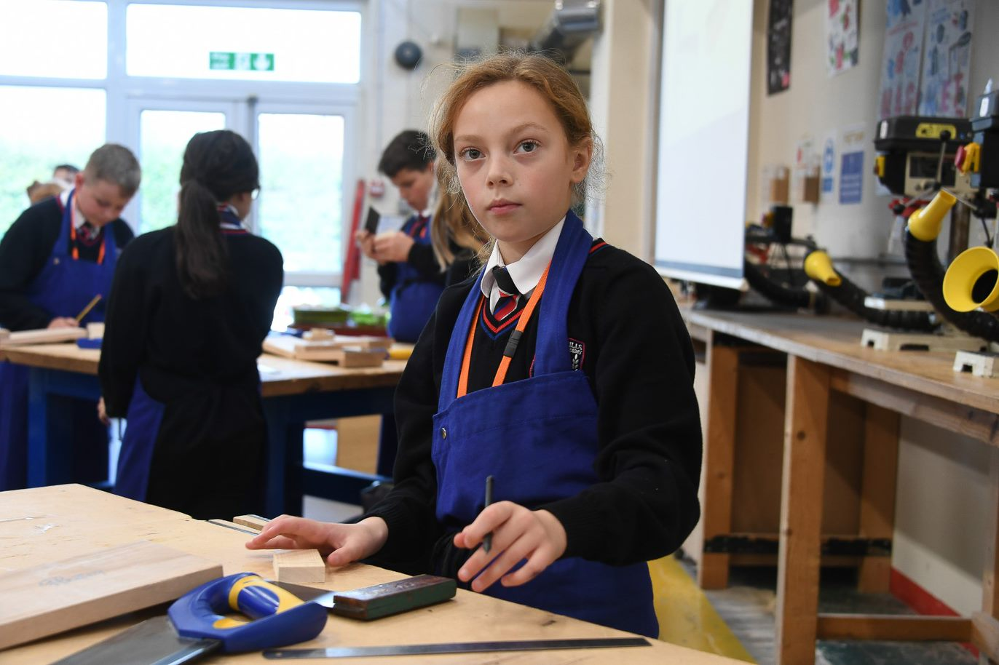
Year 9 Design Technology
Autumn Term 1 | Autumn Term 2 | Spring Term 1 | Spring Term 2 | Summer Term 1 | Summer Term 2
Aluminals  - Designer influence: Eames.  - Card modelling using 2D material and shaping into a 3D structure.  - Iteration with the focus on design development and design being a continual process by gathering feedback from others.  - Planning manufacturing stages of a product including safety and quality considerations.  Key concepts: NC content: I1, I2, I3, D1, D2, E1, E3, T1 | Aluminals  - Applying knowledge of safe working practises in the metal work room.  - Marking, cutting and shaping aluminium.  - Using more complex tools and processes including the metal bender.  - Applying manufacturing processes within a tolerance.  Key concepts: NC content: M1, M2 | Sustainable Design  - Exploring the social and moral issues in the world of design technology.  - Life cycle of a product – from cradle to grave.  - Developments in in design technology, including examples of embedding intelligence into products and considering how they may impact society and manufacture.  - The suitability of one material over another in terms of functionality and it’s impact on the environment and society.  Key concepts: NC content: I1, I2, I3, T3, T4, D1, D2, M1, M2 | Sustainable Design  - Exploring the social and moral issues in the world of design technology.  - Life cycle of a product – from cradle to grave.  - Developments in in design technology, including examples of embedding intelligence into products and considering how they may impact society and manufacture.  - The suitability of one material over another in terms of functionality and it’s impact on the environment and society.  Key concepts: NC content: I1, I2, I3, T3, T4, D1, D2, M1, M2 | Food for life  - Exploring how food and food consumption impacts the environment.  - Food waste and how to reduce it.  - Sustainable fishing  - Organic and intensive farming practices.  - Building a wider repertoire of cooking skills and techniques.  - Practical skills will focus on developing accuracy, speed and independence in using the cooker, measuring  Key concepts: NC content C1, C2, C3, C4 | Food for life  - Exploring how food and food consumption impacts the environment.  - Food waste and how to reduce it.  - Sustainable fishing  - Organic and intensive farming practices.  - Building a wider repertoire of cooking skills and techniques.  - Practical skills will focus on developing accuracy, speed and independence in using the cooker, measuring  Key concepts: NC content C1, C2, C3, C4

Year 9 English

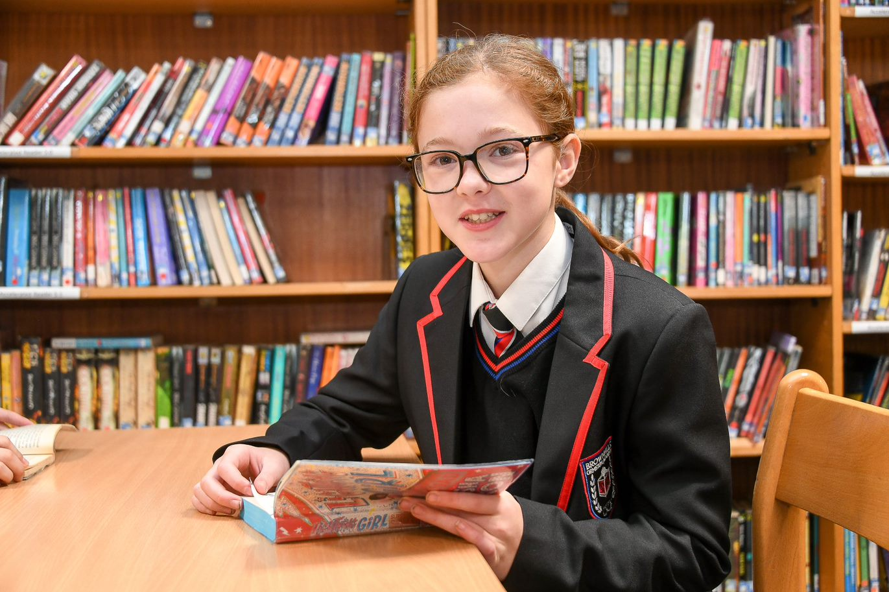

Autumn Term | Spring Term | Summer Term
Division and Dystopia  - Focus text: Noughts and Crosses  - Secondary: Incident If We Must Die, Checking Out Me History, 1984  - Themes: identity, love, relationships, discrimination, power, conflict  - L/S: narrative perspective, narratology, characterisation, dual narrative  - Story: protagonist, character development, drama, dialogue  - Writing: Never Did Than Sentence, More/Less Sentence  - Context: Stephen Lawrence: police classism, slavery and the race wars, geo-politics, alternate history, modern-day Western world | The Gothic: Awe and Fear  - Focus text: Wuthering Heights  - Secondary: The Castle of Otronto, Mysteries of Udolpho, Jekyll & Hyde, The Yellow Wallpaper, Jane Eyre, Frankenstein, Beloved  - Themes: love, supernatural, power, identity: suppression, conflict  - L/S: characterisation, symbolism, pathetic fallacy, motif, dual narrative  - Story: protagonist/antagonist, Byronic hero, theme, setting, intertextuality  - Writing: Not, Nor, Nor Sentence, Almost Almost When Sentence  - Context: Romanticism, Gothic conventions, Victorian social anxieties (science, religion, the supernatural, women, race), psychoanalytic theory | Struggle for identity  - Focus text: Of Mice and Men  - Secondary: Robert Burns: ‘To a Mouse’, Their Eyes were Watching God, Silence of the Girls, Jamaica Inn, The Yellow Wallpaper, ‘The Harvest Gypsies’, The Bell Jar  - Themes: abuse of power, identity struggle, relationships: loneliness, discrimination: gender & racial  - L/S: metaphor, tone, pathetic fallacy, symbolism, cyclical structure, motif  - Story: structure: cyclical, characterisation, narrative voice, authoritative narrator, deterministic plot  - Writing: Colon Clarification  - Context: economic downturn: The Great Depression, economic conditions, male relationships
Year 9 English

Year 9 French
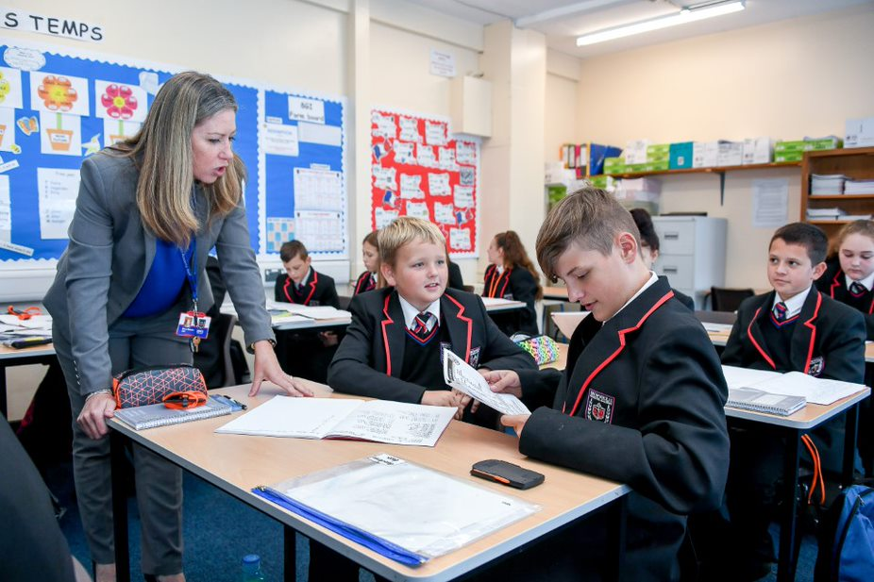

Year 9 French
Autumn term 1 | Autumn term 2 | Spring term 1 | Spring term 2 | Summer term 1 | Summer term 2
Le monde francophone  - Discovering French countries around the world  - Holiday activities  - French food specialities  - Planning an excursion  Key skills/grammar/  phonics taught  - Opinion + infinitive  - Reviewing present/perfect tense1st, 3rd pers sing  - Recevoir  - Negative perfect and near future tense)  - Asking questions & answering –subject verb inversion  - Phonics:  [a], SFE  [e] [é/er/ez] [è/ê/ai],open [o] [closed o/ô] [au/eau], [u] [ou] | Ma vie en musique  - Musical preferences  - Future plans.  - A trip to a concert  Key skills/grammar/  phonics taught  - Direct object pronouns  - Imperfect tense (1st pers sing/plural)  - Comparative  - Perfect and imperfect tenses  - Opinion in the reflexive form  - Dictations  - Photo card with P.A.L.M.O.J  - Writing with A.C.T.I.O.N  - Phonics:  [u] [ou], [closed eu] [open eu/œu], silent final [e], [i/y], [è / ê] /[u] [ou], silent final consonant(SFC), CaReFuL consonants | Ce que tu veux faire plus tard  - Future careers  - School subjects  - Ways to earn money  - Learning a language is an asset for your future  Key skills/grammar/  phonics taught  - Simple future with high frequency verbs (1st pers sing/plural)  - Near future  - Ce sera/il y aura  - Vouloir/pouvoir  - Present participle After ‘en’  - Questions in different tenses  - Photo card with P.A.L.M.O.J  - Writing with A.C.T.I.O.N  - Role play  - Phonics:  words ending with –ent,  [h muet] [h aspiré] [C], [j / soft g] [hard g] [gn], [ss / soft s] [hard s/z] | Je suis responsable: je fais attention à ma santé et à mon environnement  - Foods and drinks  - Healthy living & resolutions  - Getting to know French charities-Inventing your own charity  Key skills/grammar/  phonics taught  - Range of negatives  - Range of adverbs  - Superlative  - Choisir, venir, sortir  - Justifying opinions  - Partitive articles  - Il faut + infinitive  - Perfect tense with être  - Photo card with P.A.L.M.O.J  - Phonics:  [r] [ch] [qu] [th]  Liaisons, [oi] [oy]  [ain/in/aim/im]  [en/an/em/am]  [on/om] | Mon monde à moi  - Activities with your friends  - Describing friends and talking about relationships  - Past birthday celebrations  - French culture  Key skills/grammar/  phonics taught  - Irregular adjectives  - Phrases with the infinitive  - Near future  - Simple future  - Perfect tense vs imperfect tense  - Photo card with P.A.L.M.O.J  - Phonics:  [un/um],[ien],[tion]  [-aill-/-ail],[-ill-/-ille],[-eill-/-eil],[-euill-/-euil/-ueill-/-ueil/-œill-/-œil] | On découvre des artistes francophones  - Quiz on a French artist  - Your favourite French artist  - Revisiting learning  Key skills/grammar/  phonics taught  - Present tense (ER, IR, RE verbs)  - A.C.T.I.O.N  - Superlative  - Devoir + infinitive,  il faut + infinitive  - Using 5 tenses together  - Complex structures  - Phonics:  [-ouill-/-ouil]  Reviewing SFC, SFE  au/eau, [th], [oi],  words ending with -ent

Year 9 Geography
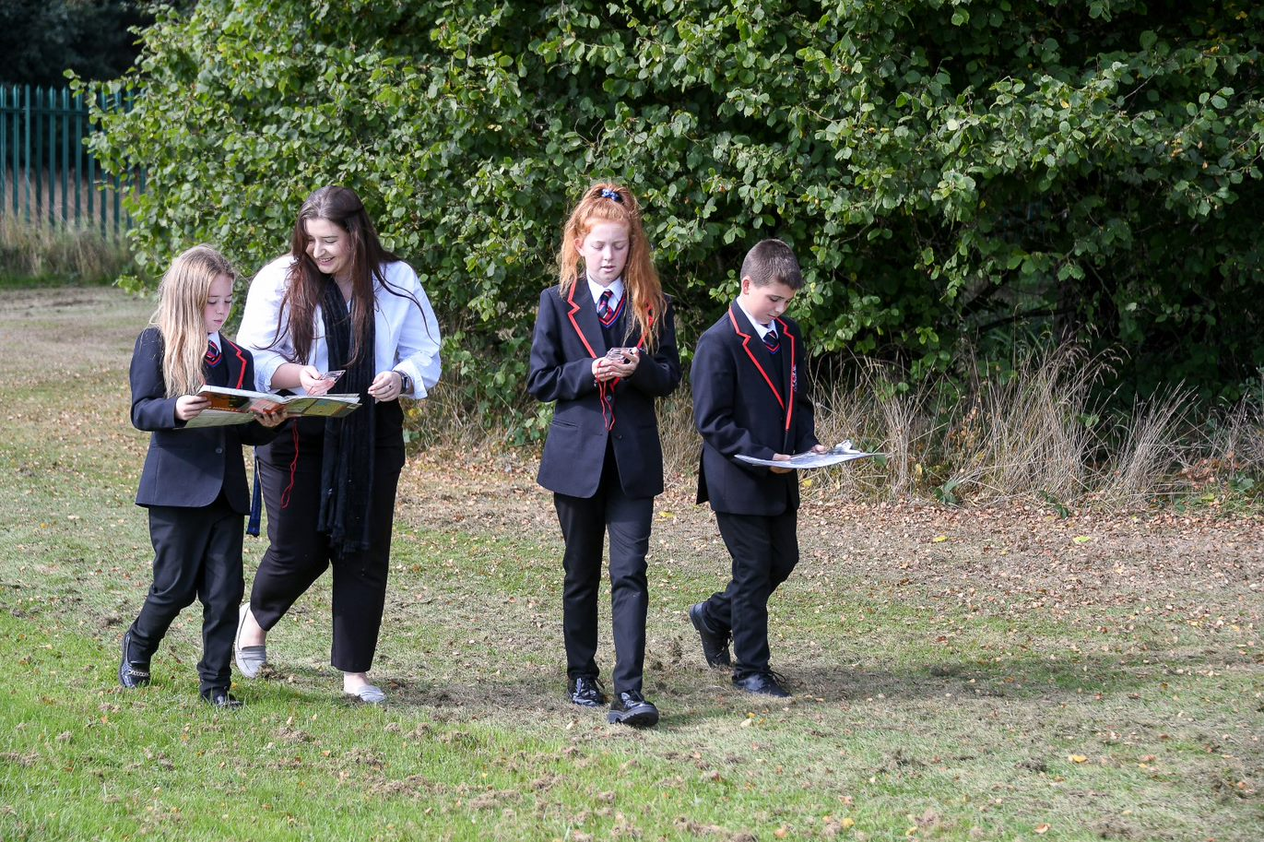
Year 9 Geography
Autumn Term 1 | Autumn Term 2 | Spring Term 1 | Spring Term 2 | Summer Term 1 | Summer Term 2
Climate change  - To explain the process of the greenhouse effect.  - To outline the causes of climate change (human and natural).  - To explain the effects of climate change.  - To outline methods of managing climate change.  - To explain the processes of adaptation and mitigation towards climate change.  - To outline the issues with plastics.  - To explain the consequences of plastic on ecosystems.  - To outline other options/recycling instead of single use plastics.  Key concepts:  Resilience  Risk  Development  Resources | Strange places  Russia – Chernobyl  Fly Geyser in the USA  Glass beach in California  Socotra Island – Yemen  Giants Causeway – Ireland  Bolivia – Salt Flats and Road of death  Unusual mountains - Chocolate Hills Philippines & Rainbow mountains China (Go Jetters) | Prisoners of Geography - Conflict and the Middle East  - To outline the reasons why some countries are prisoners of geography.  - To explain why geographical location and resources can cause conflict.  - To demonstrate an understanding of conflict in the Middle East.  - To demonstrate an understanding of current conflicts caused by geography.  Key concepts:  Risk  Resources  Resilience  Development  Globalisation | Ecosystems rainforests  - Know what an ecosystem is and be able to give examples. To outline the links between parts of an ecosystem.  - To outline the links between parts of an ecosystem.  - To outline the characteristics of a small-scale ecosystem – Epping Forest.  - To describe the distribution of world biomes.  - To outline the characteristics of the tropical rainforest biome.  - To outline the causes of deforestation is Brazil.  - To outline the effects of deforestation.  - To explain the sustainable solutions to the deforestation of TRF?  Key concepts:  Systems  Sustainability  Resources  Development  Inequality | Sustainable development  - To explain what the term sustainability means.  - To outline the problems in urban areas.  - To complete extended writing on the East Village sustainability.  - To complete the Bristol Mystery  - To outline how Curitiba is becoming more sustainable.  - To complete onsite fieldwork study for Brownhills Ormiston Academy – environmental quality survey  - To complete a write up of our onsite fieldwork.  Key concepts:  Resources  Resilience  Development  Globalisation  Inequality | Coasts  - To outline the processes of waves.  - To explain the processes of erosion, transportation, and deposition.  - Explain the processes of coastal landform formation (erosion).  - Explain the processes of coastal landform formation (transportation).  - Explain the processes of coastal landform formation (deposition).  - 3D model making (pop up headland/ stack stump etc.  - Outline the geography of the Jurassic Coast.  - Hard and soft engineering.  Key Concepts:  Systems  Fieldwork/Skills  Risk

Year 9 History
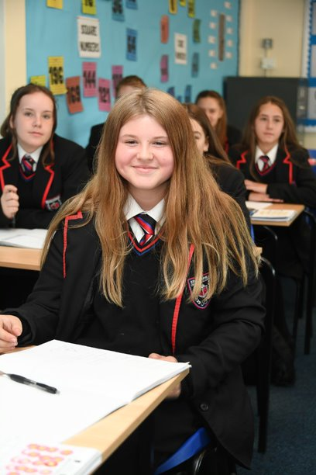
Year 9 History
Autumn Term 1 | Autumn Term 2 | Spring Term 1 | Spring Term 2 | Summer Term 1 | Summer Term 2
What was the outcome | Why was the war of | What was the reason for | How significant was | What was the tension | How did Britain and the
of women Fighting for | 1914-18 called the Great | the outbreak of WWII? | the Holocaust? | between USA and | wider world change in
their rights in the 20th | war? | ➢ What were the | ➢ What was Germany | USSR? | the 20th and 21st
century? |  |  |  |  | Century?
 |  | problems of the | like as a country
 | ➢ How did one murder | Treaty of Versailles? | between the years of | ➢What were the | - What were the origins of tensions within India?  - What were the impacts of the partition of India?  - How significant was the creation of the NHS?  - Why did racial tensions increase in Britain in the 1940s and 1950s?  - How did the British government respond to racism in the 1960s?  - How have people’s rights changed since the 1960s?  - How have people’s rights changed since the 1960s?  - What was Ireland like in the 20th century?  - How did different people experience ‘the Troubles’?  - How far did the Good Friday Agreement 1998 make lives better for people?
➢What were the | create tension in the |  | 1918 and 1933? | differences between
Victorian views on | world? | ➢ Who were the |  | superpowers Russia
women's roles? | ➢ What were the main | dictators? | ➢ How did Hitler become | and the USA by the
➢What were Victorians | reasons for the | ➢ What was Hitler’s | chancellor of Germany | end of WWI?
views on women and | outbreak of war in | early life like and | in 1933? | ➢Why did the cold war
the vote? | 1914? | why did become | ➢ What were the | start?
➢Who were the | ➢ Why did young boys | leader of Germany? | different methods that | ➢Why was there a
suffragettes? | want to join up for the | ➢ How did Hitler | Hitler used to keep | Berlin Blockade?
➢Who were the | war? | become leader of | control in Germany? | ➢How far was Korea a
suffragists? | ➢ What impact dd the | Germany in 1933? | ➢ How were Jews | boiling point in the
➢ What were the key | battle of the Somme | ➢ Why was there | treated in Nazi | Cold war?
events between 1906 | has on the British and | another war? | Germany under Hitlers | ➢Why was the Berlin
and 1914? | the German soldiers? | ➢ What were the | rule? | wall built and what
➢ What were the role of | ➢ What were the | turning points of | ➢ What was life like for | impact did it have on
the key individuals | attitudes like from the | WWII? | German Jews in the | the Cold war?
within the suffrage | British government | ➢ Was the battle of | 1930’s? | ➢How close did the
movement? | based on the soldiers | Dunkirk a victory or a | ➢ What were the | world come to nuclear
➢Why did Emily | fighting in WWI? | disaster for Britain? | experiences like for | disaster with the
Davidson die? Was | ➢ How can the Battle of | ➢ What was the impact | Jews in Germany? | Cuban Missile Crisis?
she a hero or a Martyr | the Somme be shown | of the Battle of | Using sources to help | ➢Why did Americans
➢ What does the statue | in newspapers? | Britain? | with your answers | object to the USA’s
of Millicent Fawcett tell |  | ➢ Was Britain right to |  | involvement in the war
 |  | bomb Dresden?
us about the campaign for women’s suffrage?  ➢What was the impact of WWI on the suffragettes?  ➢Why did some women get the vote in 1918?  Key concepts:  Second Order Concept  Change  Continuity  Cause  Consequence Significance | ➢What was trench warfare like for the soldiers?  ➢What were the trench conditions like for the  soldiers?  ➢How can sources of evidence be used to evaluate why soldiers  were shot at dawn, was it due to them being cowards, traitors or Victims?  ➢How can poems be used to help with an enquiry based on what life was like for a soldier in the trenches?  Key concepts:  Change  Second Order Concept  Causes and Consequence | ➢What was the impact of the nuclear attack in 1945?  ➢What was the reason for the USA dropping  the atomic bombs on Japan?  ➢To examine whether Churchill was a great leader?  Key concepts:  Second Order Concept Causes and  Consequence  Significance and Change | ➢Identify the ways in which persecution got worse from 1933-39  ➢Why were Jewish people placed in ghetto’s and what were the conditions like for the Jews?  ➢What happened under  the Nazi policy between 1941 and 1945?  ➢To investigate the final solution and its impact  on individuals and  communities  ➢Who was responsible for the Holocaust?  Key concepts:  Significance  Change and diversity | in Vietnam during the cold war?  ➢How did the Cold War cause huge advances  in the space race?  ➢Why is the war in Afghanistan in the 1970’s and 1980’s part of the cold war conflict?  ➢How did the cold war come to an end?  ➢How hot did the cold war get?  ➢What do historian’s  interpretations say about the end of the  cold war and why?  ➢What were the features of the York Cold War bunker?  Key concepts:  Second Order concept  Change and continuity | Key concepts:  Focus on developing enquiries Second Order Concept  Change and continuity

Year 9 Maths

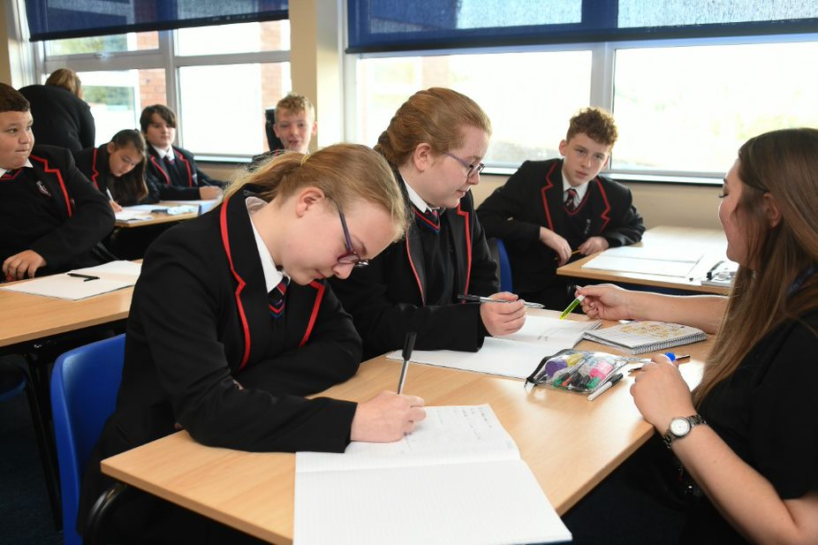

Year 9 Maths
Autumn Term 1 | Autumn Term 2 | Spring Term 1 | Spring Term 2 | Summer Term 1 | Summer Term 2
Geometry  - Angles in polygons  - Angles in parallel lines  - Area of trapezia  - Area of a circle  - Reflection | Statistics & Algebra  - Represent grouped data  - Compare distributions  - Misleading graphs  - Measures of location  - Outliers  - Compare gradients  - Compare intercepts  - Find the equation of a line  - Real life graphs | Algebra & Geometry  - Inequalities with negatives  - Equations with unknowns on both sides  - Equations and inequalities in context  - Rearranging formulae  - Expanding a pair of binomials  - Surface area  - Volume | Number & Ratio  - Percentage increase and decrease  - Percentage change  - Reverse percentages  - Repeated percentage change  - Maths and money | Geometry & Ratio  - Rotation  - Translation  - Pythagoras  - Inverse proportion  - Best buys | Ratio, Statistics & Algebra  - Compound measures  - Rates of change  - Tree diagrams  - Quadratic graphs  - Represent inequalities

Year 9 Music
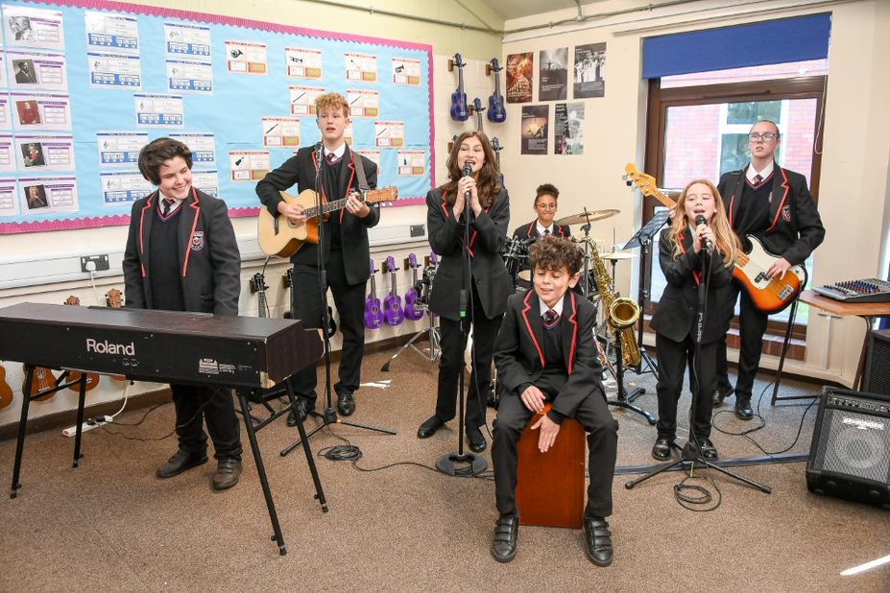
Year 9 Music
Theme 1 | Theme 2 | Theme 3
The Brownhills Songbook  Technical, Constructive & Expressive Progression:  Singing: Singing more complex repertoire with a greater melodic range, using homophonic/polyphonic harmony to sing in parts.  Keyboard: Playing chord progressions in different keys and using a broader range of devices to develop accompaniments on keyboards in ensembles.  Composing: Write chord progressions that offer greater musical contrast and introduce more rhythmic vitality to accompanying parts in compositions.  Listening: Locating musical features in pop music with more specificity and begin to provide more detailed descriptions of the application of compositional devices.  Reading Staff Notation: Following BPM makings on scores to accurately play pop music at the correct tempo. Reading music that contains triplet quavers and crotchets.  Knowledge Focus:  - Sections of Popular Songs  - Conventions of Pop/Rock Music  - Tempo (Pop Music) | Story of the Orchestra: Descriptive Music  Technical, Constructive & Expressive Progression:  Singing: Developing effective sound production in changing voices to establish blending as an ensemble and stylistic singing that is relevant to the focus genre.  Keyboard: Students play more complex melodies, ostinati and chords from orchestral music, including music in different time signatures played with a larger ensemble.  Composing: Composing music that effectively responds to briefs, using different forces within a given structure to achieve musical contrast.  Listening: Recognising musical features that achieve musical contrast between different sections in Holst’s planets and how those features achieve the compositional intention.  Reading Staff Notation: Reading music in irregular time signatures and more detailed musical directions to compose and play descriptive music.  Knowledge Focus:  - Structures  - Form  - Instruments of the Orchestras  - Contrast | Jazz & Blues  Technical, Constructive & Expressive Progression:  Singing: Singing jazz and blues melodies that feature complex melodic features such as blue notes and chromaticism in a stylistic way appropriate to genre.  Keyboard: Playing and improvise complex melodies based on blues scales, using more chromaticism in keyboard music and playing chords using extended harmony.  Composing: Students compose their own piece of 12-bar blues music and New Orleans polyphony featuring some improvisation.  Listening: Aurally identify jazz & blues music aurally and recognise stylistic features of jazz & blues in fusion music to make suggestions about musical influences.  Reading Staff Notation: Reading 7th chord symbols, swung rhythms and using chords to inform effective improvisation to play and compose jazz & blues music.  Knowledge Focus:  - Jazz/Blues Structures  - Jazz/Blues Harmony  - Jazz/Blues Instrumentation  - Jazz/Blues Rhythms  - Jazz/Blues Melody

Year 9 PE
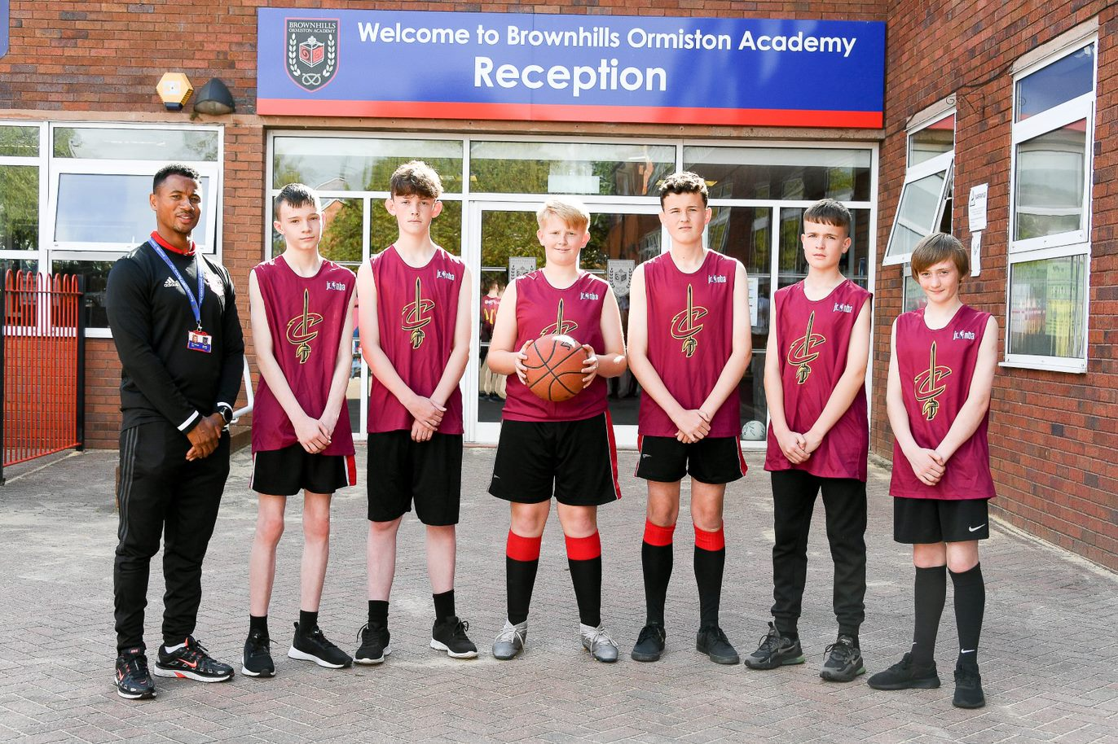
Year 9 PE
Autumn Term 1 | Autumn Term 2 | Spring Term 1 | Spring Term 2 | Summer Term 1 | Summer Term 2
Football, Rugby, Netball, Badminton, Multi-Skills, Fitness.  Key concepts  - Attacking and defensive strategies for invasion.  - Creative application of fitness towards individual training.  - Selecting and combining skills in complex situations.  - Leadership in officials and coaching roles.  - Attacking and defensive principles in netball.  - How to develop personal fitness and apply FITT principles | Swimming, Badminton, Basketball.  Key concepts  - Application of advanced skills in complex situations. E.g. net play and variation of serving.  - Formations and strategies in attacking and defensive situations.  - Evaluating performance with understanding of improvement.  - Application of rules and regulations as a leader  - Advanced swimming technique including start, turns and finishes.  - Advanced swimming technique including start, turns and finishes. | Basketball, gymnastics, Volleyball, Hockey, Tag Rugby.  Key concepts  - Creativity in performance through accurate replication in Gymnastics.  - Serving and returns in tennis.  - Leadership in officials and coaching roles.  - Tactical elements to overcome opponents in team and individual sports  - Defensive and attacking principles in basketball.  - Set plays and screening | Gymnastics, Handball, Volleyball, Hockey, Tag Rugby.  Key concepts  - Leadership in officials and coaching roles.  - Independence in sport  - Creativity in performance through accurate replication in Gymnastics.  - Introduction of new sports and rules. | Athletics, Cricket, Rounders.  Key concepts  - Maximising individual performance against criteria.  Personalised training programme in relation to fitness components.  - Intermediate relays and changeovers.  - Tactical scenarios in rounders.  - Advanced swimming technique including start, turns and finishes. | Cricket, Volleyball, Rounders, Tennis, Softball, Handball.  Key concepts  - Batting techniques- cut and pull  - Application of rules in competition.  - Leadership in officials and coaching roles.  - Training methods and how to apply to a training programme successfully.

Year 9 Religious Education
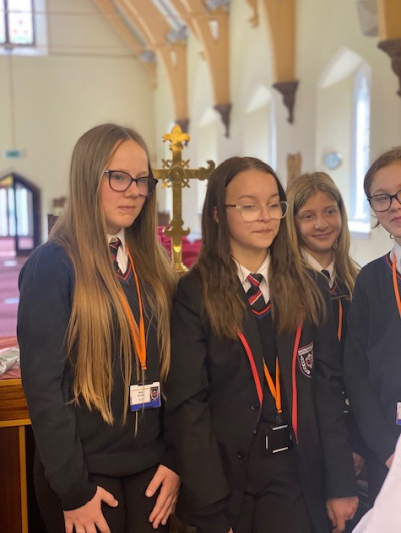
Year 9 Religious Education
Autumn Term 1 | Spring Term 1 | Summer Term
Crime and religion  - Causes of crime  - Christian attitudes to law breakers  - Aims of punishment  - Prison (UK vs Sweden)  - Treatment of criminals  - Corporal punishment and religious attitudes  - Forgiveness parable of the lost son  - Christian and Islamic examples of forgiveness  Key concepts  1.ab. 2.a 4.a 5.a,b.6a | Applied ethics  - Creation story  - The value of the natural world  - Ethical treatment of animals  - Sanctity of life  - Abortion  - Euthanasia  - Assessment  Key concepts  1,a,b 2,a,b 4,b,5,ab 6,ab | Peace, War and Conflict  - Can people find peace through faith?  - What do religions teach about peace?  - How does mindfulness or inner peace relate to issues of conflict?  - What can we learn from examples of religious conflict and religious peace making?  - Why are religions often blamed for war and conflict?  - If religions teach peace, why do they fight?  - Racism / prejudice  - Key concepts  1,a,b 2,a,b 4,b,5,ab 6,ab

Year 9 Science
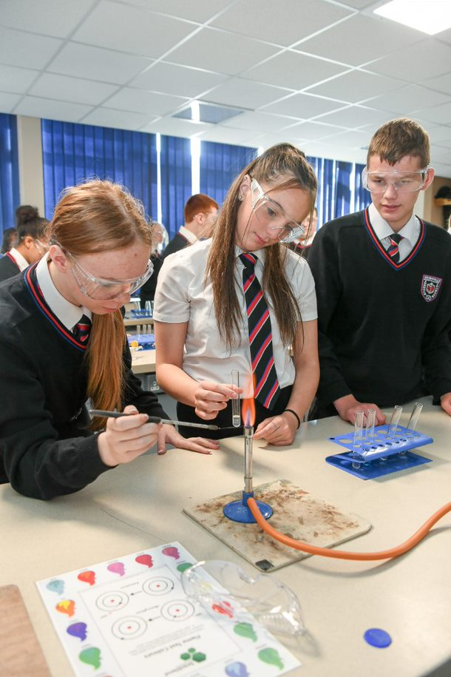

Year 9 Science
Autumn Term 1 | Autumn Term 2 | Spring Term 1 | Spring Term 2 | Summer Term 1 | Summer Term 2
Biology – The body  ➢ How the brain, eye and kidney work is studied.  Chemistry – Material science  ➢ The science used by a materials scientist when designing and using materials is investigated.  Physics – Power of particles  ➢ Understanding and using pressure and how pressure can be useful |  | Biology – Inheritance  ➢ Structure of DNA and the role it plays in inheritance and genetic disorders is studied.  ➢ Theory of evolution  ➢ Natural selection, selective breeding and cloning are all studied.  Chemistry – Forensic Science  ➢ The science used by a forensic scientist when investigating crime  Physics – Space  ➢ Engaging with the historical development of telescopes to observe and decipher the stars and night sky. Looking at what the Sun actually is and how it’s life cycle and size dictates life on Earth.  . |  | Biology – Cell biology  ➢ Introduction to GCSE cell biology, specialisation, transport in cells and cell division is studied  Chemistry – Atomic structure  ➢Introduction to GCSE atomic structure relating structure and position in the periodic table to reactivity.  Physics – Quantifying waves  ➢ Investigating different types of waves around us and ways for us to measure waves using technology we have in our pockets.

Year 9 Careers
Form activity – Aspirations, what is your Future. Students look at former OAT students and focus on their dreams.  What is a skill? (3) (S)  An intro to different types of skills pt 1 (3) (S)  An intro to different types of skills pt 2 (3) (S)  Your interest & jobs (3) (SA)  Your strengths & jobs pt1 (3) (SA)  Your strengths & jobs pt2 (3) (SA)  What jobs do people do near you? (2) (LM) | - Brownhills careers Convention - pupils will be invited to our annual careers convention. pupils will have the opportunity to speak with external delegates and receive bespoke advice and guidance. aspiring futures will also be present to offer impartial IAG.  Form activity -  - Explore some key industries in England (2) (LM)  - Explore jobs based on your interests (2) (SA)  - Explore jobs based on your strengths (2) (SA)  - Your subjects and jobs (2) (CB)  - Developing your skills in everyday life (3) (S)  - What skills are needed for different jobs? (2) (S) | Form activity -  - GCSEs - an overview of your options (8) (MoC)  - GCSEs - making your choices (4) (MoC)  - What is Stereotyping? (3) (CB)  5 session of Personal development: The Real World and financial Literacy  - KS4 options  - Personal finance  - Real world: Budgeting the cost of everyday items  - Job Roles: How your career could affect your budget and lifestyle  - Financial fraud and gambling (online) | - National Careers / Apprenticeship Weeks (March) – pupils will receive a special assembly, form time activities and also competitions will be launched. Resources to be differentiated for each year group.  - During National careers week departments will deliver a ‘Careers lesson’ in curriculum time. This will be used to inspire pupils and raise awareness of the variety of careers that are linked to their subject. Therefore connecting learning to ‘real life’. Staff will display careers postcards on their doors which highlight what previous jobs they have had prior  to teaching.  Form Activity:  - Explore Industries in your area (2) (LM)  - Explore local jobs in demand (2) (LM)  - What will jobs be like in the future? (2) (LM)  - What is your personality type? (3) (SA) | Form Time activity  - What Skills do you have (3) (S)  - How can you develop your skills? (3) (S)  - Explore local employers and what is important to them (2) (LM)  - What skills are important to employers? (2) (LM | - Form time activity:  Students will have a keynote speaker who will talk about their journey and the importance of careers choices.

Year 9 Personal development
Autumn Term 1 | Autumn Term 2 | Spring Term 1 | Spring Term 2 | Summer Term 1 | Summer Term 2
Human Rights  - Human Rights: Where do they come from and why are they important?  - Racism, prejudice and discrimination. Oxplore lesson: Does race matter?  - Black lives matter  - Malala Yousafzai: Equality in Education  - Debate: The importance of human rights.  - Influencing attitudes | Consent, Conception and contraception  - Respectful relationships  - Freedom and the capacity to consent  - Sexual health  - Contraception and Conception  - Grooming and Sexual exploitation  - Drink, drugs and sex  - Managing the ending of a relationship | The Real World and financial Literacy  - KS4 options  - Personal finance  - Real world: Budgeting the cost of everyday items  - Job Roles: How your career could affect your budget and lifestyle  - Financial fraud and gambling (online) | Diversity and Equality  - Understand people's negative attitudes and what is meant by prejudice and stereotypes.  - Recognising my own and others stereotypical and prejudicial attitudes.  - Disability: tackling discrimination and supporting others  - LGBTQ+: tackling discrimination and supporting others  - The Trans community, transphobia and feeling comfortable in your body. | Personal safeguarding  - Knife crime, the risks and consequences  - Preventing involvement in serious and organsied crime  - Cyberbullying  - Sexting, grooming and radicalisation  - The importance of staying safe online and the Dark Wed  - How to be an active bystander | E-safety, Digital Citizenship and social media  - What is the news?  - How can I judge the reliability of a news article?  - How can I revew my news?  - How is information used online?  - Your online reputation  - Potential solutions to issues with digital safety and fraud online

