Brownhills Ormiston Academy
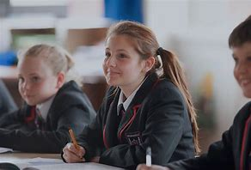
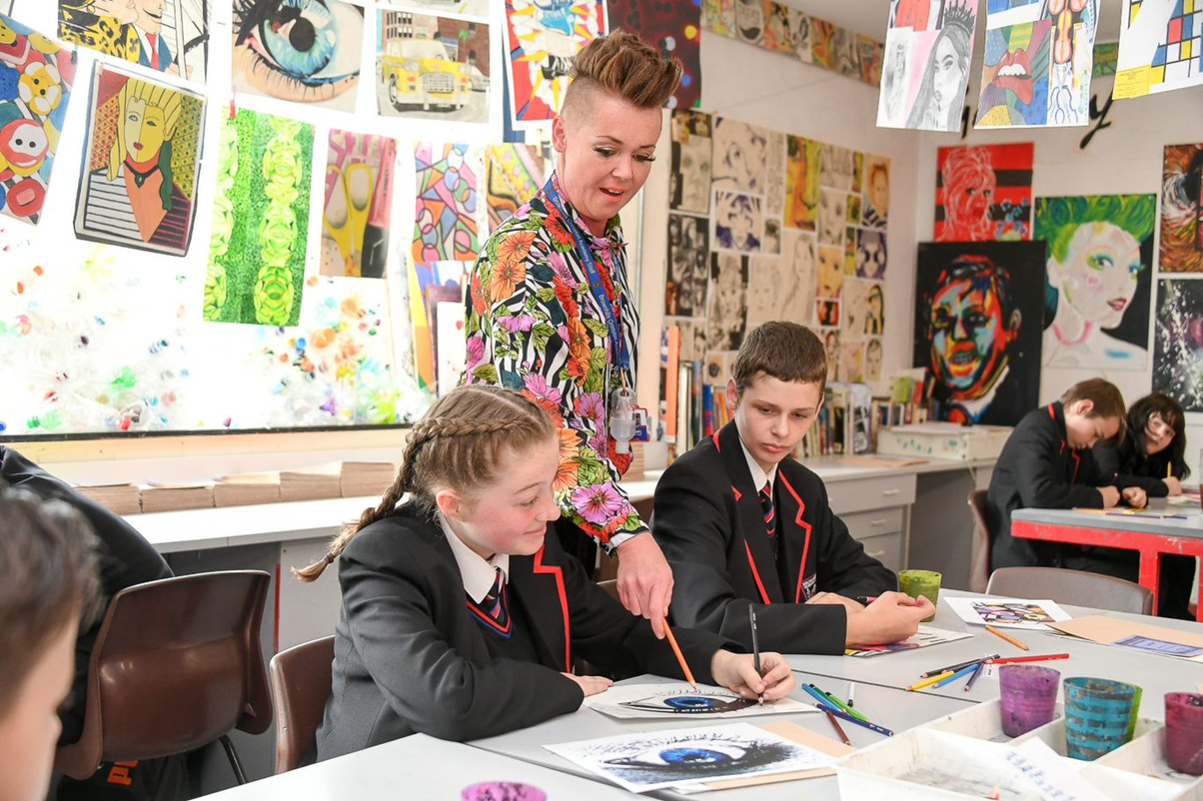
Year 8 curriculum 2023-2024
Year 8 Art

Year 8 Art
 | Autumn Term 1 |  | Autumn Term 2 |  | Spring Term 1 |  | Spring Term 2 |  | Summer Term 1 |  | Summer Term 2
 | Packaging | Packaging |  | Street Art/Culture |  | Street Art/Culture |  | Environment/ Object |  | Environment/ Object Art.
 |  | Contextual references: |  |  |  |  |  | Art.
➢ | Assessment (drawing |  |  | ➢ | Assessment | ➢ | Contextual |  |  | ➢ | Contextual
 | and use of materials) | ➢ | Graphic designers, | ➢ | (Contextual and use |  | references: Atlanta | ➢ | Assessment (final |  | references:
➢ | Contextual |  | graphic design, pop |  | of materials). |  | Street artists, Peter |  | piece). |  | Skateboard Art,
 | references: Graphic |  | art, typography. | ➢ | Contextual |  | Ferrari, Shepard | ➢ | Contextual |  | Sandra P. Koche,
 | designers, graphic | ➢ | Wax resist, |  | references: Atlanta |  | Fairey, Aboriginal art, |  | references: |  | Beastman, Steve
 | design, pop art, |  | development of pencil |  | Street artists, Peter |  | African art. |  | Skateboard Art, |  | McPherson, Robert
 | typography. |  | crayon skills, |  | Ferrari, Shepard | ➢ | Advanced pencil |  | Sandra P. Koche, |  | Bradford.
➢ | Wax resist, |  | composition, |  | Fairey, Aboriginal art, |  | colour skills, Dot |  | Beastman, Steve | ➢ | Advanced use of
 | development of pencil |  | accuracy. |  | African art. |  | painting, scrafitto. |  | McPherson, Robert |  | pencil tone shading.
 | crayon skills, | ➢ | Developing opinions | ➢ | Advanced pencil | ➢ | Developing detailed |  | Bradford. |  | Advanced use of
 | composition, |  | given on artwork. |  | colour skills, Dot |  | opinions on artwork | ➢ | Advanced use of |  | paint and crayon.
 | accuracy. |  | Keywords. |  | painting, scrafitto. |  | and use of keywords. |  | pencil tone shading. |  | Spray paint, 3D and
➢ | Developing opinions | ➢ | Evaluation. | ➢ | Developing detailed | ➢ | Evaluation. |  | Advanced use of |  | object placement.
 | given on artwork. |  |  |  | opinions on artwork |  |  |  | paint and crayon. | ➢ | Detailed and
 | Keywords. |  |  |  | and use of keywords. |  |  |  | Spray paint, 3D and |  | confident opinions on
 |  |  |  |  |  |  |  |  | object placement. |  | artwork, using art
Key Concepts |  | Key Concepts |  | Key Concepts |  | Key Concepts |  | ➢ | Detailed and |  | terminology.
 |  |  |  |  |  |  |  |  | confident opinions on | ➢ | Analysing the work of
(KS3 ref 1,2,3,4,5) |  | (KS3 ref 1,2,3,4,5) |  | (KS3 ref 1,2,3,4,5) |  | (KS3 ref 1,2,3,4,5) |  |  | artwork, using art |  | others.
1.Use a range of |  | 1.Use a range of |  | 1.Use a range of |  | 1.Use a range of |  |  | terminology. | ➢ | Evaluation.
techniques to explore |  | techniques to explore |  | techniques to explore |  | techniques to explore |  | ➢ Analysing the work of
ideas. |  | ideas. |  | ideas. |  | ideas. |  |  | others.
2.Use a range of media |  | 2.Use a range of media |  | 2.Use a range of media |  | 2.Use a range of media
including paint. |  | including paint. |  | including paint. |  | including paint. |  | Key Concepts |  | Key Concepts
3.Increase proficiency in |  | 3.Increase proficiency in |  | 3.Increase proficiency in |  | 3.Increase proficiency in
handling materials. |  | handling materials. |  | handling materials. |  | handling materials. |  | (KS3 ref 1,2,3,4,5) |  | (KS3 ref 1,2,3,4,5)
4.Analyse and evaluate |  | 4.Analyse and evaluate |  | 4.Analyse and evaluate |  | 4.Analyse and evaluate |  | 1.Use a range of |  | 1.Use a range of
own work and that of |  | own work and that of |  | own work and that of |  | own work and that of |  | techniques to explore |  | techniques to explore
others. |  | others. |  | others. |  | others. |  | ideas. |  | ideas.
5.Learn about art from |  | 5.Learn about art from |  | 5.Learn about art from |  | 5.Learn about art from |  | 2.Use a range of media |  | 2.Use a range of media
different eras and styles. |  | different eras and styles. |  | different eras and styles. |  | different eras and styles. |  | including paint. |  | including paint.



Year 8 Computer science
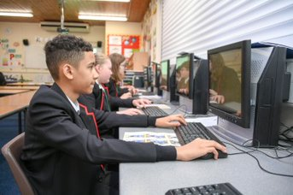

Year 8 Computer science

Autumn Term 1 | Autumn Term 2 | Spring Term 1 | Spring Term 2 | Summer Term 1 | Summer Term 2
Using media with Publisher  - DTP basics  - Using templates  - Applying text  - Using shapes  - Inserting pictures  Key Concepts  (KS3 ref 7, 8) | Understanding computers  - Elements of a computer  - The CPU  - Understanding binary  - Storage device  - New technologies  Key Concepts  (KS3 ref 4, 5, 6, 7) | Cyber Security  - Email scams  - Hacking and malware  - Protecting personal data  - Copyright  - Health and safety  Key Concepts  (KS3 ref 9) | Graphic design  - 2D software basics  - Functions and tools  - Rendering  - Bitmaps  - Vector images  - Adding text  Key Concepts  (KS3 ref 7, 8, 9) | Modelling data: Spreadsheets  - Basic terms and structure  - Columns of data  - Functions used in Excel  - Tools and techniques  - Charts  Key Concepts  (KS3 ref 1, 7) | Introduction to Small Basic  - Introduction to Small basic  - Making decisions  - Repetition  - Graphics  - Turtle Graphics  - Subroutines and Arrays  Key Concepts  (KS3 ref 1, 2, 3

Year 8 Design Technology
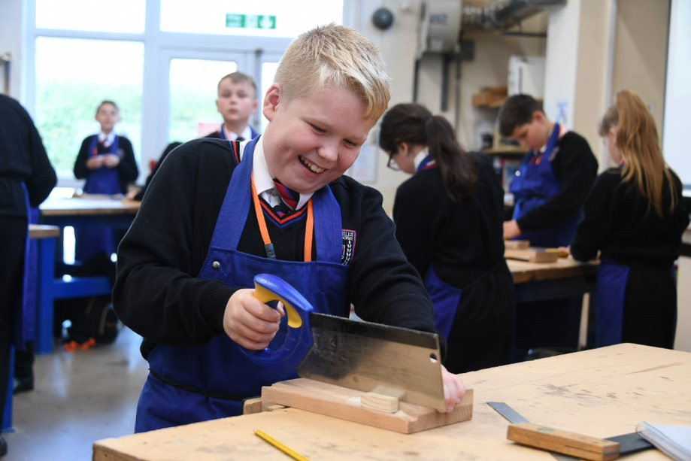
Year 8 Design Technology
Autumn Term 1 | Autumn Term 2 | Spring Term 1 | Spring Term 2 | Summer Term 1 | Summer Term 2
Bughouse  - Measuring, marking, cutting timber with accuracy.  - Using woodwork tools such as disc sander, chisel, marking gauge, try square and tenon saw. .  - Material properties, including why a material is more suitable in comparison to others.  - Exploring and demonstrating construction methods for timber housing joint, lap joint.  Key concepts: NC  concepts I2, M1, M2, T1 | Bughouse  - Measuring, marking, cutting timber with accuracy.  - Using woodwork tools such as disc sander, chisel, marking gauge, try square and tenon saw. .  - Material properties, including why a material is more suitable in comparison to others.  - Exploring and demonstrating construction methods for timber housing joint, lap joint.  Key concepts: NC  concepts I2, M1, M2, T1 | Cultural Jewellery  - Exploring ergonomic and anthropometrics  - Analysing a product to considers a broad range of features.  - Develop a range of varied and creative designs which respond to a brief, specification, and link to research.  - Using annotations to enhance the communication of ideas.  - Exploring material properties, CAD.CAM and construction methods.  Key concepts: NC  content I1, I2, D1, D2, E1, E3,  E4, T1, M1 | Cultural Jewellery  - Exploring ergonomic and anthropometrics  - Analysing a product to considers a broad range of features.  - Develop a range of varied and creative designs which respond to a brief, specification, and link to research.  - Using annotations to enhance the communication of ideas.  - Exploring material properties, CAD.CAM and construction methods.  Key concepts: NC  content I1, I2, D1, D2, E1, E3,  E4, T1, M1 | Food from around the world  - Macronutrients (carbohydrates, fats and protein) and their role in our diets.  - Health risks associated with unhealthy eating habits.  - Suggesting alternative ingredients when modifying recipes.  - Exploring and cooking dishes from a range of cultures.  - Demonstrating growing confidence with kitchen equipment and cooking techniques.  - Measure liquids and dry ingredients with independence and some accuracy.  Key concepts: NC  content C1, C2, C3, C4 | Food from around the world  - Macronutrients (carbohydrates, fats and protein) and their role in our diets.  - Health risks associated with unhealthy eating habits.  - Suggesting alternative ingredients when modifying recipes.  - Exploring and cooking dishes from a range of cultures.  - Demonstrating growing confidence with kitchen equipment and cooking techniques.  - Measure liquids and dry ingredients with independence and some accuracy.  Key concepts: NC  content C1, C2, C3, C4

Year 8 English
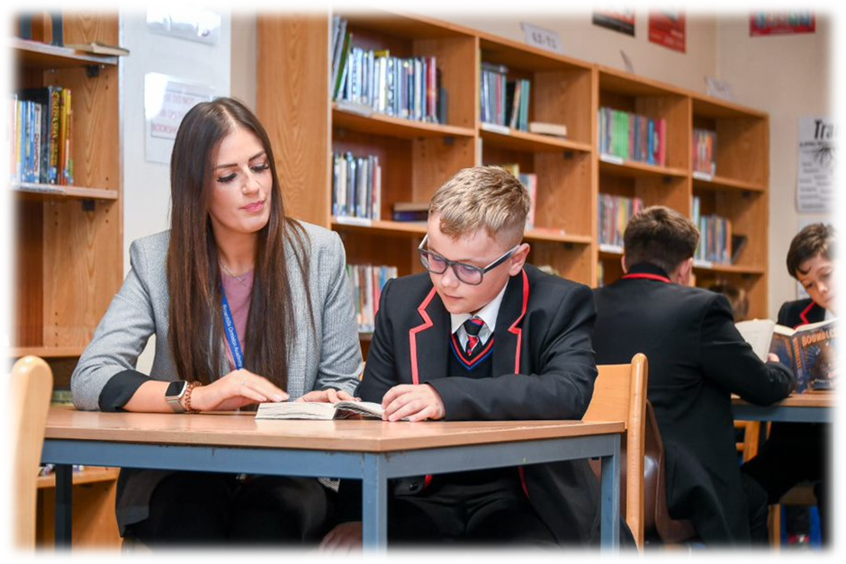
Autumn | Spring | Summer
Belonging, Survival and Mercy  - Focus text: In the Sea, there are Crocodiles  - Secondary: The Beekeeper of Aleppo, Lake Urmia, What Were They Like, Blessing, Our City- Jon Bloomfield, Windrush, Salt to the Sea, Malala narrative  - Themes: Identity, relationships, conflict, fear, discrimination  - L/S: theme, characterisation, narrative perspective, narrative voice, authoritative intent, irony, tone  - Story: mystery of origins, self-discovery, character journey, storytelling and narration  - Writing:Three Adjective Punch, Without Without  - Context: life of a refugee, tyranny, poverty, mysteries of origin, struggle in a contemporary world | Love and Hour  - Focus text: Romeo and Juliet  - Secondary: Sonnet 116, The Kennedy’s, Valentine  - Themes: power, relationships, love, conflict, religion & fate, violence  - L/S: genre: tragedy, prologue, epilogue, story structure, metaphor, iambic structure  - Story: plot, dialogue, drama, characterisation, verse  - problem/solution, summaries  - Writing: The So So Sentnece, The As If Start  - Context: Elizabethan period, patriarchy, demands of religion, family structure | Power and Exploitation  - Focus Text: Animal Farm  - Secondary: the Rise of Part-time Vegans, Forever Against Animal Testing, How doth the little Crocodile?, Jabberwocky, The Eagle and The Jaguar  - Themes: power, exploitation, identity, conflict, relationships  - L/S: animalism, symbolism, metaphor, rhetoric, language as power  - Story: fable, moral, ideology, character voice  - Writing: Semi-Colon Split  - Context: Russian revolution: Stalinism, democracy, Cold War, Soviet Union, socialism, Totalitarianism
Year 8 English

Year 8 French
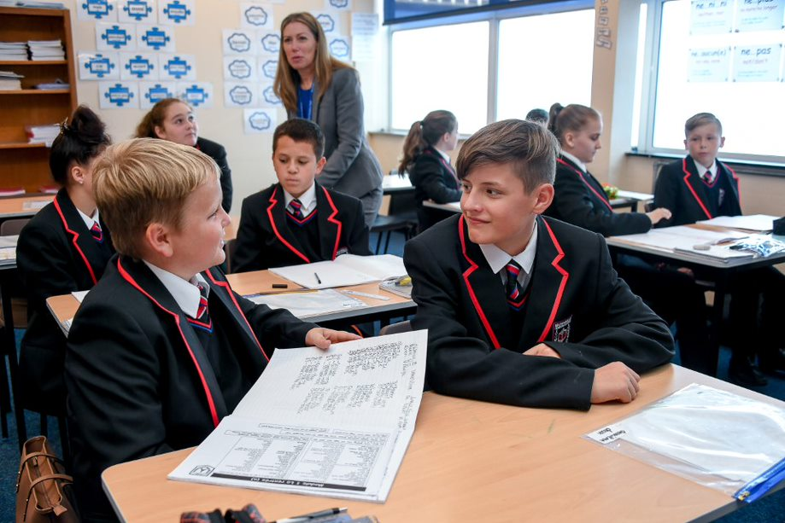

Year 8 French
Autumn term 1 | Autumn term 2 | Spring term 1 | Spring term 2 | Summer term 1 | Summer term 2
Raconte moi tes vacances  - Activities on holidays  - A virtual tour to Disney Land  - A visit to the Parc Asterix & futuroscope  Key skills/grammar/  phonics taught  - Revision of the verb ‘avoir’ and ‘être’  - Perfect tense with ‘avoir’ (1st pers sing and plur)  - Using A.C.T.I.O.N.s  - Perfect tense with ‘aller’ (first pers sing/plural)  - Negatives in the perfect tense  - Superlative  - Phonics:  ‘a’, SFE,[e] [é/er/ez] [è/ê/ai], open o] [closed o/ô] [au/eau]  [u] [ou] | Je me débrouille en vacances  - Ordering food  - Asking information  - Booking a room  - Identifying key information on tourism ads  - Planning an activity according to the weather  Key skills/grammar/  phonics taught  - Present tense of regular –ir and –re verbs  - Question words  - Boire (1^{st, 3rd} pers sing)  - Adverbs  - Perfect tense with ‘être’ (1st sing/plural)  - Using P.A.L.M.O.J  - Near future  - Phonics:  [u] [ou]  [closed eu] [open eu/œu], silent final [e], [i/y], è / ê /[u] [ou]silent final consonant (SFC), CaReFuL consonants | Mes loisirs et ma vie numérique  - Spare time activities  - A past visit to the shopping centre  - Digital activities  Key skills/grammar/  phonics taught  - Adjective agreement (irregular)  - Revisit present tense of ER, IR, RE verbs  - Conditional tense (1st pers sing)  - Possessive adjectives  - ‘faire’ and ‘suivre’ (1st, 3rd person sing)  - Negatives (jamais/ ni…ni…)  - Perfect tense with être and avoir  - Phonics  Words ending with –ent,  [h muet] [h aspiré]  C, [j / soft g] [hard g] [gn], [ss / soft s] [hard s/z] | Plongez dans la vie des grands athlètes  - Opinions on sports  - Your favourite athlete  - Healthy choices  - Asking and answering questions  Key skills/grammar/  phonics taught  - Jouer à/faire de  - Comparative & superlative  - Il faut + infinitive  - Revision of the near future  - The verb ‘pouvoir, vouloir- 1st/3rd person narrative  - Perfect tense with avoir (whole paradigm)  - Using A.C.T.I.O.N  - Phonics:  [r] [ch] [qu] [th],Liaisons  [oi] [oy] [ain/in/aim/im]  [en/an/em/am] [on/om] | Vivre ici ou ailleurs  - Describing your town & the weather  - Talking about what you can do in town & inviting someone out  - Inviting someone in town  - Recent activities in your town  - Bastille day in Paris  Key skills/grammar/  phonics taught  - Pouvoir /vouloir + infinitive  - Using P.A.L.M.O.J  - Relative clauses (où, quand)  - Perfect tense with ‘être’ (whole paradigm)  - Using A.C.T.I.O.N  - Reflexive verbs (1st pers sing)  - The imperfect tense (1st person narrative (implicit teaching)  - Combining 2 & 3 tenses  - Phonics:  [un/um],[ien],[tion]  [-aill-/-ail],[-ill-/-ille]  [-eill-/-eil],[-euill-/-euil/-ueill-/-ueil/-œill-/-œil] | Si seulement tu étais ici!  - Destination to a French speaking country  - A past visit to Nice carnival/design a mask for the carnival  - Planned activities  - Planning a dream holiday  Key skills/grammar/  phonics taught  - Asking questions  - The conditional tense (implicitly)  - Combining three tenses  - Imperfect tense (1st pers sing/plur)  - Extensive piece of writing with A.C.T.I.O.N  - Superlative  - Reading with the correct pronunciation & applying knowledge of SSCs  - Phonics:  [-ouill-/-ouil]  Reviewing SFC, SFE  au/eau, [th], [oi],  words ending with -ent

Year 8 Geography
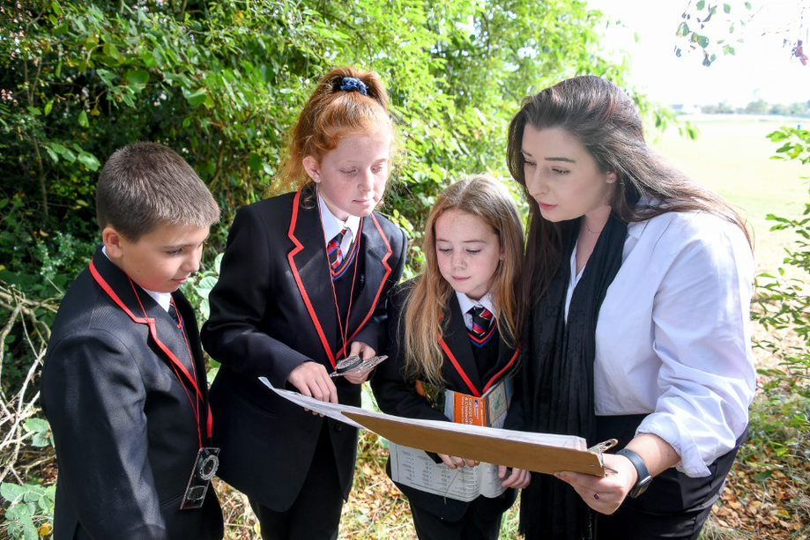
Year 8 Geography
Autumn Term 1 | Autumn Term 2 | Spring Term 1 | Spring Term 2 | Summer Term 1 | Summer Term 2
Our Angry Earth  To explore what a natural hazard is  To outline the global distribution of earthquakes and understand the reasons for their locations  To understand the physical processes at plate boundaries  To complete a case study on the Lombok Case Study  To explore the effects and responses to the Lombok earthquake  To have an understanding of the Amatrice Earthquake, Italy 2016  To complete extended writing – a comparison between the two earthquakes.  To understand why people, live with the risk of natural hazards.  To understand the management of tectonic hazards.  Volcanoes – formation and explosions  Key Concepts  Risk  Systems  Resilience  Inequality  Development | Strange places  To explore ‘strange places’ around the world, gaining an understanding of the physical and human geography of these locations.  We will focus on the following places:  1.Russia – Chernobyl (2 lessons)  2.USA – Fly Geyser  3.USA – Glass Beach California  4.Yemen – Socotra Island  5.Ireland – Giants Causeway  6.Bolivia – Salt Flats and Road of Death  7.Unusual Mountains – Chocolate Mountains Bolivia and Rainbow Mountains China  Key Skills/Concepts  Sustainability  Globalisation  Inequality, field work skills | Weather hazards  - To describe the process of the global atmospheric circulation.  - To outline the distribution and formation of Tropical Storms.  - To introduce the Typhoon Haiyan case study.  - To explain the severity of the Typhoon Haiyan tropical storm.  - To outline the impacts of Typhoon Haiyan.  - To evaluate the responses to Typhoon Haiyan.  - To explain why people, live in areas at risk of tropical storms.  Key Skills/Concepts Taught  Risk  Systems  Resilience  Development | River landscapes  - To demonstrate a clear understanding of the water cycle  - To describe the process of erosion, transportation, and deposition.  - To outline the distribution of rivers across the UK.  - To outline the characteristics of a rivers long and cross profiles, with a focus on the upper, middle, and lower courses of the river.  - To outline how the river Tees changes from source to mouth.  - To outline the causes of flooding.  Key Skills/Concepts Taught  Fieldwork/ Skills  Systems  Risk | Our planets resources.  - To outline how energy is significant for our wellbeing and to outline its global distribution.  - To outline how food is significant to our wellbeing and describe its global distribution  - To explain how the demand for food in the UK is changing and how the UK is adapting.  - To outline the causes and impacts of food insecurity.  - To outline how global food supply can be increased  - To outline how food supply can be increased. How has the UK’s demand for water changed and how is the UK managing this?  Key Skills/Concepts  Sustainability  Globalisation  Inequality, field work skills | Cold environments  - To describe the features and location of cold environments.  - To compare the Artic and Antarctica.  - To outline what glacial landforms are, the processes and features of them.  - To complete a case study on Mt Everest.  - To outline the challenges in cold environments, including Antarctica tourism.  - To explain how animals adapt to survive in the cold environments.  Key Skills/Concepts Taught  Sustainability  Systems  Resilience

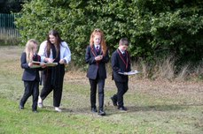
Year 8 History
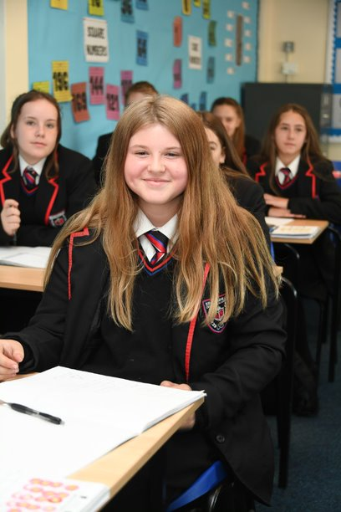
Year 8 History
Autumn Term 1 | Autumn Term 2 | Spring Term 1 | Spring Term 2 | Summer Term 1 | Summer Term 2
How did Early | How far was Elizabeth | How can we explain | How did Life change | What was the impact | How significant was
modern changes | England a Golden | the Civil War? | within Industrial | of the slave trade? | the British Empire?
influence the | Age? |  | Britain?
Tudors? |  | ➢ How did the |  | ➢ How did sugar spread | ➢ What was the British
 | ➢ How did Elizabeth’s | gunpowder plot affect | ➢ To infer what life was | to Europe and the | Empire?
- What were the key changes in Europe between 1450-1750?  - How did the Renaissance change Europe?  - What were early reformist ideas?  - How did these changes influence England in the 15th century?  - How significant was the Battle of Bosworth?  - How successful was Henry VII as a monarch?  - How did the renaissance influence Henry VIII?  - How did the reformation influence Henry VIII?  - How successful was Henry VIII as a monarch?  - What were the changes Edward VI made to religion in England?  - How far did the reformation influence Mary I?  - How much did England change during the early-mid Tudors? | early life change her | James I? | like in the Georgian | Caribbean 1100- | ➢ What attitudes where
 | reign? | ➢ What were the | Era (1714-1830). | 1500? | there towards the
 | ➢ Why did Elizabeth kill | problems facing | ➢ What was Britain like | ➢ What was the impact | British Empire?
 | Mary Queen of | Charles I? | 250 years ago? | of the slave trade on | ➢ What did Britain gain
 | Scots? | ➢ What were the causes | ➢ Why was there an | enslaved Africans? | from having an
 | ➢ How were portraits | of the Civil War? | increase in population | ➢ How was sugar | Empire?
 | used as Propaganda | ➢ What were the | between the years | produced?
 | during Elizabethan | significant events of | 1745-1901? | ➢ What was lifelike on a | ➢ How did Australia
 | England? | the Civil War? | ➢ What was the reason | slave ship? | become part of the
 | ➢ What was the main | ➢ What weapons were | for changing from the | ➢ How were slaves | British Empire?
 | reason for England | used during the Civil | domestic system to | treated at a slave | ➢ How was a convict
 | beating the Spanish | War? | the factory system? | auction? | colony established in
 | Armada? | ➢ How significant was | ➢ How did factories and | ➢ What was lifelike for a | Sydney?
 | ➢ How far was | the New Model | the increase of mining | slave working on a | ➢ What was the cultural
 | Elizabethan England | army? | cause the population | plantation? | differences between
 | a ‘golden age’? | ➢ What were the | to expand? | ➢ How did parliament | the British and
 | ➢ Was it a golden age | consequences of the | ➢ What was working life | ban slavery in 1807? | Aboriginal Australian
 | for the poor? | Civil War? | like for Victorian |  | people?
 | ➢ How significant were | ➢ How significant was | children? |  | ➢ How did Australia
 | the Explorers and | Charles I execution? | ➢ How did Cholera affect |  | develop from a penal
 | colonisers in | ➢ Was Cromwell seen | people's lives? |  | colony to a settlement
 | Elizabethan | as a hero or a | ➢ How did the conditions |  | ➢ How did India react to
 | England? | Villain? | in the Industrial towns |  | the British rule?
 | ➢ What Elizabethan | ➢ What can Dyrham | affect health? |  | ➢ Who was Ghandi and
 | England a golden | Park tells us about how | ➢ Did the Government |  | why was he important
 | age of culture? | the rich lived in the | improve health? |  | to India?
 | ➢ How did theatres | seventeenth century? |  |  | ➢ What was significant
 | contribute to a |  |  |  | about the Amritsar
 | golden age? |  |  |  | Massacre?
 | ➢ How successful was Elizabeth I in establishing  authority?  Key skills/concepts taught  ➢ Change and continuity  ➢ Significance  ➢ Diversity | Key skills/concepts taught  ➢Second Order Concept  ➢Change and continuity  ➢Interpretations | Key skills/concepts taught  ➢ Second order concept  ➢ Similarities and differences  Interpretations  ➢ Change | Key skills/concepts taught  ➢ Second Order  Concept:  ➢ Significance Diversity | ➢ Who were the Indian Independence movement?  Key skills/concepts taught  ➢ Second Order Concept  ➢ Similarities and Differences  Significance  Interpretations

Year 8 Maths
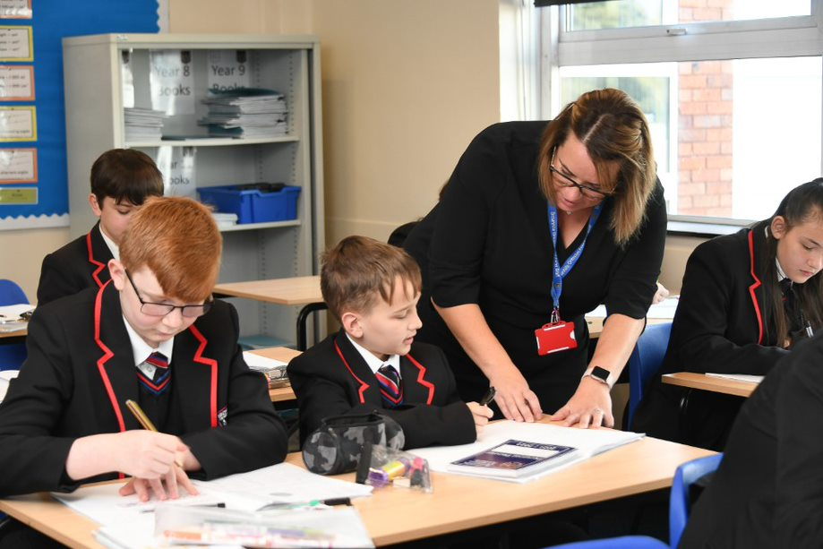

Year 8 Maths
Autumn Term 1 | Autumn Term 2 | Spring Term 1 | Spring Term 2 | Summer Term 1 | Summer Term 2
Geometry  Key skills  - Formal geometric notation  - Angles, drawing & measuring  - Angle facts  - Pie charts  - Properties of shapes  - Angles in polygons | Number & Probability  Key skills  - Fractions & decimal arithmetic  - Use known facts to derive other facts with number  - Use known facts to derive other facts with algebra  - Identify sets  - The intersection and union  - The complement of a set  - Vocabulary of probability  - Probability of single events  - The probability scale  - Primes  - HCF & LCM | Ratio  Key skills  - Ratio notation  - Simplify ratio  - Divide into a ratio  - Compare ratios  - Direct proportion  - Conversion graphs  - Currency exchange  - Similar shapes  - Scale diagrams  - Fraction arithmetic (2)  - Fractions with algebra | Algebra & Statistics  Key skills  - Coordinates in all 4 quadrants  - Graphs of straight lines  - Non-linear graphs  - Midpoints  - Scatter graphs  - Frequency tables  - Two way tables  - Sample space  - Probability from diagrams  - Product rule for counting | Algebra  Key skills  - Forming expressions  - Expanding brackets  - Solve two-step equations  - Form and solve inequalities  - Equations and inequalities with unknowns on both sides  - Using the nth term of a sequence  - Finding the nth term of a sequence  - Rules of indices | Ratio & Number  Key skills  - Percentage increase and decrease  - Percentage change  - Reverse percentages  - Writing numbers in standard form  - Arithmetic with standard form  - Rules of indices (2)  - Error intervals  - Metric conversions  - Working with time

Year 8 Music
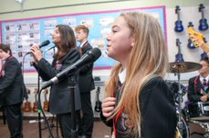
Year 8 Music
Theme 1 | Theme 2 | Theme 3
The Brownhills Songbook  Technical, Constructive & Expressive Progression:  Singing: Learning popular and choral music singing with accurate phrasing, appropriate style and using dynamic contrast.  Keyboard: Playing more complex riffs from popular songs along with a wider ranger of chords that includes primary and secondary chords in different keys.  Composing: Developing rhythmic interest in chord progressions composing using block chords, broken chords and dotted rhythms to develop accompaniments.  Listening: Identify the tempo of music (using Italian terms), musical structures and melodic devices aurally in popular and traditional vocal music.  Reading Staff Notation: Reading music following tempo markings, using dotted rhythms and in new simple time signatures.  Knowledge Focus:  - Melodic Devices/Shape  - Tempo (Italian Terms)  - Accompaniment (Broken/Block Chords)  - Popular & Traditional Structures  - Primary & Secondary Chords | Story of the Orchestra: Eras of Music  Technical, Constructive & Expressive Progression:  Singing: Develop breathing technique to achieve accurate phrasing in more difficult music with longer phrases, in songs by, or inspired by, the music of Great Composers  Keyboard: Playing more complex melodies, using a greater melodic range and accompaniment from the Baroque/Classical/Romantic era.  Composing: Recognising stylistic features of Baroque/Classical/Romantic music and manipulate elements of music to compose a piece of theme & variations.  Listening: Recognise musical features and typical instrumentation to identify the era of music an extract was composed in.  Reading Staff Notation: Recognising and notating ornaments, music in 6/8 and using the tonic minor with key signatures to modulate theme & variations compositions.  Knowledge Focus:  - Features of Baroque Music  - Features of Classical Music  - Features of Romantic Music  - Instruments of the Orchestra  - Musical Devices for Variation | Music for Stage & Screen  Technical, Constructive & Expressive Progression:  Singing: Learning ensemble and solo musical theatre songs, led by a musical director, learn to act through song to communicate meaning and intention.  Keyboard: Playing more disjunct melodies with more accidentals accompanied by chords that include some dissonance.  Composing: Composing leitmotifs, underscores and ostinati for film music and musical theatre that respond to a brief.  Listening: Aurally identifying vocal techniques and textural devices in musical theatre. Identify specific devices in film music and link these to compositional intention.  Reading Staff Notation: Read more complex chords and musical directions such as markings for sforzando, accents and staccato.  Knowledge Focus:  - Features of Film Music (e.g. Leitmotif)  - Types of Music in Musical Theatre (e.g. Finale)  - Vocal Techniques  - Harmonic Devices  - Vocal Arrangements (Solo, Duet, Trio)

Year 8 PE
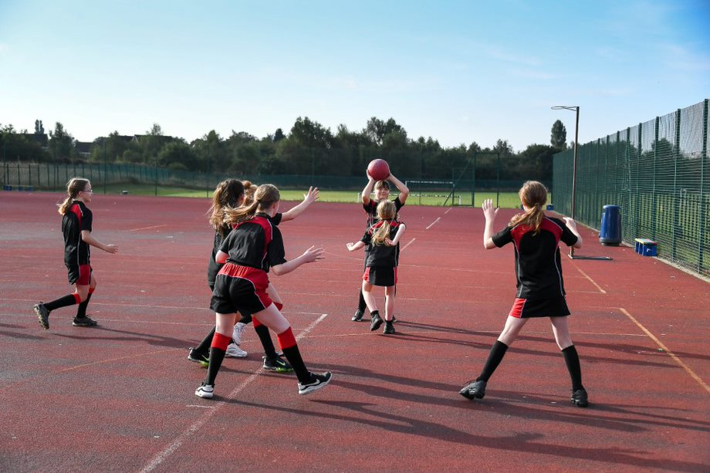
Year 8 PE
Autumn Term 1 | Autumn Term 2 | Spring Term 1 | Spring Term 2 | Summer Term 1 | Summer Term 2
Football, Rugby, Netball, Gymnastics, Multi-Skills, Fitness.  Key skills/concepts taught  - Exploring advanced skills, techniques and tactics for invasion.  - Linking skills and application in competition.  - Analysing performance on how skills have been used.  - Exploring the importance of physical activity and sport to health and well-being.  - Application of fundamental movements in multi skills. | Gymnastics, Swimming, Badminton, OAA, Futsal.  Key skills/concepts taught  - Application of fundamental movements in multi skills.  - Evaluating and analysing performance in Futsal  - Advanced replication in net and wall.  - Recap previous strokes and apply advanced skills e.g., tumble turns and diving.  - Accurate replication of gymnastics skills | Futsal, OAA, Hockey, Badminton, Basketball.  Key skills/concepts taught  - Advanced replication in net and wall.  - Application to different formats. E.g. doubles in badminton.  - Developing rules and regulations in sport and application to competition.  - Implementing basic tactics in competition  - .  Exploring advanced skills, techniques and tactics for invasion.  - Advanced navigations skills with use of compass and grid references  - Exploring and implementing own dance techniques and themes independently.  - Serving and returns in badminton | OAA, Handball, Basketball, Hockey  Key skills/concepts taught  - Advanced navigations skills with use of compass and grid references.  - Solving problems through competition.  - Developing importance of teamwork and cooperation.  - Exploring advanced skills, techniques and tactics for invasion. | Athletics, Cricket, Rounders  Key skills/concepts taught  - Intermediate sprint starts.  - Progressive throwing techniques  - Advanced jumping techniques.  - Post work and tactical development in rounders  - Exploring advanced skills, techniques and tactics for invasion | Swimming, Tennis, Softball, Dance,Futsal  Key skills/concepts taught  - One handed retrieval in fielding.  - Advanced batting techniques  - Ground fielding and overarm throwing.  - Etiquette and sportsmanship through sport  - Competition and intellectual challenge  - Recap previous strokes and apply advanced skills e.g., tumble turns and diving.  - Analysing and replicating movements used in Dance.

Year 8 Religious Education
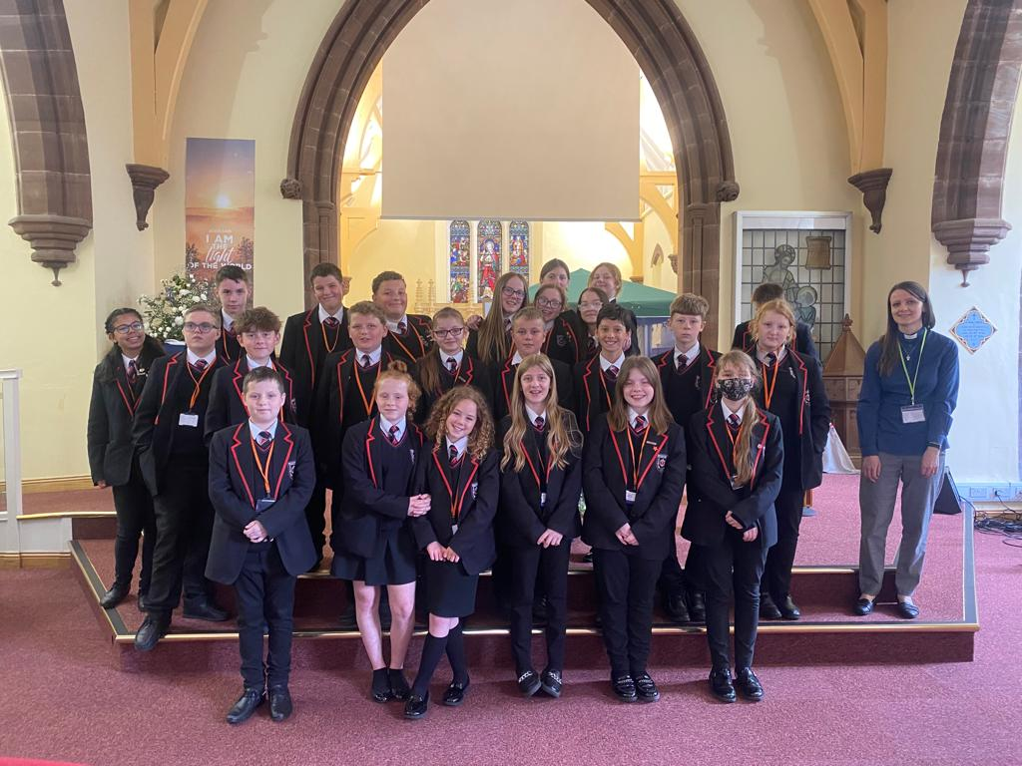
Year 8 Religious Education
Autumn | Spring | Summer
Islam  - Islam – Background, history and basics  - The life of Muhammed  - Global Islam and Islam in the UK  - The Qu’ran  - The Mosque – Islamic Place of worship  - 5 Pillars of Islam – Introduction  - 5 Pillars Hajj  - Hajj continued  - 5 Pillars Ramadan and Eid  Key concepts  1a.b.2a.b.5a.b6a.b  4a.b  Christianity (H+K)  - A brief history on Christianity and dominations.  - Nature of God and the trinity  Key concepts  1a.b.2a.b.5a.b6a.b  4a.b | Christianity (H+K)  - The problem of evil and Christian responses  - Parable of the sheep and the Goat.  - Story of Joab  - Assessment  The New Testament  - What is the New Testament?  - Birth of Jesus?  Key concepts  1a.b.5a.b 6b | The New Testament  - Baptism and temptation  - Miracles  - Parable of the good Samaritan  Religious views on Poverty and wealth  - Poverty in the UK  - Jewish views on poverty  - Christian views on poverty  - Sikhs view on poverty  - Uses of wealth  - Christian Aid  Key concepts  1a,b,2a,4a,5b,6a,b

Year 8 Science
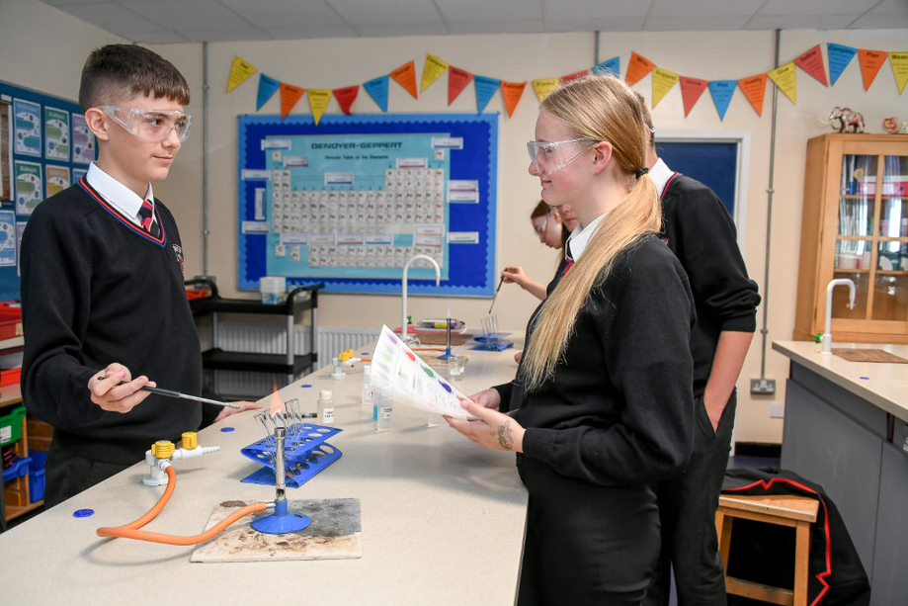

Year 8 Science
Autumn Term 1 | Autumn Term 2 | Spring Term 1 | Spring Term 2 | Summer Term 1 | Summer Term 2
Chemistry – Matter 2  The periodic table elements and compounds are studied, along with polymers, ceramics and composites.  This topic builds on the work carried out in matter  ➢Group1, metals and non-metals  ➢Patterns in elements  ➢Comparing elements and compounds  ➢Exploring materials  Physics -Electricity  This topic builds on KS2 basic circuits and year 7 energy 1.  ➢Series and parallel circuits will be constructed  ➢Concepts of voltages, current and resistance will be will be studied. | Biology – Organisms 2  The respiratory and digestive system will be investigated during this topic, building on previous learning in Organisms 1  ➢ Understanding how we breath  ➢ Explaining gas exchange in humans  ➢ Exploring the effect of disease and lifestyle on our health  ➢ Understanding the importance of a healthy diet  ➢Understanding digestion  Chemistry - Reactions 1  Chemical reactions of acids and alkalis, displacement and neutralisation reactions are study in this topic, | Physics – Forces 2  Forces in equilibrium and unbalanced forces will be studied, different forces and pressure in liquids will be investigated.  Chemistry – Reactions 2  This builds on previous topic reactions 1 in year 7 and will investigate energy changes in endothermic and exothermic reactions. Catalysts will be introduced and related to enzymes in Organisms 2 topic later on. Combustion and thermal decomposition reactions will be carried out and equations to represent these reactions will be studied. | Physics – Energy 2  This topic builds on the ideas of energy being transferred (Energy 1 and Waves 1 topic) and studies how force multipliers work, how thermal energy is transferred and how fuels contain chemical energy (linked to Reactions 1 and 2 topics studied previously).  Biology – Genes 2 Natural selection, evolution and DNA will studied during this topic building on the work completed in year 7 Genes 1  ➢ Comparing aerobic and anaerobic respiration ➢ Exploring how plants make food  ➢ Exploring the movement of water and minerals in plants | Ecosystems 2  Cell structure will be returned to in this topic where respiration and photosynthesis are studied in plants and animals.  Chemistry –Earth 2  The composition of the atmosphere, evolution of the atmosphere and global warming will be introduced in this unit. The extraction of metals from the Earth will also be studied. This requires knowledge from reactions 1 and 2. | Physics – Electromagnetism  Magnetic fields, permanent and induced magnetism will be studied, this will be related to the previous study of forces, electricity and energy. Students will build their own electromagnets and investigate how to increase the strength of the electromagnet.  ➢Magnets  ➢Magnetic fields ➢Electromagnet investigation  ➢Uses of electromagnets

Year 8 Careers
Autumn Term 1 | Autumn Term 2 | Spring Term 1 | Spring Term 2 | Summer Term 1 | Summer Term 2
Aspirations, what is your Future. | Sky Up Academy studios- Students working in small teams, taking on real life media roles to create a news report. | PSHE Careers module – 1. Skills, strengths & attributes.  2. Setting Goals  3.Workplace skills  4.Exploring your aspirations.  5. Let's look at careers  6. What is an Apprenticeship? | National Careers / Apprenticeship Weeks (March) – pupils will receive a special assembly, form time activities and competitions will be launched. Resources to be differentiated for each year group.  During National careers week departments will deliver a ‘Careers lesson’ in curriculum time. This will be used to inspire pupils and raise awareness of the variety of careers that are linked to their subject. Therefore, connecting learning to ‘real life’ | Careers Assembly- Meet the apprentice | Start Careers Platform: Your future starts now.

Year 8 Personal development
Autumn Term 1 | Autumn Term 2 | Spring Term 1 | Spring Term 2 | Summer Term 1 | Summer Term 2
Self Esteem & Identity  - Is it more important to be yourself than it is to be liked by everyone?  - Peer pressure and road safety  - Positive body image  - Body image and the media  - Learning to speak out to banish body talk | Relationships  - Sexual orientation and gender identity  - Consent in a relationship  - Consent – avoiding assumptions  - Positive intimate relationships  - Identifying unhealthy relationships  - Influences on relationship expectations  - Coping with a breakup | Options For the Future  - Skills, strengths and attributes  - Setting goals  - Workplace skills  - Exploring your aspirations  - Looking at different careers.  - What is an apprenticeship? | - Diversity & Equality  - Understand what equality means and why it is important.  - Understand the Equality Act 2010 and how it can be applied in different cases.  - To describe different, common disabilities in our community and explore how people with disabilities discriminated against.  - Basic first aid – how can I help someone during an asthma attack.  - What is ageism and who does it impact?  - Gender discrimination: What is sexism?  - Race and Religion: What is racism and how does it present itself in the UK? | Drugs & Alcohol  - How can we have a healthy body, mind and teeth?  - The HPV vaccine, what is it and why do we have it?  - Understanding drugs and their effects on the mind and the body  - Drugs and the law  - Tobacco, the risks and influences  - Alcohol and the risks  - County lines: the dangers and how to get help. | British Society & Democracy  - What is democracy?  - Politics and the monarchy in the UK  - The political parties and their beliefs  - The voting system. Leaving the European Union  - Government structures within the UK, Scotland, Wales and Northern Ireland  - How decisions are made in parliament  - Your first vote. Who would you vote for?

