
Brownhills Ormiston Academy
Year 7 curriculum 2023-2024
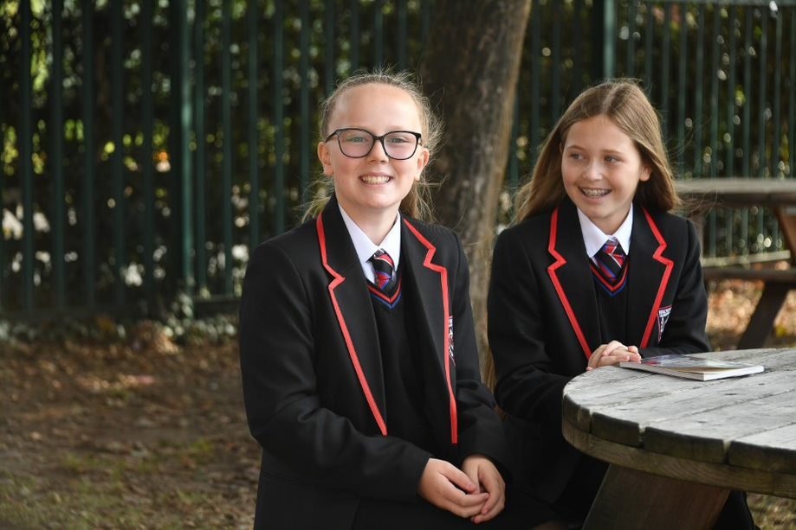

Year 7 Art

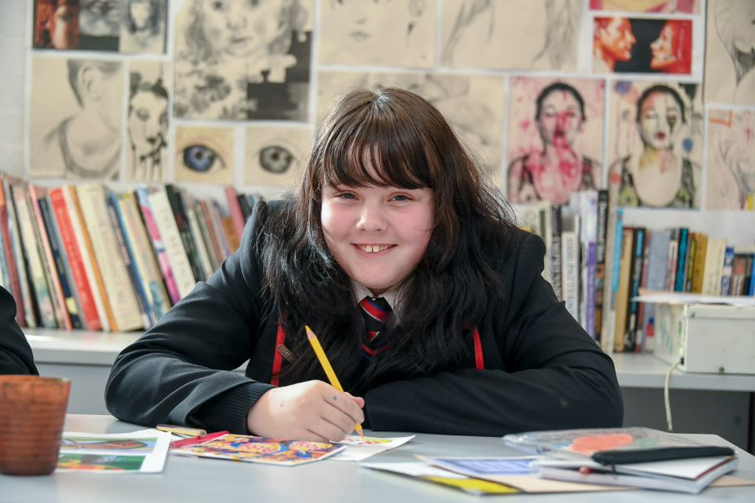

Year 7 Art
Autumn Term 1 | Autumn Term 2 | Spring Term 1 | Spring Term 2 | Summer Term 1 | Summer Term 2
Self-image  ➢ Baseline assessment. Contextual references: Sarah Clarkson, Picasso, Julian Opie, Marlina Shapiro.  ➢ Oil pastel, basic paint skills, drawing to proportion, scale, use of colour. Basic colour theory.  ➢ Introduction to artists names and styles.  Key Concepts  (KS3 ref 1,2,3,4,5)  1. Use a range of techniques to explore ideas  2.Use a range of media including paint  3.Increase proficiency in handling materials. 4.Analyse and evaluate own work and that of others  5.Learn about art from different eras and styles. | Self-image  ➢ Baseline assessment. Contextual references: Sarah Clarkson, Picasso, Julian Opie, Marlina Shapiro.  ➢ Oil pastel, basic paint skills, drawing to proportion, scale, use of colour. Basic colour theory.  ➢ Introduction to artists names and styles.  Key Concepts  (KS3 ref 1,2,3,4,5)  1. Use a range of techniques to explore ideas  2.Use a range of media including paint  3.Increase proficiency in handling materials. 4.Analyse and evaluate own work and that of others  5.Learn about art from different eras and styles | Buildings and architecture  ➢ Contextual references: Gaudi, Sarah Morris,  ➢ Architecture and futuristic architecture.  ➢ Patterns in buildings. Perspective drawing, accuracy, detail  ➢ Development of artists names and styles.  ➢ Evaluation.  Key Concepts  (KS3 ref 1,2,3,4,5)  1.Use a range of techniques to explore ideas.  2.Use a range of media including paint.  3.Increase proficiency in handling materials. 4.Analyse and evaluate own work and that of others. 5.Learn about art from different eras and styles. | Buildings and architecture  ➢ Contextual references: Gaudi, Sarah Morris,  ➢ Architecture and futuristic architecture.  ➢ Patterns in buildings. Perspective drawing, accuracy, detail  ➢ Development of artists names and styles.  ➢ Evaluation.  Key Concepts  (KS3 ref 1,2,3,4,5)  1.Use a range of techniques to explore ideas.  2.Use a range of media including paint.  3.Increase proficiency in handling materials. 4.Analyse and evaluate own work and that of others. 5.Learn about art from different eras and styles. | Landscapes  ➢ Contextual references: Hundertwasser. Lichtenstein.  ➢ Range of pencil tone, oil pastel, blending.  ➢ Growing confidence in Artists names and styles.  ➢ Evaluation  Key Concepts  (KS3 ref 1,2,3,4,5)  1.Use a range of techniques to explore ideas.  2.Use a range of media including paint. 3.Increase proficiency in handling materials  4. Analyse and evaluate own work and that of others  5.Learn about art from different eras and styles | Buildings and architecture  ➢ Contextual references: Gaudi, Sarah Morris, Architecture, and futuristic architecture.  ➢ Patterns in buildings. Perspective drawing, accuracy, detail.  ➢ Development of artists names and styles.  ➢Evaluation.  Key Concepts  (KS3 ref 1,2,3,4,5)  1.Use a range of techniques to explore ideas.  2.Use a range of media including paint. 3.Increase proficiency in handling materials. 4.Analyse and evaluate own work and that of others.  5.Learn about art from different eras and styles

Year 7 Computer science

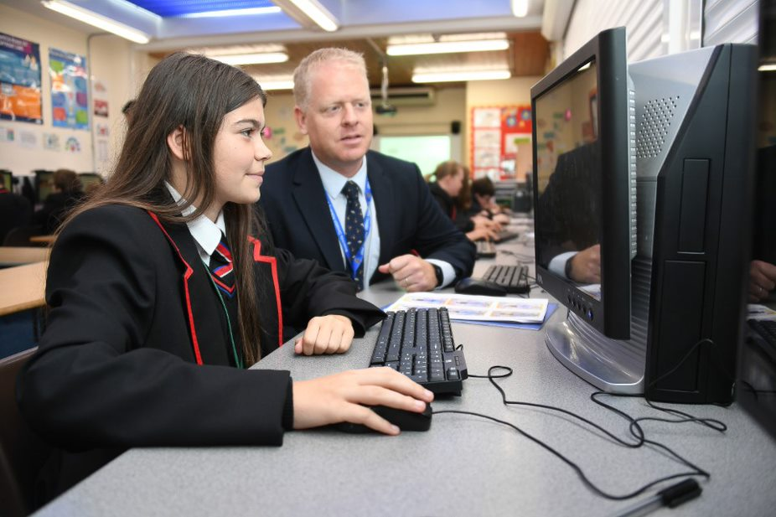
Year 7 Computer science
Autumn Term 1 | Autumn Term 2 | Spring Term 1 | Spring Term 2 | Summer Term 1 | Summer Term 2
Using computers safely, effectively, and responsibly  - File management  - E-safety and networking  - Keeping your data safe  - Using email  - Searching the web  (KS3 ref 5, 9) | Using media with Word  - Features of MS Word  - Font types and styles  - Cut and paste  - Working with templates  - Inserting tables  (KS3 ref 7,8) | Networks  - The internet  - Connectivity  - Topology  - Client-server networks  - Encryption  (KS3 ref 5) | Programming essentials in Scratch  - To navigate Scratch  - To use a sequence  - To use a variable  - To use an IF statement  - To select logical operators  - To use Iteration (loop)  (KS3 ref 2, 3, 4, 8) | Games programming in Scratch  - Sequencing  - Use of algorithms  - Loops  - Operators  - Coordinates  - Adding sound  (KS3 ref 2, 3, 4, 8) | App development  - Introduction to Apps  - Home screen  - Adding files and images  - sing map functions  - Programming with blocky  - Publishing apps  (KS3 ref 7, 8)

Year 7 Design Technology
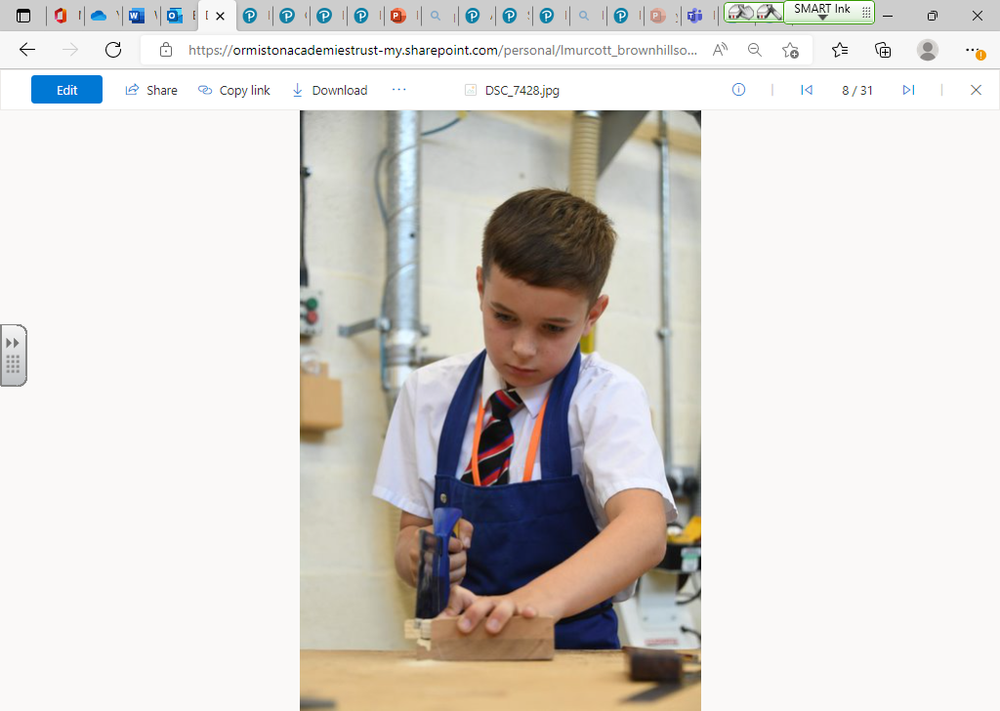
Year 7 Design Technology
Autumn Term 1 | Autumn Term 2 | Spring Term 1 | Spring Term 2 | Summer Term 1 | Summer Term 2
Model boat  - Identifying the categories of timber, their properties and examples.  - Analysing how to read a simple technical drawing. Create a model boat using a range of tools and processes.  - Understand the term tolerance and how to check a product is within tolerance throughout the making process.  - Use a range of hand tools to produce a wooden product.  Key concepts:  NC content M1, T1, T2 | Model boat  - Identifying the categories of timber, their properties and examples.  - Analysing how to read a simple technical drawing. Create a model boat using a range of tools and processes.  - Understand the term tolerance and how to check a product is within tolerance throughout the making process.  - Use a range of hand tools to produce a wooden product.  Key concepts:  NC content M1, T1, T2 | Biomimicry  - Exploring biomimicry and real-life examples.  - Exploring a brief and specification and how they guide their work.  - How to best sketch/design freehand.  - Presenting ideas in 2D (orthographic) and 3D (isometric).  - The difference between a technical drawing and freehand sketching.  Key concepts:  NC content I1, I2, D1, D2, E1, E3 | Biomimicry  - Exploring biomimicry and real-life examples.  - Exploring a brief and specification and how they guide their work.  - How to best sketch/design freehand.  - Presenting ideas in 2D (orthographic) and 3D (isometric).  - The difference between a technical drawing and freehand sketching.  Key concepts:  NC content I1, I2, D1, D2, E1, E3 | Introduction to the kitchen  - Understanding the Eatwell Guide and different food groups.  - Exploring nutrients and eating for health.  - The 8 healthy eating tips.  - Measuring ingredients in ml, l, g and kg.  - Show the difference between a tablespoon and teaspoon.  - Using cooker controls Independently.  - Demonstrate basic food safety measures.  Key concepts:  NC content C1, C2, C3, C4 | Introduction to the kitchen  - Understanding the Eatwell Guide and different food groups.  - Exploring nutrients and eating for health.  - The 8 healthy eating tips.  - Measuring ingredients in ml, l, g and kg.  - Show the difference between a tablespoon and teaspoon.  - Using cooker controls Independently.  - Demonstrate basic food safety measures.  Key concepts:  NC content C1, C2, C3, C4

Year 7 English
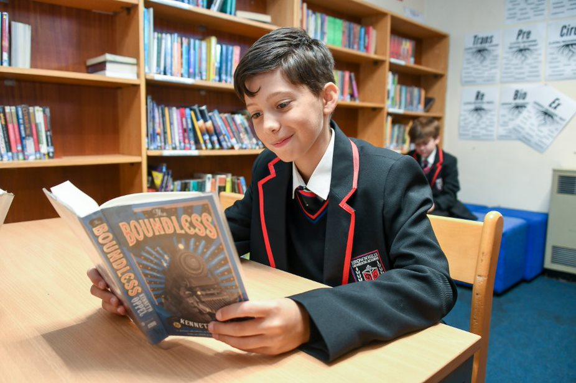
Autumn | Spring | Summer
Focus text: Treasure Island, Robert Louis Stevenson  - Secondary: Coral Island, Colonialism v Imperialism, Sea Fever, Brothers, Ballad of Charlotte Dymond, Ballad of Long John Silver  - Themes: power, adventure, conflict, identity, violence  - L/S: tenor, vehicle, epithets, syntax: word class and subjects.  - Story: sense making, heroes, narrative perspective, conflict  - Writing: Adjective Attack, Prepositional Push off  - Context: colonialism, adventure, piracy, imperialism, justice | Focus text: A Midsummer Night’s Dream  - Secondary: Parents and Children, Amnesia, Weddings, Forest Bathing, Winter Swans, Hour and Dreams  - Themes: supernatural, love, relationships, conflict of women, treatment of women, identity  - L/S: tenor, vehicle, ground, abstract to concrete, changing word classes  - Story: genre: comedy & tragedy, drama, plot, characterisation  - Writing: Simile Start, Adverb/Double Adverb Snap  - Context: Elizabeth I, Pyramus and Thisbe. Matriarchal society vs Patriarchal society | , Focus text: 12 Angry Men  - Secondary: Obama, Frederick Douglass, Churchill, Paradise Lost, Malala, Emma Watson, Elizabeth I, Richard Nixon, Sojourner Truth  - Themes: power, relationships, conflict, identity, discrimination  - L/S: tenor, vehicle, ground, literary tropes, anaphora, metaphor, symbolism  - Story: genre: tragedy, origins of rhetoric, drama  - Writing: Comma Sandwich  - Context: origins of rhetoric, Elizabethan anxieties, political campaignsSojourner Truth
Year 7 English

Year 7 French

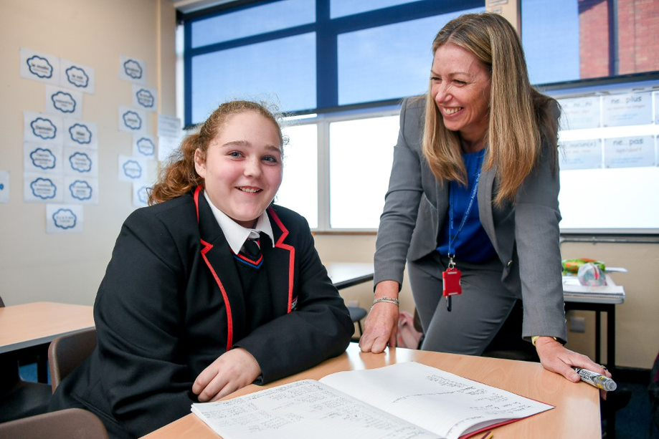

Year 7 French
Autumn term 1 | Autumn term | Spring term | Spring term | Summer term 1 | Summer term 2
On fait connaissance  - Greetings, the alphabet  - Introducing yourself  - Describing your personality and that of others  Key skills/grammar/  phonics taught  - Numbers 1 to 31  - The importance of learning French phonics  - Asking and answering simple questions-raising intonation  - Phonics:  Sound ‘a’, SFE  [e] [é/er/ez] [è/ê/ai], open [o] [closed o/ô] [au/eau], [u] [ou] | Tout sur moi  - Describing your physical appearance  - Introducing and describing your family  Key skills/grammar/  phonics taught  - Avoir and être  - Numbers 1 to 100  - Adjective agreements  - Question words  - Simple connectives, opinions & intensifiers  - The imperfect tense  (implicitly)  - Literary extracts  - Phonics:  [closed eu] [open eu/œu], silent final [e], [i/y], è / ê /[u] [ou], silent final consonant(SFC),CaReFuL consonants | Mes loisirs et ceux de mes fans  - Weather phrases  - Your activities & your favourite star’s hobbies  - Talking about ‘le tour de France’  Key skills/grammar/  phonics taught  - Using A.C.T.I.O.N  - The infinitive  - Jouer + au/à la  - Faire + du/de la/des  - Negatives ‘ne…pas./ni…ni/  - Comparisons ‘plus…que’  - The imperfect tense (implicitly)  - Phonics:  words ending with –ent,  [h muet] [h aspiré]  [C], [j / soft g] [hard g] [gn], [ss / soft s] [hard s/z] | Venez rendre visite à mon collège  - Describing your school  - Opinions on school subjects & teachers  - French & British schools  - Writing a card to your pen pal  Key skills/grammar/  phonics taught  - Aller (1st, 3rd pers sing/1st pers plur)  - Using comparisons ‘plus…que’/moins que’  - Possessive adjectives  - Inversion questions  - Irregular –re verbs ‘apprendre, comprendre’  - Describing a photo using P.A.L.M.  - Phonics:  [r] [ch] [qu] [th],Liaisons, [oi] [oy], [ain/in/aim/im],  [en/an/em/am], [on/om] | Mon style au bahut  - Weather & clothing  - Opinion on school uniforms  - Designing a new uniform  - Describing a photo  - French culture  Key skills/grammar/  phonics taught  - Irregular adjectives  agreements  - Devoir + infinitive (1st person sing)  - Using A.C.T.I.O.N  - Question words  - Using P.A.L.M.O.J  - ‘‘aller’/the whole paradigm  - Present & past tense  (1st/3rd pers sing)  - Phonics:  [un/um],[ien],[tion]  [-aill-/-ail],[-ill-/-ille],[-eill-/-eil],[-euill-/-euil/-ueill-/-ueil/-œill-/-œil] | Ce que je porte pour une fête  - Clothes for special occasions  - Describing models & cultural outfits  - Revisiting past topics  Key skills/grammar/  phonics taught  - Near future tense  - Using A.C.T.I.O.N  - Describing a photo  with P.A.L.M.O.J  - Savoir (1st/3rd pers sing)  - Using the present & the past tense (1st pers sing/plur)  - Question words  - Phonics:  Reviewing SFC, SFE  au/eau, [th], [oi],  words ending with -ent

Year 7 Geography
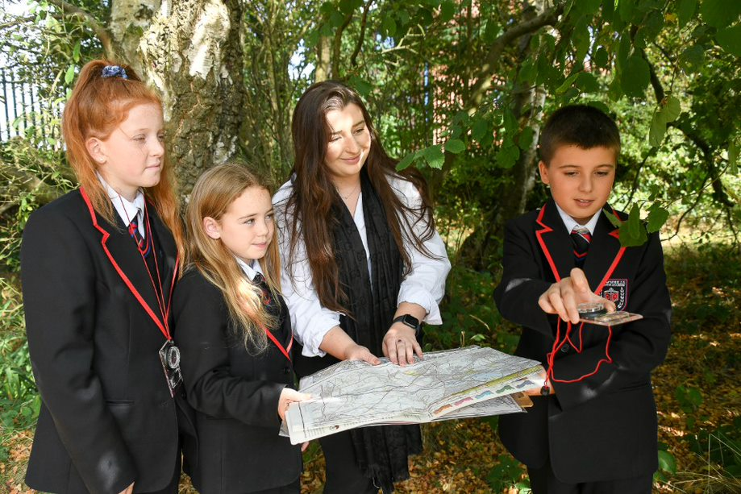
Year 7 Geography
Autumn Term 1 | Autumn Term 2 | Spring Term 1 | Spring Term 2 | Summer Term 1 | Summer Term 2
Becoming a geography  Detective  - To explore what geographical skills are and how to speak like a geographer.  - To understand map projections, atlases, and OS maps.  - To introduce skills of coordinates, compass directions, scale, grid references and contours.  - To practice collecting and presenting geographical data.  - To outline what statistical skills are and how they are applied in geography.  Key Concepts  - Fieldwork/Skills  - Systems | UK island home  - To understand where the UK is located.  - To use GIS systems to view, analyse and to view, analyse and UK.  - To understand how  the UK changes from north to south.  - To understand the UKs unique landscapes and why they need protecting.  - To outline the  attractions of the  Lake District.  - To identify landscapes in the UK and explain why they vary.  - To understand the weather in the UK.  - To explore the different types of weather hazards experienced in the UK. To complete a piece of creative writing on “The Beast from the East”  Key Concepts Taught  - Fieldwork/Skills  - Systems  - Resources  - Development | Superpowers  - To know and understand what a superpower is.  - To understand what factors are needed to make a country powerful.  - To know what makes the USA a superpower.  - To explore the continent of Asia.  - To describe the physical and human aspects of China.  - To explain why China is an emerging superpower.  - To complete extended writing on China as an emerging superpower.  - To explore the population distribution in China  - To understand the difference between hard and soft power.  Key Concepts Taught  - Globalisation  - Inequality Resilience  - Development  - Resources | Africa  - To describe the location of Africa.  - To successfully understand the climates of Africa and to create a climate graph.  - To explain how the landscape changes throughout Africa.  - To describe the location of Nigeria and its global importance.  - To know what TNC’s are and how they impact Nigeria.  - To explain why Kenya is such a popular tourist destination.  - To explore the issues with the growing urban population in cities in Kenya.  Key Skills/Concepts Taught  - Inequality  - Development  - Globalisation  - Resilience  - Resources | The Almighty Dollar  - Chapter 1:  Worshipping at the Worshipping at the and endless offers The USA to China.  - Chapter 2: Making and working the global red-carpet China  - Chapter 3: Finding love in the Niger Delta—China to Nigeria.  - Chapter 4: Spicing up the recipe for success – India  - The end of the journey – the Almighty Dollar: Iraq, Russia, Germany, UK and the USA.  Key Skills/Concepts Taught  - Development  - Sustainability  - Inequality  - Globalisation  - Resources | The World Tour  - Coldest place Vostok  - Hottest place Death Valley  - Driest – Atacama  - Highest place – Everest  - Lowest – Mariana Trench  - Busiest place – Tokyo  - Happiest place - Finland  Key Skills/Concepts Taught  - Skills  - Inequality  - Development  - Resources

Year 7 History
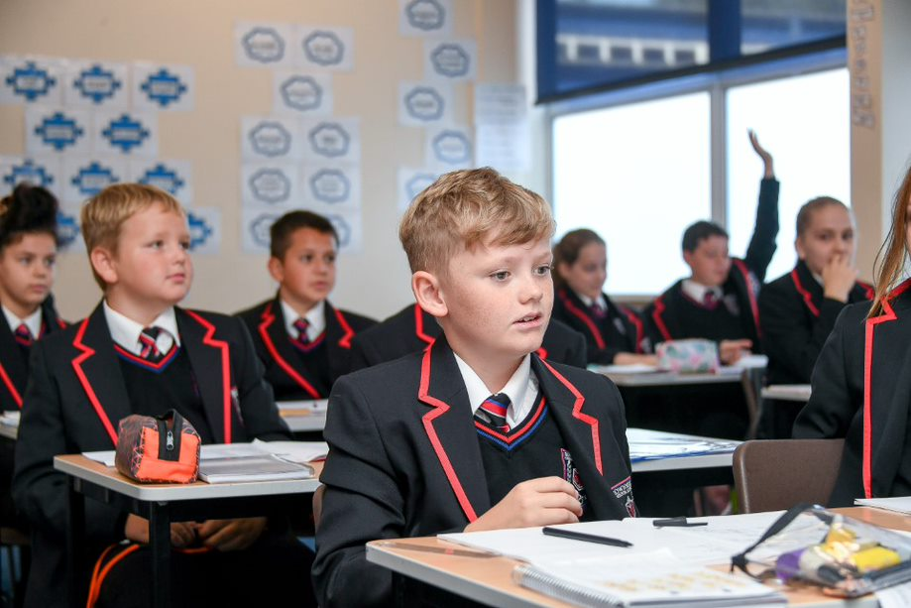

Year 7 History
Autumn Term 1 | Autumn Term 2 | Spring Term 1 | Spring Term 2 | Summer Term 1 | Summer Term 2
What was Britain like | Why was England a | Who were the | What mattered to | What | What was the
before 1066? | Battlefield in 1066? | strong and weak | Medieval people? | problems did | impact of the key
➢ What changes took | ➢ What was Britain | rulers during the | ➢ Who joined the first | people face | developments on
 |  | medieval times? |  | during the | Migration?
place in Britain? | like in 1066? | ➢ What happened to  Thomas Beckett?  ➢ How did Henry II  respond to the  death of Beckett?  ➢ How important was  the Magna Carta?  ➢ What mattered to  medieval society? |  | Medieval times?
 |  | ➢What mattered to people in the towns?  ➢What was the influence of religion on people living in the Middle Ages?  ➢What was lifelike in a medieval village? | crusade and why?
➢From the Stone age | ➢ Why were there | ➢ What were the | ➢ What difficulties did | ➢ How did people | ➢The impact of migrants
to the Iron age? | three men claiming | problems that |  |  | Britain?
 | to be King in 1066? | Edward faced at | the crusaders face | respond to the
➢ What impact did |  | the beginning of his | on their journey to | Black death? | ➢ How did the Anglo-
the Roman Empire | ➢ What happened at | reign in 1274? | Jerusalem? | ➢ What were the | Saxons change
have I Britain? | the Battle of |  | ➢ How did the | black death | Britain?
➢ What was a typical | Stamford bridge? | ➢ What wars did | crusaders capture | symptoms? | ➢ What benefits did
Anglo-Saxon | ➢ What happened at | Edward fight in | Jerusalem? | ➢ What were the | the Jewish people
Settlement like in | the Battle of | Wales and | ➢ What was the | cures of the Black | bring to Britain?
Britain? | Hastings? | Scotland? |  | death?
 |  |  | differences
➢ Why did the | ➢ What type of | ➢ Who were the | between the Islamic and the Christian worlds? | ➢ How did people | ➢What were the reasons for the Huguenots and
Vikings come to | soldiers fought at | strong and weak |  | respond to the | African people’s
England? | the Battle of Hastings? | rulers from 1087- 1272? |  | Black death? | migrations and
➢ What were the |  |  | ➢ How did Medieval | ➢ Was the Black
achievements of | ➢ Why did William |  | England differ | Death a disaster?
the earliest | win at the Battle of |  | to medieval Mali? | ➢ What was medieval
civilisations like in | Hastings? |  |  | medicine? | ➢ What was the
the Ancient | ➢ How did Harold |  |  | ➢ Why were the | impact of Jewish
Egyptians? | Godwinson die? |  |  | peasants angry? | and Asian migration?
 |  |  | ➢Who was
➢ How did the | ➢ What were |  | Mansa Musa? | ➢ What were the
Ancient Greeks | William’s problems |  | ➢ What does Mansa | consequences of
way of life influence | after he was |  | Musa’s pilgrimage | the peasant’s
the rest of the | crowned King of |  | to Mecca reveal | revolt?
world?  ➢What was everyday life like for Islamic people in Baghdad in 900AD?  ➢What was the most important parts of the Bridging curriculum? – complete the end of term test | England?  ➢How did William keep control of England | ➢What mattered to people in the towns?  ➢What was the influence of religion on people living in the Middle Ages?  ➢What was lifelike in a medieval village? | about him?  ➢What can we learn about Mansa Musa’s journey back from Mecca?  ➢What was Mansa Musa’s legacy and what does this tell you about medieval Mali?

Year 7 Maths
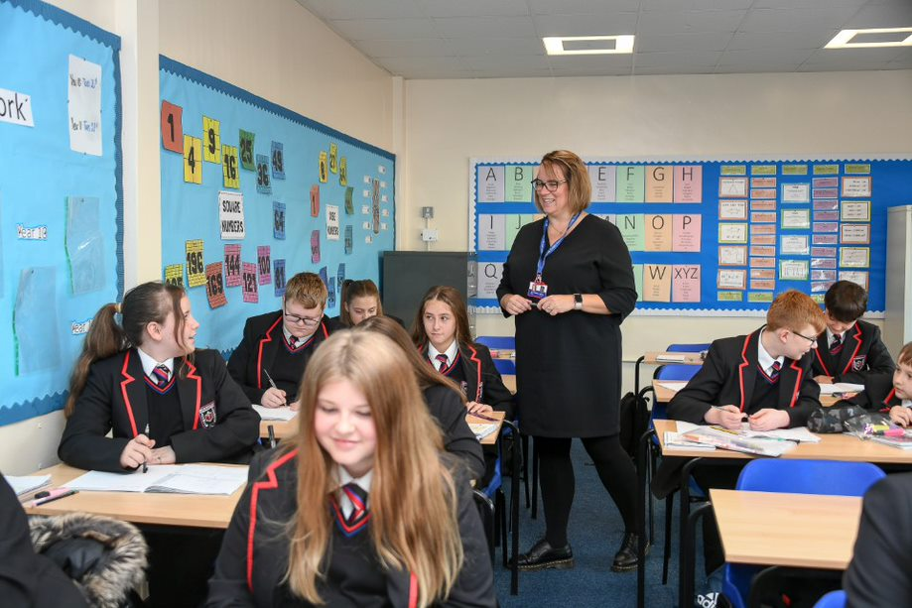

Year 7 Maths
Autumn Term 1 | Autumn Term 2 | Spring Term 1 | Spring Term 2 | Summer Term 1 | Summer Term 2
Number 1 & 2  - Place value  - Number lines  - Rounding  - Mean & median  - Metric conversions  - Different bases  - Commutative law  - Associative law  - Zero pairs  - Perimeter  - Angle facts  - Mean  - Range  - Number in context  - Addition with unknowns | Number 3  - Divisibility rules  - LCM  - HCF  - Multiplicative reasoning  - Rectilinear area  - Volume of cubes, cuboids & prisms  - Multiplication in context | Number 4 & 5  - Calculating with powers  - Index form  - Roots as inverses  - Primes  - Prime factorisation  - Order of operations | Number 6 & Algebra 1  - Negative numbers in context  - Additive inverse  - Directed number arithmetic  - The language of algebra  - Simplifying linear expressions  - Substitution  - Solving problems with unknowns | Number 7 & 8  - Fraction representation  - Complement of a fraction  - Arithmetic with fractions  - Fractions in context  - Fraction, decimal, percentage equivalence  - Representations of percentages  - Percentage increase & decrease  - Pie charts  - Simple interest | Number 9 & Algebra 2  - Single and double inequalities  - Error intervals  - Approximation  - Timetables  - Algebraic notation  - Collecting like terms  - Simplifying indices  - Writing algebraic expressions

Year 7 Music
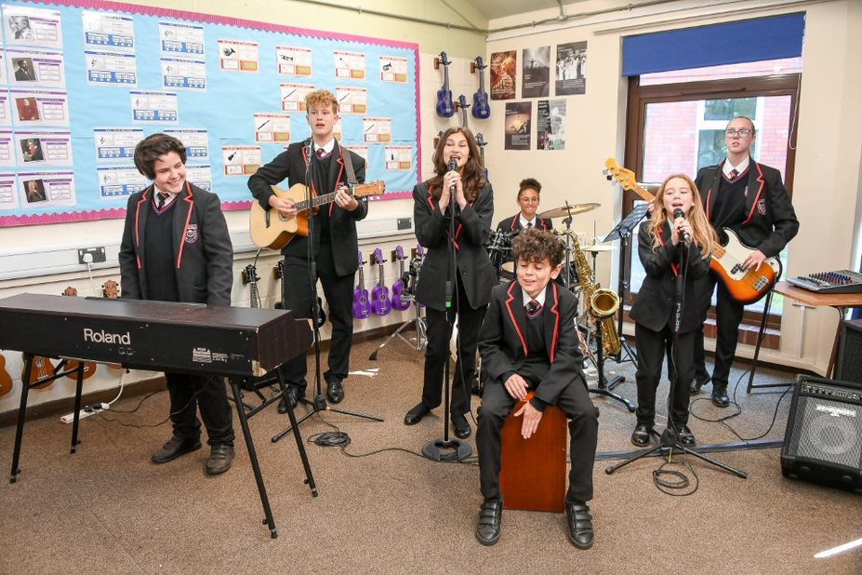
Year 7 Music
Theme 1 | Theme 2 | Theme 3
The Brownhills Songbook  Technical, Constructive & Expressive Progression:  Singing: Learning popular and traditional songs as an ensemble, learning to create an accurate, well projected sound with others.  Keyboard: Learning 5 finger position and the geography of the keyboard to play simple melodies and chords.  Composing: Creating chord progressions with root note bass lines to accompany a simple pop melody.  Listening: Aurally identify musical features in a variety of musical examples focusing on dynamics, tempo, pitch and texture.  Reading Staff Notation: Reading notes in the treble and bass clef and using semibreves, minims, crotchets, quavers and rests to accurately read music on the stave.  Knowledge Focus:  - Dynamics  - Tempo  - Pitch  - Texture  - Major & Minor Chords  - Voice Types | Story of the Orchestra: Instruments of the Orchestra  Technical, Constructive & Expressive Progression:  Singing: Developing performance technique and phrasing to create more expressive performances whilst singing in parts in an ensemble or as a soloist.  Keyboard: Playing music with more flats and sharps and a greater ranger of melodies and chords.  Composing: Writing melodies and selecting instruments in response to a brief and selecting chords to accompany the melody.  Listening: Aurally identify the instruments of the orchestra, techniques used by string players and the way instruments are playing together.  Reading Staff Notation: Reading music with more accidentals including naturals as well as using key signatures with one flat or sharp.  Knowledge Focus:  - String Family (inc. Techniques)  - Woodwind Family  - Brass Family  - Percussion Family  - Texture | World Music: Sub-Saharan & Samba Music  Technical, Constructive & Expressive Progression:  Singing: Learn a cappella music from other cultures by call and responses from a musical leader, singing accurately in different languages.  Keyboard: Working as a ensemble to play melodic/rhythmic ostinati, syncopated rhythms, polyrhythms and some basic improvisation.  Composing: Composing idiomatic, stylistic rhythms to be used as part of a larger ensemble piece within a given structure.  Listening: Aurally identify stylistic features of music from other cultures including features such as syncopation and polyrhythms in other genres of music.  Reading Staff Notation: Using staff notation and graphic score to notate more complex rhythms and read rhythms for multiple parts.  Knowledge Focus:  - Ostinato  - Rhythmic Devices  - A Cappella  - Djembe Drums  - Samba Drums

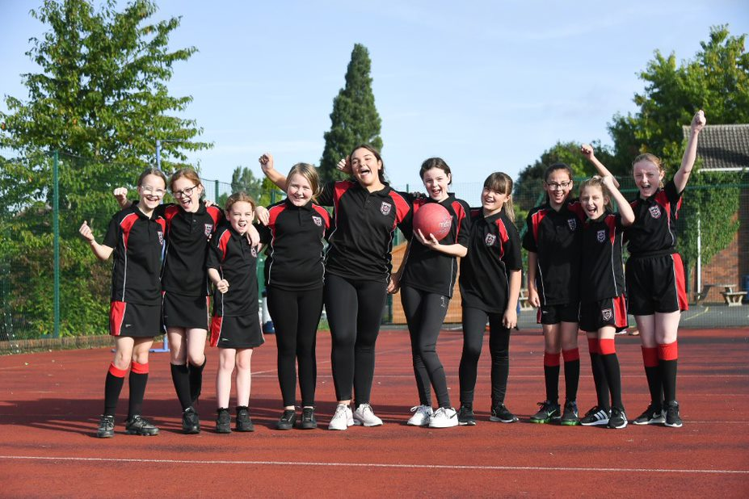
Year 7 PE
Autumn Term 1 | Autumn Term 2 | Spring Term 1 | Spring Term 2 | Summer Term 1 | Summer Term 2
Rugby, Netball, Fitness, Badminton, Football, Multi Skills.  Key concepts/ skills taught  ➢ Fundamental movement skills – Running, jumping, throwing, catching, balancing and stability.  ➢ Introduction to outwitting opponents for invasion Developing basic skills for invasion  ➢ Basic passing and handling, introductions to contact and tackling, identifying space in attack and defence offside and laws of rugby.  ➢ Developing different types of passing basketball and application, stopping and pivoting, dribbling, ball familiarisation, introduction to lay up and rules of basketball  ➢ Footwork, jumping, pivoting, dodging, passing and shooting. Rules of netball, positions and basic tactics.  ➢ Introduction to attacking, defending, passing, dribbling and shooting in football.  ➢ Introduction to commenting on skills and performance  ➢ Introduction to warm up and cool downs  ➢ Health and wellbeing the role of physical activity on personal health  ➢ Effects of exercise on the body  ➢ Ready position and grip, control and contact with the ball, introduction to forehand and backhand, maintaining a rally over a net. | Basketball and Swimming  Key concepts/ skills taught  ➢ Introduction to accurate replication  ➢ Basic passing and dribbling of the ball.  ➢ Developing different types of passing basketball and application, stopping and pivoting, dribbling, ball familiarisation, introduction to lay up and rules of basketball  ➢ Familiarisation of swimming strokes and developing body position in swimming.  ➢ Water safety and stroke development  ➢ Understanding passing, attacking and defending in Basketball. | Gymnastics, Badminton, Fitness, Futsal, Hockey, Tag Rugby.  Key concepts/ skills taught  ➢ Accurate replication in parkour  ➢ Out witting in net and wall.  ➢ Identifying new rules in sport  ➢ Introduction to body control and movement, fundamentals of performing a shoulder roll travel across the apparatus.  ➢ Ready position and grip, control and contact with the ball, introduction to forehand and backhand, maintaining a rally over a net.  ➢ Introduction to basic passing and ball control, identifying and moving into space, fundamental dribbling and shooting  ➢ Ready position in badminton, basic rules and regulations of the sport, grip and serves, overhead clears, introduction to drop shot and smash.  ➢ Outwitting opponents in net and wall.  ➢ Balances and rolls, creating and applying sequences independently, introduction to travel, weights on hands, control and extension.  ➢ Identifying new rules in sport such as Tag Rugby. | Handball, Gymnastics, Hockey, Fitness, Gymnastics.  Key concepts/ skills taught.  ➢ Introduction to body control and movement, fundamentals of performing a shoulder roll travel across the apparatus.  ➢ Understand the correct grip and techniques in hockey.  ➢ Balances and rolls, creating and applying sequences independently, introduction to travel, weights on hands, control and extension.  ➢ Introduction to warm up and cool downs  ➢ Health and wellbeing the role of physical activity on personal health  ➢ Effects of exercise on the body | Athletics, Cricket & Rounders.  Key concepts/ skills taught  ➢ Basic striking and fielding techniques.  ➢ How to field and retrieve the ball correctly.  ➢ Performing the basic throwing and catching techniques and application.  ➢ Introduction to bowling technique and application towards a target.  ➢ Fielding techniques, application to game like situations. Batting fundamentals, grip, stances and contact. Bowling and introduction to rules and regulations.  ➢ Sportsmanship and game etiquette in cricket.  ➢ Batting –grip, stance front foot drive. | Softball, Tennis, Dance, Futsal, Swimming.  Key concepts/ skills taught  ➢ Basic skills and techniques for throwing, jumping and running events in athletics.  ➢ Basic skills and techniques in rugby and futsal.  ➢ Making and applying decisions, in competition  ➢ Safety in swimming, introduction to stroke development in front crawl, backstroke and breaststroke, sculling, floating and push and glide.

Year 7 Religious Education
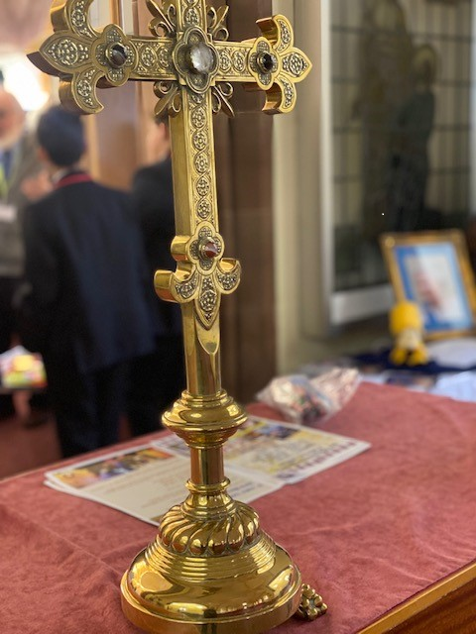
Year 7 Religious Education
Autumn Term | Spring Term 1 | Spring Term 2 | Summer Term 1 | Summer Term 2
What is belief?  • Hermeneutics  • Religion of the world and UK  • What is Fact and belief: Blondin  • Who was Corrie Ten boom and what are her Christian beliefs?  • What is Modern day faith? Theology in action  Key concepts covered  1.a, b2.a,3. a,4, b,5,b,6.a,b | Places of worship (cultural capital)  • What are the purposes of sacred spaces?  • Why do people of all religions build holy buildings?  • Why are there over 50,000 Churches in the UK and 2000 mosques?  • What are the similarities and differences between a Synagogue, Mosque, Gurdwara, church Can religions share a holy building in a e.g. hospital, Airport or prison.  Key concepts covered  2.a,3. a,b, 4a,b,5a,b,6.b | The Old Testament Hermeneutics  • What is the Old Testament  • Creation and the fall  • Noah and the Flood  • Abraham and Isaac  Moses and the 10 Commandments  Key concepts covered  1.a, b 4b,5a, b,6.b | Christianity in the Modern World  • What is the Bible?  • Is Britain a Christian country  • Should women lead the Church and those form the LGBTQ community  • Slavery and the Crusades  • Persecution of Christians | How do Festivals influence belief?  • Holi  • Lent  • Vaisaki  • Eid  Key concepts covered  1.a, b 4b,5a, b,6.b

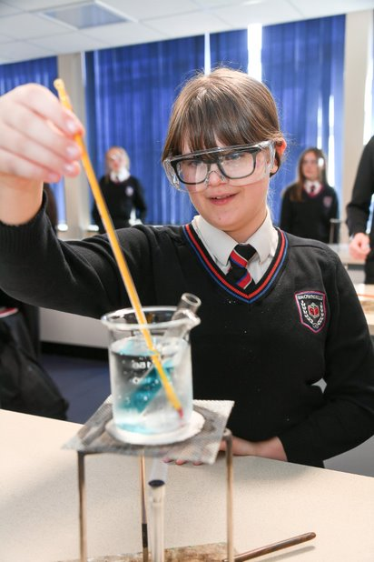
Year 7 Science

Year 7 Science
Autumn Term 1 | Autumn Term 2 | Spring Term 1 | Spring Term 2 | Summer Term 1 | Summer Term 2
Scientific method  An introduction to scientific methods  ➢ Identifying variable  ➢ Writing methods  ➢ Data collection  ➢ Data handling and analysis  ➢ Conclusions and evaluations  Chemistry Earth 1  The structure of the Earth and the rock cycles and the position of the Earth within the solar system, this topic builds on KS2 enquiry into classification of objects and fossils  ➢ Structure of the Earth  ➢ Exploring igneous rocks, sedimentary rocks and metamorphic rocks  ➢ The rock cycle  ➢ Describing stars and galaxies  ➢ Explaining the effects of the Earth’s motion  ➢ Exploring our neighbours in the Universe  ➢ Using models in science | Physics – Forces 1  Speed and acceleration, resultant forces and gravity. This develops KS2 ideas about forces being push and pulls.  ➢ Understanding speed and calculating speed. ➢Describing journeys with distance–time graphs  ➢ Exploring journeys on distance–time graphs  ➢ Investigating the motion of a car on a ramp  ➢ Understanding relative motion  ➢Understanding gravitational fields  ➢ Understanding mass and weight  ➢ Understanding gravity | Biology – Organisms  How the skeleton and muscles work together and the organisation of living things.  ➢ Exploring the human skeleton  ➢ Understanding the role of joints and muscles  ➢ Examining interacting muscles  ➢ Exploring problems with the skeletal system  ➢ Understanding organisation of organisms ➢ Describing animal and plant cells  ➢ Describing cell adaptations  ➢ Using a microscope | Biology – Genes 1  Variation and Human reproduction developing ideas from Organisms  ➢ Looking at variation  ➢ Exploring causes of variation  ➢ Considering the importance of variation  ➢ Understanding the female reproductive system and fertility  ➢ Understanding the male reproductive system and fertilisation  ➢ Learning how a foetus develops Understanding factors affecting a developing foetus  ➢ Communicating ideas about smoking in pregnancy  Chemistry – Matter 1 (continued summer term 1) | Chemistry – Matter 1  The particle model is introduced and states of matter are explored. Separating mixtures and investigating how new materials are made from elements along with an introduction to the periodic table.  Physics –Energy 1  Buidling of matter 1 this topic looks at changes of state and investigates energy in different forms.  ➢ Understanding energy transfers by fuels and food  ➢ Looking at the cost of energy use in the home  ➢ Getting the electricity, we need  ➢ Using electricity responsibly  ➢ Energy stores and transfers | Chemistry – Matter 2  The periodic table elements and compounds are studied, along with polymers, ceramics and composites.  This topic builds on the work carried out in matter  ➢Group1, metals and non-metals  ➢Patterns in elements  ➢Comparing elements and compounds  ➢Exploring materials  Physics -Electricity  This topic builds on KS2 basic circuits and year 7 energy 1.  ➢Series and parallel circuits will be constructed  ➢Concepts of voltages, current and resistance will be will be studied.

Year 7 Careers
Autumn Term 1 | Autumn Term 2 | Spring Term 1 | Spring Term 2 | Summer Term 1 | Summer Term 2
Form activity – What's your future | Whitmore Lakes activity center careers talk | PSHE Careers module – The Real Game During this PSHE activity students will role play as single adults in occupational roles. They see how schoolwork links relates to occupational choices and therefore to lifestyle and income. | National Careers / Apprenticeship Weeks – pupils will receive a special assembly and form time activities During National careers week departments will deliver a ‘Careers lesson’ in curriculum time. This will be used to inspire pupils and raise awareness of the variety of careers that are linked to their subject. , | Form activity Start Profile: module 1 – Opening your eyes, which jobs suits by interests and values) | Form activity Start Profile: module 1 – Opening your eyes, which jobs suits by interests and values)  Form Activity – Meet your careers advisor, what do they do, how can they help.

Year 7 Personal development
Autumn Term 1 | Autumn Term 2 | Spring Term 1 | Spring Term 2 | Summer Term 2 | Summer Term 1
My New School / Settling In.  - An introduction to personal, social and health education  - Your new friends and social media•  - How you will make an individual impact on the school  - Study skills to improve your learning  - Using the internet: privacy controls, getting help and offensive content  - Self-evaluation –how has your first half term gone? | My Friends: Friendship & Bullying  - What makes a good friend?  - What is bullying and cyber-bullying?  - Dealing with bullying and cyber-bullying  - The LGBT community and our responsibilities.  - Race and Religion: Supporting our whole community  - Oxplore Lesson: It is okay to judge other people?  - Campaign: Creating a friendlier school | My Future: Who do I want to be?  - Who is your role model?  - What is it about them that you look up to?  - What do you want from your time at Brownhills? Setting goals.  - What is success?  - Exploring personal strengths.  - Developing my strengths  - Money matter - develop an understanding of the cost of living. | My Life: Healthy Living and Relaxation  - What does it mean to be healthy?  - Exploring the importance of wellbeing and how to talk about our feelings.  - How does our body change during puberty?  - What is the menstrual cycle?  - How do we deal with the changing that occur during puberty?  - Healthy balanced diet and exercise - why are they important?  - Explain the impact of sleep on health and wellbeing and provide strategies to ensure a good sleep pattern.  - Describe ways to maintain good dental health. | . Diversity & Equality  - Diversity and equality: Is everyone treated the same way?  - How are people with disabilities treated differently?  - Gender: The history of gender equality in the UK  - The equality act: What are LGBTQ+ rights?  - What is racism?  - Can sport help stop racism? Show them the red card | Personal safety and First Aid  - First Aid, bleeding, choking and basic life support  - Peer pressure: Making the right decisions this summer  - How can I be safe near roads?  - How can I be safe around water?

