Brownhills Ormiston Academy
Year 11 Curriculum 2023-2024
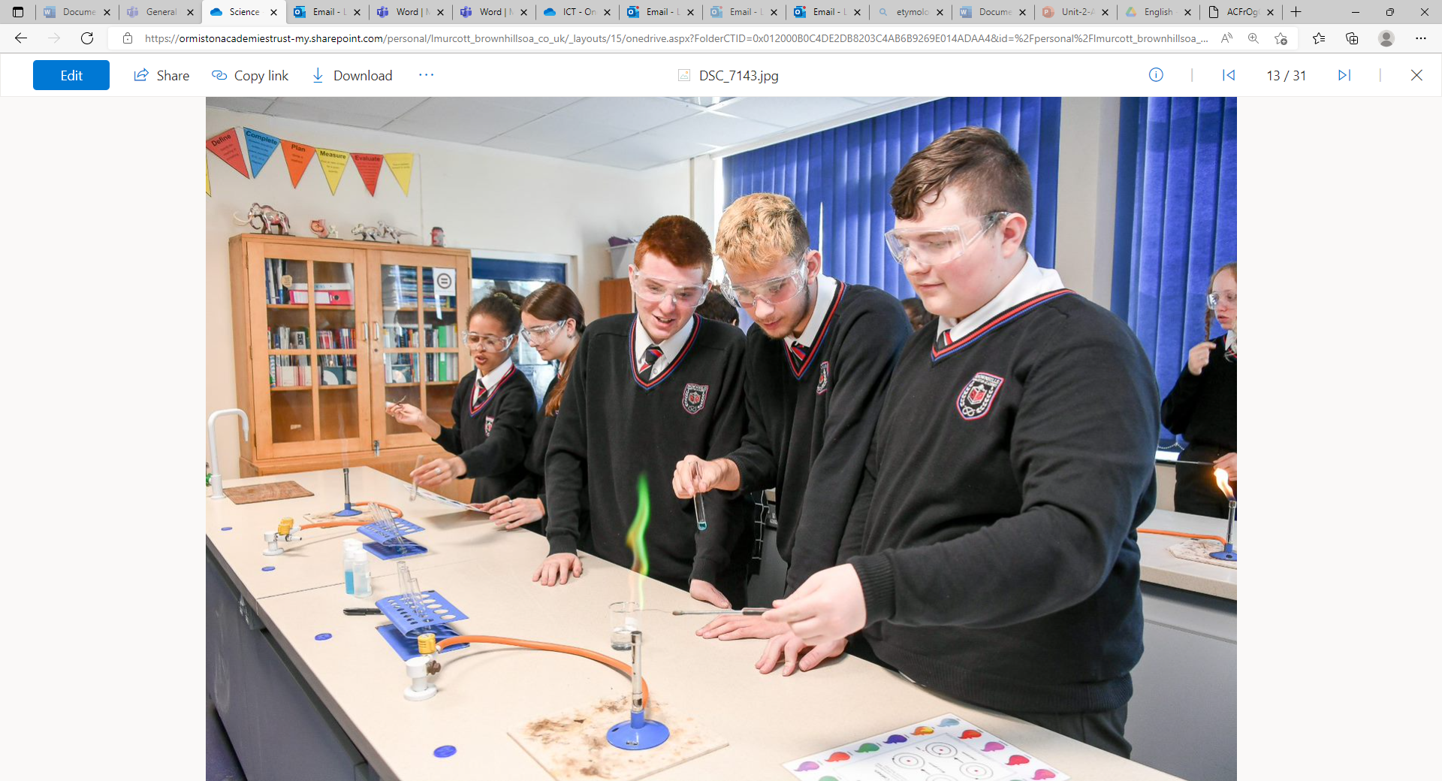
Year 11 Animal care
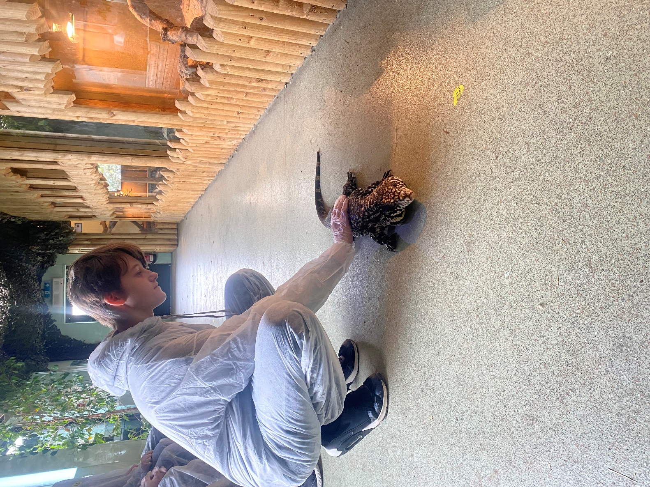
Year 11 Animal Care
Autumn Term 1 | Spring Term | Summer Term
Component 2: Animal Housing and Accommodation Levels: 1/2 Assessment type: Internal, externally moderated Guided learning hours: 36  Learning outcomes  A Understand factors affecting the selection of animal accommodation  B Prepare and check animal accommodation using safe working practices  C Be able to clean out animal accommodation using safe working practices.  Assignments Pearson sets the assignments for the assessment of this component. The assignment for this component consists of four tasks.  ● In response to Task 1, learners will explore the factors that need to be considered when selecting animal accommodation.  ● In response to Task 2, learners will prepare and check the safety and security of the animal accommodation.  ● In response to Task 3, learners will clean out animal accommodation following safe working practices.  ● In response to Task 4, learners will review how animal accommodation was prepared and cleaned | Component 3: Animal Health and Welfare  External synoptic Guided learning hours: 48  Component in brief  Component 3 covers all aspects of animal health and welfare and will equip learners with a good understanding of the relationship between looking after the wellbeing of the animal and the effect this has on maintaining animal strength and vigour. The component also gives an understanding of how animals are used in society and how they are protected by legislation  A Animal health  This learning outcome will enable learners to understand what to look out for to determine whether an animal is well. It will also cover the signs of ill health that may need further investigation. Animal species covered in this learning outcome must include dogs, cats, rabbits, hamsters and guinea pigs  A2 Animal housing and care  Learners will understand what constitutes good housing and care appropriate to different types of animal. They will gain knowledge about what aspects of care need to be put in place as a responsible animal owner and the importance of its provision to ensure the health and welfare of animals.  B Animal disease  This section looks at the common diseases that affect animals, the symptoms of these diseases and what steps can be taken to administer treatment. It will also cover the approaches that can be taken to prevent infection and diseases spreading | C Animals and legislation  This section looks at the importance of animals in society and the role that they play. It also covers the ethical responsibility of the owner to ensure the animal’s health and wellbeing are of paramount importance.  Final Examination – May 2024

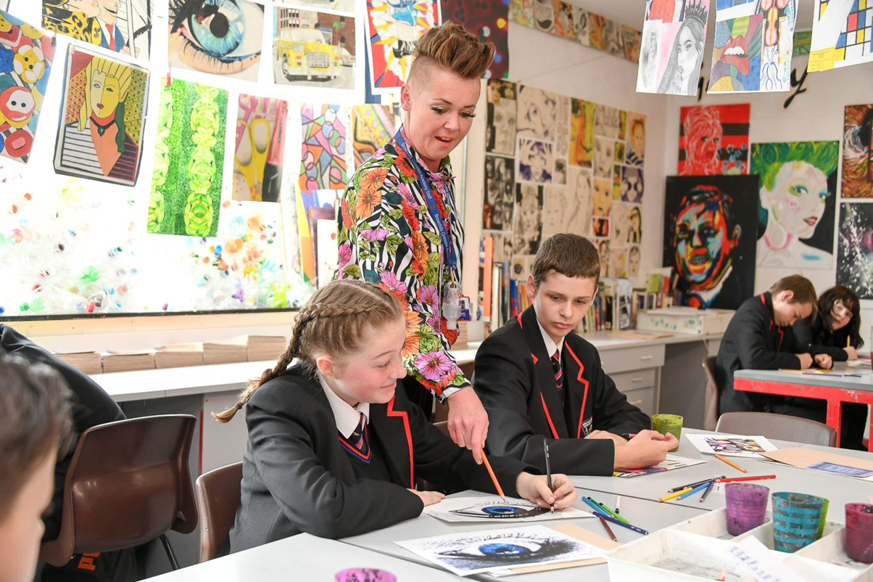
Year 11 Art

Year 11 Art
Autumn Term 1 | Autumn Term 1 | Spring Term 1 | Spring Term 2 | Summer Term 1 | Summer Term 2
OCR GCSE Art and Design Fine art element.  - Portfolio work based on the title famous faces famous places.  - Contextual references.  - Observational drawing.  - Use of materials and techniques.  - Independent study and skills. | OCR GCSE Art and Design Fine art element.  - Portfolio work based on the title famous faces famous places.  - Contextual references.  - Observational drawing.  - Use of materials and techniques.  - Final piece.  - Independent study and skills. | Exam preparation | Exam preparation. | Exam preparation. | Public Examinations

Year 11 Biology
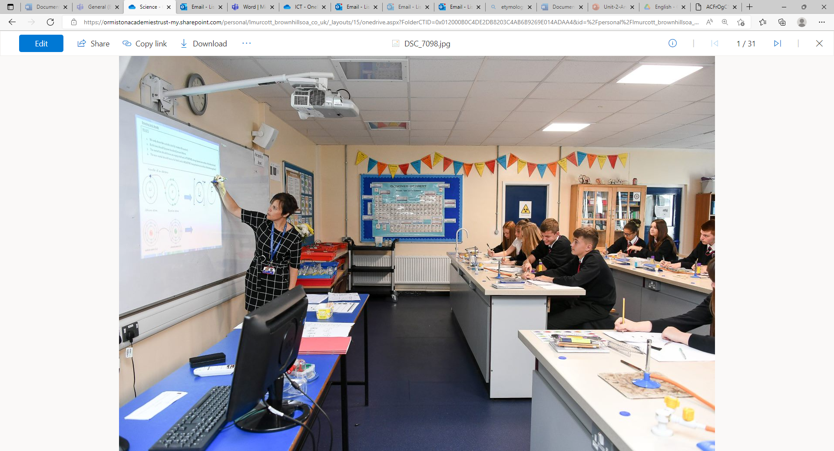

Year 11 Biology
Autumn Term 1 | Autumns Term 2 | Spring Term 1 | Spring Term 2 | Summer Term 1 | Summer Term 2
➢Genetic modification  ➢Plant Hormones  ➢Food security and farming  ➢Pyramid of numbers  ➢Decay  ➢DNA  ➢Brain  ➢Mitosis | ➢cell structure and magnification  ➢Mitosis and meiosis  Mock feedback and intervention | ➢Transport in cells. Diffusion and Osmosis theory  Osmosis required practical  Therapeutic cloning using stem cells  Animal tissues, organs and organ systems | ➢Mock 2 feedback and intervention | ➢Revision

Year 11 Chemistry



Year 11 Chemistry
 | Autumn Term 1 |  | Autumn Term 2 | Spring Term 1 | Spring Term 2 | Summer Term 1 | Summer Term 2
➢ | Earth’s resources  Potable water and water treatment  Life cycle assessments  Identification of ions  Hydrocarbons  Alkenes  Alcohols  Carboxylic acids  Polymers |  |  | Atomic structure and  periodic table  Bonding  Quantitative chemistry | Chemical reactions  Energy changes  Mock 2 feedback and  intervention | Revision | Public Examinations
 |  | ➢ Mock 1 feedback and
➢ |  |  | intervention
➢ |  | ➢
➢ |  | ➢ | Titration calculations
➢ |  | ➢ | Further quantitative
➢ |  |  | chemistry
➢
➢

Year 11 Child Development
Autumn 1 | Autumn 2 | Spring 1 | Spring 2 | Summer 1 | Summer 2
Unit RO59  Understand the development of a child from one to five years  OCR SET ASSIGNMENT  Task 1 Investigate the expected development norms for a child;  Observe a child; Compare findings with the development norms) | Unit RO59  Understand the development of a child from one to five years  OCR SET ASSIGNMENT  Task 2a Plan and evaluate play activities for a child aged one to five years for a chosen area of development  OCR SET ASSIGNMENT  Task 2b Use self reflection to produce a report on the strengths and weaknesses of your activity  External Moderation takes place Jan 2024 if entries made | Unit RO57  Health and Well-Being for Child Development (exam unit) Topics covered in yr 9 also  Revision of Topic Areas 1+2  Exam paper practise | Unit RO57  Health and Well-Being for Child Development (exam unit)  Revision of Topic Areas 3+4  Exam paper practise  RO59 MODERATOR SUBMISSION MAY 15TH (if work not sampled in Jan) | Unit RO57  Revision  Revision of Topic Areas 3+4  Exam paper practise  R057 EXTERNAL ASSESSMENT EXAM (MAY)1 hr 15mins  (70 marks) (60%) | LIVE ASSIGNMENT RELEASE  JUNE (RO58/59) FOR NEXT COHORT
Topic Area 1: Physical, intellectual and social developmental norms from one to five years  Topic Area 3: Observe the development of a child aged one to five years | Topic Area 1: Physical, intellectual and social developmental norms from one to five years  Topic Area 2: Stages and types of play and how play benefits development  Topic Area 4: Plan and evaluate play activities for a child aged one to five years for a chosen area of development | Topic Area 1: Pre-conception health and reproduction  Topic Area 2: Antenatal care and preparation for birth | Topic Area 3: Postnatal checks, postnatal care and the conditions for development  Topic Area 4: Childhood illnesses and how to meet the needs of the child | Topic areas 1-4  Topic Area 1: Pre-conception health and reproduction  Topic Area 2: Antenatal care and preparation for birth  Topic Area 3: Postnatal checks, postnatal care and the conditions for development  Topic Area 4: Childhood illnesses and how to meet the needs of the child
Recognise: The development stages of the child through an observation  Apply: An appropriate observation and recording method for different activities  Explain and analyse: the expected development norms (PIS) for children of different ages; explain reasons for different choices of observation and recording methods  Demonstrate: Recording of the observation findings and confidentiality | Recognise: The stage of development of the child  Apply: An appropriate play activity  Explain and analyse: The aims of the activities, safety considerations and resources needed; benefits of the activity to the child  Demonstrate: Appropriate choice of activity according to the needs of the child – why is the activity appropriate for the area of development | Topic Area 1  Recall: Factors affecting pre-conceptual health; types of contraception, functions of the reproductive system.  Recognise: Areas of the reproductive systems, sign + symptoms of pregnancy)  Topic Area 2  Recall: The purpose and importance of antenatal clinics; the role of the birthing partner; methods of pain relief; stages of labour  Explain: Screening and diagnostic test; The purpose and importance of antenatal (parenting) classes; choices for delivery | Topic Area 3:  Recall: The different postnatal checks performed on mother and baby  Recognise: Descriptions of post natal checks  Apply: Give recommendations for the postnatal care of the mother and baby  Explain and analyse: The risks of postnatal checks  Topic Area :  Recognise general signs and symptoms of illness in children  Explain how to meet the needs of an ill child  Explain how to ensure a child-friendly safe environment | All topic areas

Year 11 LEVEL 1 / 2 Award ICT


Year 11 English
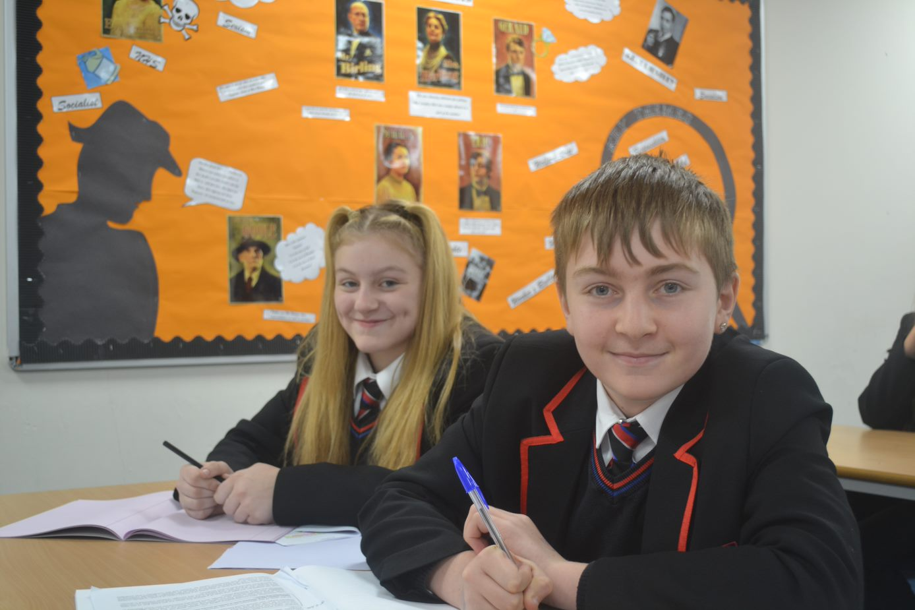
Year 11 English
Autumn Term 1 | Autumn Term 2 | Spring Term 1 | Spring Term 2 | Summer Term 1 | Summer Term 2
Love and Relationships: Poetry Anthology  Edexcel Literature  Paper 2  - Study of the ideas, context, themes and language of poetry  - Comparing poems | Revision and Exam Practice: Literature Paper 2 and Language Paper 1  - Love and Relationships Poetry Anthology  - Unseen Poetry Analysis  - Revision A Christmas Carol  - Language Paper 1 English Reading and Writing  PPE1 | - Revision – all literature texts (A Christmas Carol / Love and Relationships Poetry/ Unseen poetry/ Inspector Calls/ Macbeth)  - Practice and revision of both language papers  - Timed exam practice and techniques | - Revision – all literature texts (A Christmas Carol / Poetry/ Unseen poetry/ Inspector Calls/ Macbeth)  - Practice and revision of both language papers  - Timed exam practice and technique | - Revision | Public Examinations  Edexcel English Literature Paper 1: 1 Hour 45 minutes  An Inspector Calls  Macbeth  Edexcel English Literature Paper 2: 2 hours 15 minutes  A Christmas Carol  Relationships Poetry  Unseen Poetry  AQA English Language Paper 1: 1 hour 45 minutes  Fiction Extract and Creative Writing  AQA English Language Paper 2: 1 hour 45 minutes  Non-Fiction Extracts and Transactional Writing

Year 11 French
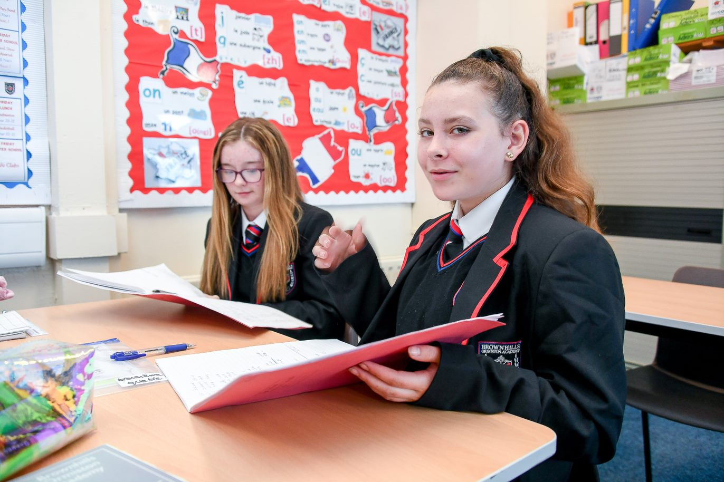

Year 11 French
Autumn term 1 | Autumn term | Spring term | Spring term | Summer term 2 | Summer term 1
Mon expérience  - Career choices  - Best subjects at school and future projects  - Earning money  - Work experience & qualities necessary for certain types of jobs  - Extra curricular activities  Grammar, skills and phonics  - Superlative  - Subjunctive (implicit)  - Direct object pronouns in perfect tense  - Verbs followed by ‘de’ and ‘à’  - Use of higher structures & exceptional vocabulary  - Phonics  Review on how to pronounce simple vowels  a’, SFE  [e] [é/er/ez] [è/ê/ai],open [o] [closed o/ô] [au/eau], [u] [ou] | Ce que je fais pour améliorer ma ville  - Role plays  - Your town: advantages & disadvantages  - Projects for your town  - Big events in my country & in the world  Grammar, skills and phonics  - Indirect object pronouns  - Relative clauses  - Combining time frames  - Analysing literary texts  - Listening for details  Use of higher structures & exceptional  vocabulary  - Phonics  Revisiting the following sounds  u] [ou] [closed eu] [open eu/œu], silent final [e], [i/y], è / ê /[u] [ou]silent final consonant(SFC), CaReFuL consonants  - Mocks all skills | Un oeil sur le monde  - Ethical shopping  - What you do to protect the environment  - Volunteering  - Big events  Grammar, skills and phonics  - Modal verbs in present and conditional tense  - The passive voice  - Indirect object pronouns  - Combining time frames  - Analysing literary texts  - Reviewing of phonics Answering questions with the correct pronunciation  - Phonics  Revisiting diphthongs (sounds with 2 vowels), nasals (when a vowel is followed by a single ‘n’ or ‘m’ in the same syllable and blends (2 consonants together) | Tu te souviens de ce que tu as appris?  - Exam skills /mixed themes  Grammar, skills and phonics  - Using all tenses and referring to 3 time frames (foundation),  referring to 6 time frames (higher)  - Higher level expressions revisions  - Listening for details  - Literary texts  - Use of (Teachit booklets) to review essential vocabulary for the speaking exam  - Phonics:  Answering questions with the correct pronunciation, practising liaisons.  - Mocks all skills | Tu es prêt(e)?  Speaking exams (Foundation and higher tiers)  Revision  Exam techniques  Revision with W.A.G.O.L.Ls & sentence builders  Review of A.C.T.I.O.N J.A.C  - Use of Exampro resources for final exam practise in listening and reading  - Literary extracts reading practise  - GCSE past papers to consolidate learning  - Listening, reading and writing revision  www.sentencebuilders.com  www.languagegym.com  Quizlets on all themes  Quizlets on tenses | Public Examinations  All papers are either taken at Foundation or Higher Tier  Speaking Exam (25%)  Listening (25%) and Reading Exam (25%)  Writing Exam (25%)

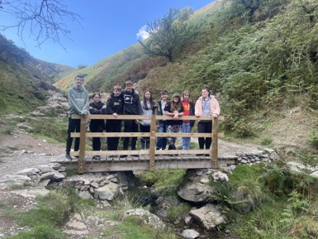
Year 11 Geography
Year 11 Geography
Autumn Term 1 | Autumn Term 2 | Spring Term 1 | Spring Term 2 | Summer Term 1 | Summer Term 2
- Urban issues and challenges  - Overview of the distribution of population and the major cities in the UK.  - A case study of a major city in the UK to illustrate:  - the location and importance of the city in the UK and the wider world  - impacts of national and international migration on the growth and character of the city  - how urban change has created opportunities:  - social and economic: cultural mix, recreation and entertainment, employment, integrated transport systems  - environmental: urban greening  - how urban change has created challenges:  - social and economic: urban deprivation, inequalities in housing, education, health and employment  - environmental: dereliction, building on brownfield and greenfield sites, waste disposal  - the impact of urban sprawl on the rural–urban fringe, and the growth of commuter settlements.  - An example of an urban regeneration project to show:  - reasons why the area needed regeneration  - the main features of the project. | - Changing economic world: Nigeria  - Different ways of classifying parts of the world according to their level of economic development and quality of life.  - Different economic and social measures of development: gross national income (GNI) per head, birth and death rates, infant mortality, life expectancy, people per doctor, literacy rates, access to safe water, Human Development Index (HDI).  - Limitations of economic and social measures.  - Link between stages of the Demographic Transition Model and the level of development.  - Causes of uneven development: physical, economic and historical.  - Consequences of uneven development: disparities in wealth and health, international migration.  - An overview of the strategies used to reduce the development gap: investment, industrial development and tourism, aid, using intermediate technology, fairtrade, debt relief, microfinance loans.  - An example of how the growth of tourism in an LIC or NEE helps to reduce the development gap.  - A case study of one LIC or NEE to illustrate:  - the location and importance of the country, regionally and globally  - the wider political, social, cultural and environmental context within which the country is placed  - the changing industrial structure. The balance between different sectors of the economy. How manufacturing industry can stimulate economic development  - the role of transnational | - Resource reliance  - The significance of food, water and energy to economic and social well-being.  - An overview of global inequalities in the supply and consumption of resources.  - An overview of resources in relation to the UK.  - Food:  - the growing demand for high-value food exports from low income countries and all-year demand for seasonal food and organic produce  - larger carbon footprints due to the increasing number of ‘food miles’ travelled, and moves towards local sourcing of food  - the trend towards agribusiness.  - Water:  - the changing demand for water  - water quality and pollution management  - matching supply and demand – areas of deficit and surplus  - the need for transfer to maintain supplies.  - Energy:  - the changing energy mix – reliance on fossil fuels, growing significance of renewables  - reduced domestic supplies of coal, gas and oil  - economic and environmental issues associated with exploitation of energy sources.  - Areas of surplus (security) and deficit (insecurity):  - global patterns of calorie intake and food supply  - reasons for increasing food consumption: economic development, rising population  - factors affecting food supply: climate, technology, pests and disease, water stress, conflict, poverty.  - Impacts of food insecurity – famine, undernutrition, soil erosion, rising prices, social unrest.  - Overview of strategies to increase food supply:  - irrigation, aeroponics and hydroponics, the new green revolution and use of biotechnology, appropriate technology  - an example of a large scale agricultural development to show how it has both advantages and disadvantages.  - Moving towards a sustainable resource future:  - the potential for sustainable food supplies: organic farming, permaculture, urban farming initiatives, fish and meat from sustainable sources, seasonal food consumption, reduced waste and losses  - an example of a local scheme in an LIC or NEE to increase sustainable supplies of food. | The Living world  - An example of a small-scale UK ecosystem to illustrate the concept of interrelationships within a natural system, an understanding of producers, consumers, decomposers, food chain, food web and nutrient cycling.  - The balance between components. The impact on the ecosystem of changing one component.  - An overview of the distribution and characteristics of large scale natural global ecosystems.  - The physical characteristics of a tropical rainforest.  - The interdependence of climate, water, soils, plants, animals and people.  - How plants and animals adapt to the physical conditions.  - Issues related to biodiversity.  - A case study of a tropical rainforest (deforestation).  - The physical characteristics of a hot desert.  - The interdependence of climate, water, soils, plants, animals and people.  - How plants and animals adapt to the physical conditions.  - Issues related to biodiversity.  - A case study of a hot desert (desertification)  Paper 3:  Pre release  Paper 1 revision:  Natural hazards  Living world  Coasts  Rivers  Paper 2 revision:  Urban issues and challenges  Changing economic world  Resource management  Paper 3:  Pre-release  Human fieldwork: Brownhills Highstreet urban regeneration  Physical fieldwork: Carding Mill Valley | Revision  Paper 1:  - Natural hazards  - The living world  - UK landscapes – coasts and rivers  Paper 2:  - Changing economic world  - Urban issues and challenges  - Resource management  Paper 3:  - Issue evaluation  - Fieldwork | Paper 1 PM 17th May  Paper 2 AM 5th June  Paper 3 AM – 14th June

Year 11 History
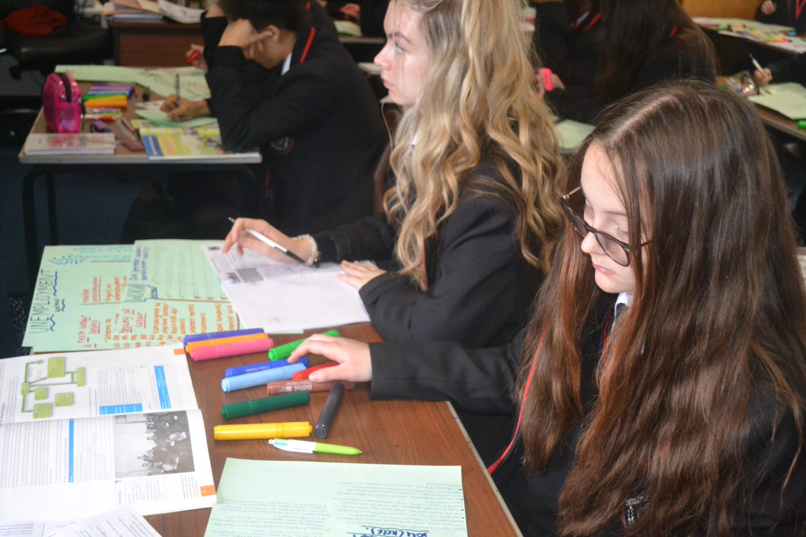
Year 11 History
Autumn Term 1 | Autumn Term 2 | Spring Term 1 | Spring Term 2 | Summer Term 1 | Summer Term 2
Early Elizabethan England 1558-88  - Elizabeth's situation  - Elizabeth's religious settlement  - Challenges to Elizabeth  - The situation on Elizabeth’s accession Elizabethan England in 1558: society and government.  - The Virgin Queen: the problem of her legitimacy, gender, marriage. Her character and strengths.  - Challenges at home and from abroad: the French threat, financial weaknesses.  - The ‘settlement’ of religion  - Religious divisions in England in 1558.  - Elizabeth’s religious settlement (1559): its features and impact.  - The Church of England: its role in society. 3 Challenge to the religious settlement  - The nature and extent of the Puritan challenge.  - The nature and extent of the Catholic challenge, including the role of the nobility, Papacy and foreign powers. 4 The problem of Mary, Queen of Scots  - Mary, Queen of Scots: her claim to the English throne, her arrival in England in 1568.  - Relations between Elizabeth and Mary, 1568–69.  - Concepts and Skills:  - require students to understand the complexity of a society or historical situation and the interplay of different aspects within it. Depending on the depth study chosen, these may include social, economic, political, religious and military aspects | Early Elizabethan England 1558-1588  - Relations with Spain  - Plots and revolts at home  - The reasons for, and significance of, the Revolt of the Northern Earls, 1569–70.  - The features and significance of the Ridolfi, Throckmorton and Babington plots. Walsingham and the use of spies.  - The reasons for, and significance of, Mary Queen of Scots’ execution in 1587. 2 Relations with Spain  - English direct involvement in the Netherlands, 1585–88. The role of Robert Dudley.  - Drake and the raid on Cadiz: ‘Singeing the King of Spain’s beard’. 4 The Armada  - Spanish invasion plans. Reasons why Philip used the Spanish Armada.  - The reasons for, and consequences of, the English victory.  - Political and religious rivalry.  - Education and the poor  - Raleigh and America  - Commercial rivalry. The New World, privateering and the significance of the activities of Drake. 3 Outbreak of war with Spain, 1585–88  - Concepts and Skills:  - Students will be assessed on their knowledge and understanding. Questions will target key features and causation, and may also target other second order concepts (change, continuity, consequence, similarity, difference, significance) | Elizabethan society in the Age of Exploration, 1558–88  - Education in the home, schools and universities.  - Sport, pastimes and the theatre.  - The reasons for the increase in poverty and vagabondage during these years.  - The changing attitudes and policies towards the poor  - Factors prompting exploration, including the impact of new technology on ships and sailing and the drive to expand trade. The reasons for, and significance of, Drake’s circumnavigation of the globe  - Factors prompting exploration, including the impact of new technology on ships and sailing and the drive to expand trade. The reasons for, and significance of, Drake’s circumnavigation of the globe  - Concepts and Skills:  - Students will be assessed on their knowledge and understanding. Questions will target key features and causation, and may also target other second order concepts (change, continuity, consequence, similarity, difference, significance) | Revision  - Paper 1: Crime and Punishment in Britain c1000-present and Whitechapel c1870-1900 (crime, policing and the inner city)  - Paper 2: Early Elizabethan England 1558-88 and Superpower relations and the Cold War 1941-91  - Paper 3: Weimar and Nazi Germany 1918-39 | Revision  - Paper 1: Crime and Punishment in Britain c1000-present and Whitechapel c1870-1900 (crime, policing and the inner city)  - Paper 2: Early Elizabethan England 1558-88 and Superpower relations and the Cold War 1941-91  - Paper 3: Weimar and Nazi Germany 1918-39 | Public Examinations
Year 11 Health and Social
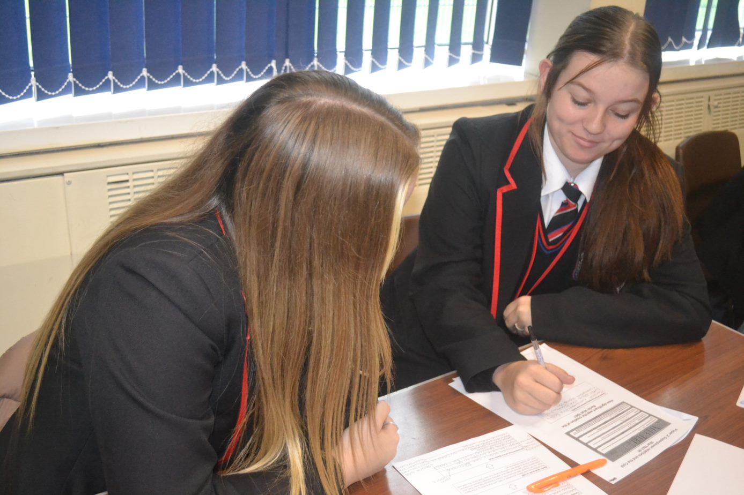
Year 11 Health and Social
Important Information: Component 2 Assignment Tasks are released by the exam board and are referred to as PSA (Pearson Set Assignments) Tasks throughout the document
Autumn 1 | Autumn 2 | Spring 1 | Spring 2 | Summer 1 | Summer 2
COMPONENT 2 - HEALTH & SOCIAL CARE SERVICES & VALUES  The skills and attributes in health and social care  - Skills:  Problem solving, observation, dealing with difficult situations, organisation  - Attributes:  Empathy, patience, trustworthiness, honesty  The benefits to individuals of the skills, attributes and values in health and social care practice  - services user right, professional behaviours, individual expectations, being involved in care plans, protected from harm, dignity and respect, confidentiality protected, rights promoted)  (PSA released in mid-late September; completed by 15th December; 5 tasks)  PSA Task 1 + 2 :  Controlled assessment conditions  (4 weeks)  Resubmission opportunity given for each task | COMPONENT 2 - HEALTH & SOCIAL CARE SERVICES & VALUES  PSA Task 3 + 4 a/b :  Controlled assessment conditions  (6 weeks)  Resubmission opportunity given for each task | COMPONENT 3 - HEALTH & WELL BEING (external component)  A: Factors that affect health and wellbeing  - Maslow’s Hierarchy of Needs (Physiological, Safety, Love and belonging, Self Esteem, Self actualisation)  - Physical Factors (Inherited conditions, Ill health - CV Disease, Obesity, Type 2 Diabetes; Mental health – Anxiety, Stress; Physical Abilities / sensory impairments)  - Lifestyle (nutrition, smoking, alcohol, substance misuse, Exercise)  - Social Factors (relationships, social inclusion and exclusion, bullying, discrimination)  - Cultural Factors (religion, gender roles + identity, sexual orientation, community participation)  - Economic Factors (employment, income, inheritance, savings)  - Environmental Factors (housing needs, conditions, location, home environment, pollution)  - The Impact of Life Events: physical events / relationship changes / life circumstances / imprisonment  B: Interpreting health indicators and physiological data (positive + negative effects )  - Resting Pulse Rate  - Blood pressure  - Body Mass Index (BMI)  - The potential significance of abnormal readings  - The impact on current health (short term risks)  - Risks to future health (long term risks) | COMPONENT 3 - HEALTH & WELL BEING  B: Interpreting health indicators and physiological data (positive + negative effects )  How lifestyle choices determine physical health.  - How to interpret data – who? What?(nutrition, smoking, alcohol, substance misuse)  C: Person-centred approaches to improving health and wellbeing  - The ways in which a person-centred approach takes into account an individual’s need (needs, wishes, circumstances)  - The importance and benefits of a person-centred approach  - Recommendations and actions to improve health and wellbeing  - Support available (formal/informal) | COMPONENT 3 - HEALTH & WELL BEING  C: Person-centred approaches to improving health and wellbeing  - Barriers and obstacles to following recommendations (Physical, sensory, social and cultural, language, geographical, resources, financial, psychological, time, unachievable targets, lack of support)  Exam practise  Revision topics  EXTERNAL ASSESSMENT  May

Year 11 Hospitality
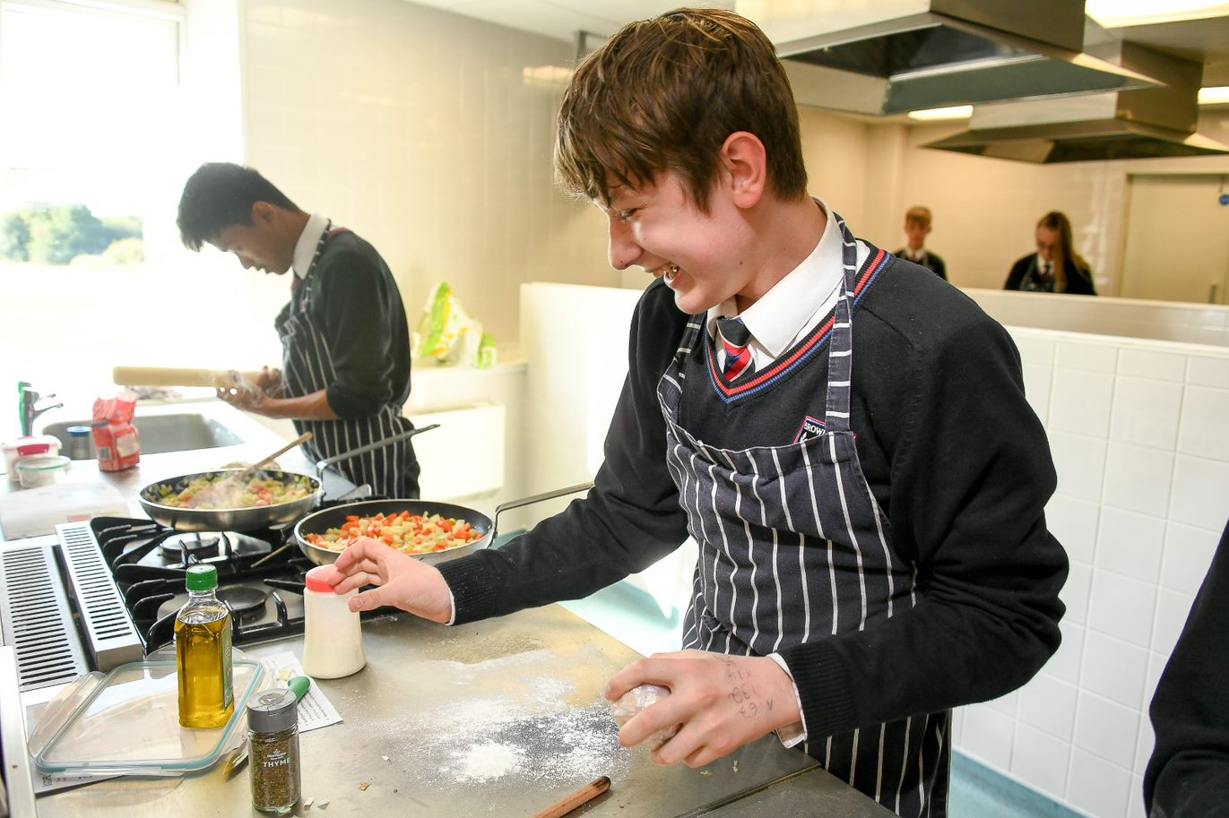

Year 11 Hospitality
Autumn Term 1 | Autumn Term 2 | Spring Term 1 | Spring Term 2 | Summer Term 1 | Summer Term 2
Introduction to Unit 2:  - Reflection on progress so far.  - Recap on qualification structure – understanding of bigger picture.  - Retrieval of learning from unit 1.  Students begin learning key knowledge and skills in unit 2 before attempting their NEA task.  2.1 The Importance of Nutrition  Topics of study:  Describing the functions of nutrients in the human body  Comparing nutritional needs of specific groups.  Specific groups  •Different life stages  •Childhood  •Adulthood  •Later adulthood  •Special diets  •Medical conditions  •Activity levels  Characteristics of unsatisfactory nutritional intake  Characteristics  •Visible  •Non-visible  •Unsatisfactory  •Nutritional deficiencies  •Nutritional excesses | How cooking methods impact on nutritional value.  Cooking methods  •Boiling  •Steaming  •Baking  •Grilling  •Stir-fry  •Roasting  •Poaching  2.2 Menu Planning  Topics of study:  Factors to consider when proposing dishes for menus  Factors  Time of year e.g.  - seasonality of commodities,  - seasonal events  - Skills of staff  - Equipment available  - Time available  - Type of provision e.g. Service, location, size, standards  - Finance e.g. costs,  - customer needs  - Client base  How dishes on a menu address environmental issues.  - Dishes  - Preparation and cooking methods  - Ingredients used  - Packaging  - Environmental issues  - Conservation of energy and water  - Reduce, reuse, recycle  - Sustainability e.g. food miles,  Explain how menu dishes meet customer needs  Needs  •Nutritional  •Organoleptic  •Cost e.g. premium priced dishes, value for money  Plan production of dishes for a menu  Plan, Sequencing, Timing,  Mise en place, Cooking,  Cooling, Hot holding ,  Completion, Serving  (presented as if to be  served) | Begin Controlled Assessment (NEA)  Students will be presented with a brief. They will then complete a piece of work to reflect their investigation and proposed dishes in response to the brief.  During NEA, students will work towards meeting the assessment criteria areas below:  Topics of study focussed on in NEA:  2.1 The Importance of Nutrition  •Macronutrients  •Micronutrients  •Compare nutritional  Needs of specific groups  •Explain characteristics of  unsatisfactory nutritional  intake  •Explain how cooking  methods impact on  nutritional value  2.2 Menu Planning  •Explain factors to consider when proposing dishes for menus  •Explain how dishes on a menu address environmental issues  •Explain how menu dishes meet customer needs  •AC2.4 plan production of dishes for a menu  Mock trials of dishes to refine skills.  Practical cooking examination linked to NEA | 2.3. Cooking techniques  •Use techniques in preparation of commodities  •Assure quality of commodities to be used in food preparation  •Use techniques in cooking of commodities  •Complete dishes using presentation techniques  2.4 Evaluating cooking skills  •Review of planning. This includes a review of their planning, preparation and cooking; highlighting areas of success and of potential further development. Areas to consider: dish production, dish selection, health and safety, hygiene, improvements, organoleptic, presentation and waste.  •Identifying personal strengths and weaknesses relating to: decision making, organization and planning.  End of NEA  Reteaching/retrieval of unit 1 topics linked to student's needs.  Topics of study:  All content from unit 1:  Hospitality and catering provision  How hospitality and catering provisions operate  Health and safety in hospitality and catering  Food safety in hospitality and catering | Reteaching/retrieval of unit 1 topics linked to student's needs.  Topics of study:  All content from unit 1:  •Hospitality and catering provision  •  •How hospitality and catering provisions operate  •  •Health and safety in hospitality and catering  •Food safety in hospitality and catering | Written Examinations  •Duration: 80 minutes  •Number of marks: 80  Topics of study:  All content from unit 1:  •Hospitality and catering provision  •  •How hospitality and catering provisions operate  •  •Health and safety in hospitality and catering  •  •Food safety in hospitality and catering

Year 11 Maths

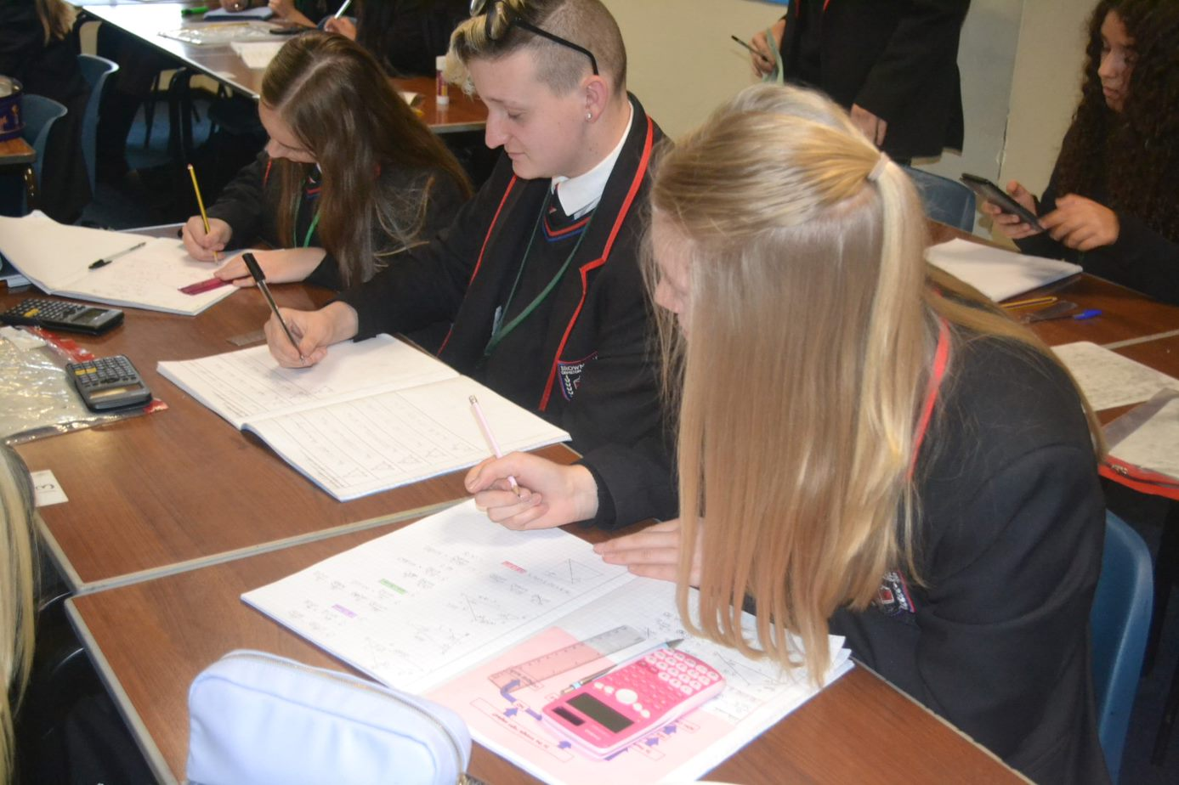
Year 11 Maths
Autumn Term 1 | Autumn Term 2 | Spring Term 1 | Spring Term 2 | Summer Term 1 | Summer Term 2
Core:  - Two-way tables  - Frequency trees  - Error intervals  - Estimation  - Prime factorisation  - HCF and LCM  - Fraction arithmetic  - Ratio  - Proportion  - Percentages  - Linear sequences  - Index laws  - Linear equations  - Linear inequalities  - Factorising quadratics  - Changing the subject  Extension:  - Recurring decimals  - Surds  - Fractional and negative indices  - Calculating with bounds  - Quadratic sequences  - Geometric sequences  - y = mx + c | PPE 1  Core:  - Standard form  - Angles  - Bearings  Extension:  - Similar shapes  - Compound measures  - Proportion equations  - Non-linear graphs | Core:  - Pythagoras  - Trigonometry  - Circles  - Arcs and sectors  - Surface area  - Volume  - Measures of location  - Drawing graphs and charts  - y = mx + c  Extension:  - Factorising harder quadratics  - Complete the square  - Quadratic formula  - Interpret gradient of curves  - Interpret area under curves | PPE 2  Core:  - Non-linear graphs  - Real life graphs  - Compound measures  Extension:  - Harder change the subject  - Iteration  - Functions  - Quadratic inequalities | Core:  - Congruence  - Transformations  - Vectors  - Probability  - Simultaneous equations  Extension:  - Circle theorems  - Algebraic proof  - Transformations of functions | External Examinations
Year 11 Media
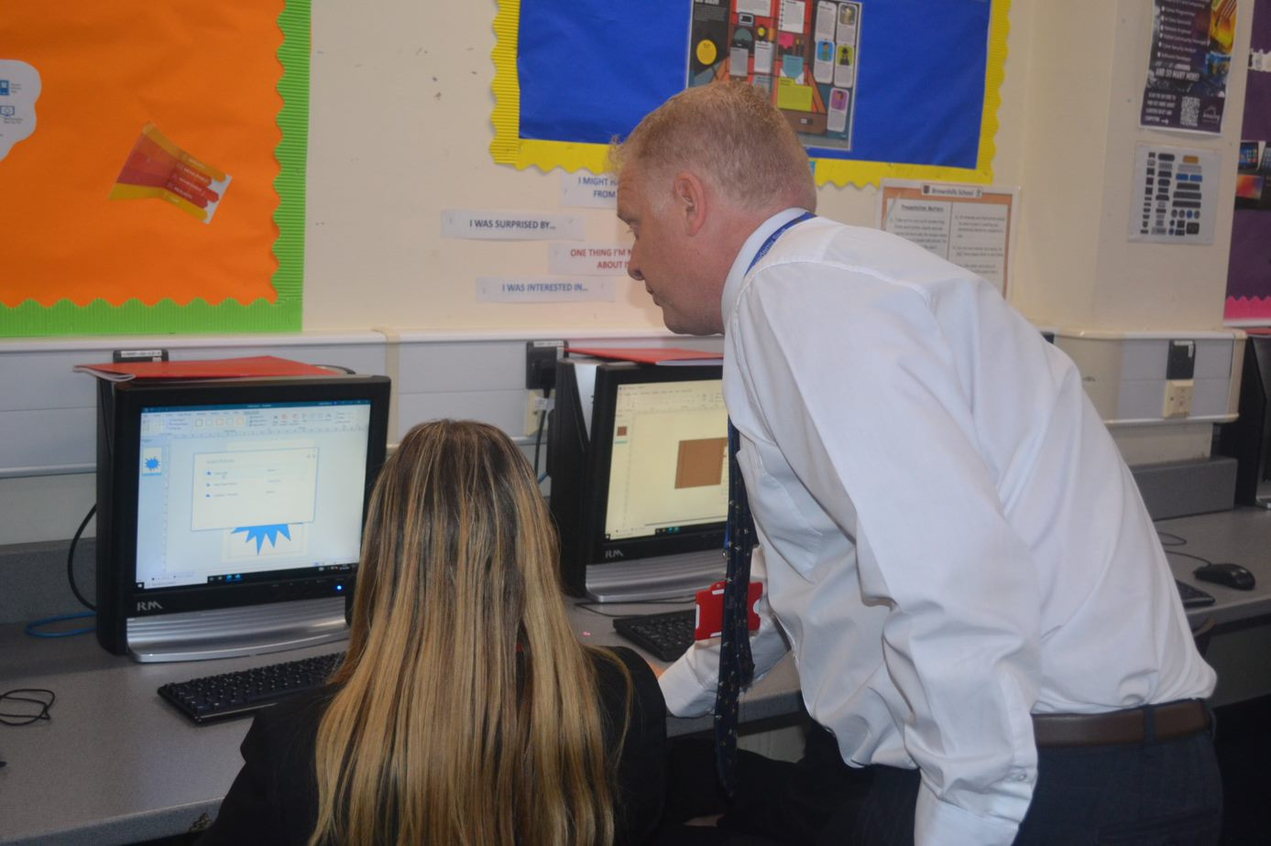

Year 11 Media
Autumn Term 1 | Autumn Term 2 | Spring Term 1 | Spring Term 2 | Summer Term 1 | Summer Term 2
Component 2: Developing Digital Media Production Skills  Learning Aim A – Develop media production skills and techniques  - Developing narratives and storylines, synopsis, treatment, dialogue and sound scripts, screenplays, storyboards, shot lists;  - Shooting video in various locations, shot composition, framing, angle, camera movement, recording audio in a studio and on location, acoustics, microphones, ambient sound, recording levels;  - Editing audio, editing video, mixing sound, transitions, audio effects, visual effects. | Component 2: Developing Digital Media Production Skills  Learning Aim B – Apply media production skills and techniques  - Reworking extracts of an existing media product/s, such as a movie trailer.  B1 Pre-production processes and practices  - Creating a sound script, a shooting script, a storyboard.  B2 Production processes and practices  - Recording audio, shooting footage.  B3 Post-production processes and practices  - Editing audio, editing audio and video footage, together into a finished extract and rendering audio and video.  Learning Aim C  – Review own progress and development of skills and practices | Component 3: Create a Media Product in Response to a Brief  Learning Aim A – Develop ideas in response to a brief  A1 Responding to a brief  A2 Generating ideas  Learning Aim B – Develop pre-production materials in response to a brief  B1 Planning materials  B2 Managing the production process | Component 3: Create a Media Product in Response to a Brief  Component 3: C – Apply skills and techniques to the creation of a media product  C1 Monitor and review the outcomes of the production process  C2 Production skills and techniques | Component 3: Create a Media Product in Response to a Brief  Learning Aim C – Apply skills and techniques to the creation of a media product  C4 Testing and Exporting for distribution | Revision/public examinations

Year 11 Music


Year 11 Music
Theme 1 | Theme 2 | Theme 3 | Theme 4 | Theme 5 | Theme 6
Recognising Musical Features  Technical, Constructive & Expressive Progression:  Listening & Appraising:  1) Knowing all possible answers based on the element of music being questioned.  2) Recognising musical features in previously unheard styles of music and isolating compositional devices in those examples.  3) Filtering musical information when listening to extracts to give descriptions about individual elements of music.  4) Confidently using musical language from all elements of music to name/state/describe musical features from different genres.  Performing:  Solo Performance: Students select repertoire for solo performances and rehearse these independently focusing on accuracy, technique and expression.  Ensemble Performance: Students select repertoire for ensemble performances and rehearse these in ensembles focusing on accuracy, technique, expression and ensemble rapport.  Composing: Students are provided with four briefs which they need to choose between. Ideas for instrumentation and model examples are discussed in order to ensure that students can successfully meet their brief. | Using Score & Dictation  Technical, Constructive & Expressive Progression:  Listening & Appraising:  1) Recognising each musical feature studied both aurally and notated.  2) Being able to give bar and beat numbers, written in the correct format to locate features.  3) Using score to support answers to questions about time signatures and key signature.  4) Identifying intervals from score to identify melodies notated in questions, state the names of intervals heard and seen in musical examples and support with melodic dictation.  5) Recognise and accurately notate rhythms.  Performing:  Solo Performance: Students begin solo performance rehearsals with member of staff at regular intervals to refine performance and practise with accompaniment.  Ensemble Performance: Students ensembles begin rehearsals with member of staff at regular intervals to refine performance and practise with accompaniment.  Composing: Students complete research into similar compositions based on their brief to look for musical features to use as inspiration. Students begin to use trial and error with chord progressions and melodies. | Writing Like A Musician  Technical, Constructive & Expressive Progression:  Listening & Appraising:  1) Listening to a piece of music and being able to chronologically identify musical features that cover all aspects of DR SMITH.  2) Turning notes into full sentence descriptions of the use of musical features in a piece of music with location examples to fit the chronology.  3) Grouping musical features identified into sections and linking each section of answers to the intention of the piece of music. Specific focus on film music and programme music as examples of descriptive music.  Performing:  Students develop performance communication and consider how effectively expressive performance looks and sounds to ensure it is communicated visually and audibly for audiences.  Composing: Students finalise ideas and begin to notate compositions using Notion. Students record chord progressions, melodic fragments and rhythmic ideas initially, before developing these fragments and manipulating the elements of music to create coherent compositions. | Exploring Genre & Style  Technical, Constructive & Expressive Progression:  Listening & Appraising:  1) Recognising the conventions of different genres of music.  2) Discussing how the elements of music are manipulated in order to meet those conventions of each genre.  3) Identifying different genres using those compositional fingerprints.  Performing: Students look more closely at accuracy, particularly of rhythms, to ensure their performances are true to the score. Ensemble pieces are rehearsed in order to try and achieve effective blend between parts and ensemble rapport.  Composing: Students finalise compositions, ensuring their compositions successfully contain the stylistic fingerprints of the genre of choice, checking musical directions and checking for stylistic coherence throughout the composition. Students complete a composition log reviewing their process and the inspiration they have taken from other sources. | Revision | Public Examinations

Year 11 Performing Arts
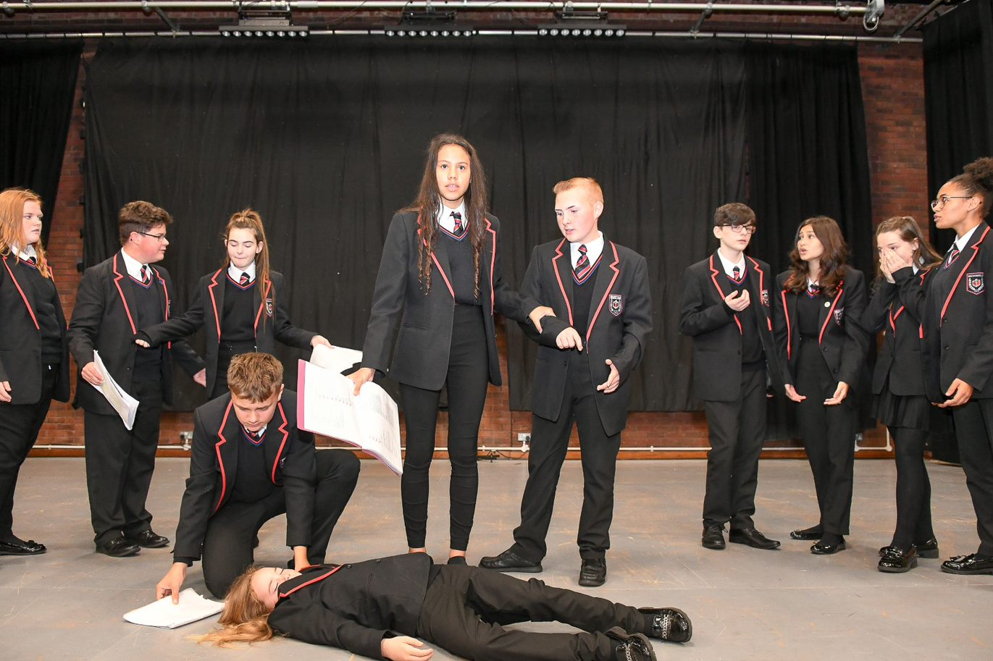
Year 11 Performing Arts
Autumn Term 1 | Spring Term | Summer Term 2
Component 2  Learning Aim A: Develop skills and techniques for performance. Students will participate in workshops and rehearsals in order to prepare students for a performance of their selected piece.  Learning Aim B: Apply skills and techniques in rehearsal and performance. Students' complete rehearsals and perform one of the following pieces for an audience: Two, Chatroom, Teechers, DNA, Bouncers & Shakers, Missing Dan Nolan.  Learning Aim C: Review own development and performance. Students complete a logbook and produce write ups of four milestone logs to evidence the progress they have made throughout the process. | Component 3  Assessment Objective 1: Understand how to respond to a brief  Assessment Objective 2: Select and develop skills and techniques in response to a brief  Assessment Objective 3: Apply skills and techniques in a workshop performance in response to a brief  Assessment Objective 4: Evaluate the development process and outcome in response to a brief  Students work in groups of up to 7 to devise a piece of drama based on the brief provided by Pearson. It must be between 7-15 minutes in length. Students write a commentary of their work evaluating the process of taking the idea from page to stage and reviewing their success | Revision and public examination

Year 11 PE
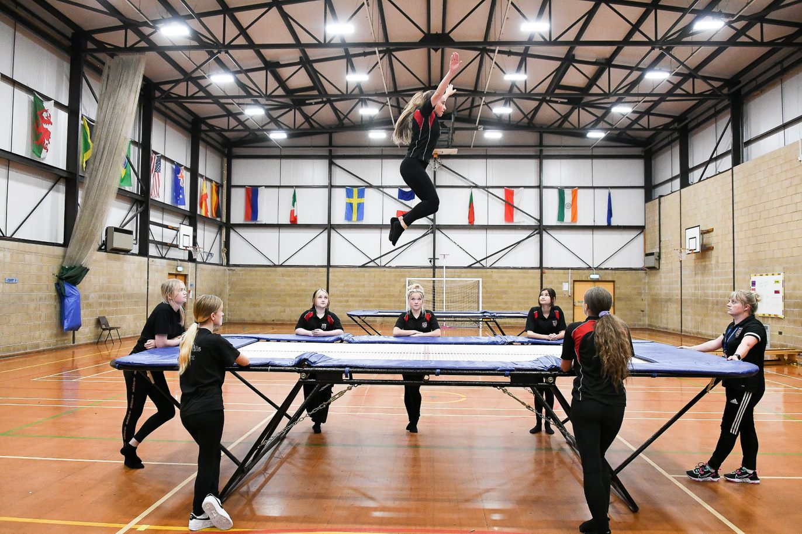

Year 11 PE
Autumn Term 1 | Autumn Term 2 | Spring Term 1 | Spring Term 2 | Summer Term 1 | Summer Term 2
- Netball, Football, Rugby  - Developing own tactics and strategies through attacking and defensive play  - Understanding how to improve in different phases of play.  - Linking competitive sport to a healthy active lifestyle.  Application of rucking and mauling in rugby.  - Develop kicking techniques in rugby.  - Practical of application in competitive sport. | - Basketball, Fitness, Badminton  - Attacking strategies in basketball, screens, blocks, and post play.  - Advanced shooting techniques- Jump shots and lay ups.  - The role of umpire and application of rules and regulations.  - Understanding how to create a training programme to suit individual needs.  - Participating in a personalised training programme to improve overall fitness | - Handball, Table Tennis, Volleyball  - To replicate the dig, serve, set, and spike.  - Apply fundamentals consistently in a game.  - To be able to officiate a game of volleyball.  - To learn the basics of outwitting strategies in volleyball.  - To learn how to time and perform a block effectively  - To learn rules of new sports such as table tennis.  - The role of umpire and application of rules and regulations. | - Table Tennis, Dodgeball, Futsal  - Developing own tactics and strategies through attacking and defensive play  - Linking competitive sport to a healthy active lifestyle.  - The role of umpire and application of rules and regulations. | - Cricket, Rounders, Softball  - The role of umpire and application of rules and regulations.  - Apply fundamentals consistently in a game.  - Developing own tactics and strategies through attacking and defensive play  - Understand formations | - Cricket, Rounders, Tennis  - The role of umpire and application of rules and regulations.  - Apply fundamentals consistently in a game.  - Developing own tactics and strategies through attacking and defensive play  - Understand formations

Year 11 BTEC Sport
Autumn Term 1 | Autumn Term 2 | Spring Term 1 | Spring Term 2 | Summer Term 1 | Summer Term 2
Understand how different components of fitness are used in different physical activities  Be able to participate in sport and understand the roles and responsibilities of officials | Demonstrate ways to improve participants sporting techniques | Developing Fitness to Improve Other Participants Performance in Sport and Physical Activity | Developing Fitness to Improve Other Participants Performance in Sport and Physical Activity | Developing Fitness to Improve Other Participants Performance in Sport and Physical Activity | Developing Fitness to Improve Other Participants Performance in Sport and Physical Activity

Year 11 Physics
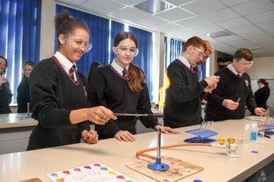

Year 11 Physics

 | Autumn Term 1 |  |  | Autumn Term 2 |  |  | Spring Term 1 | Spring Term 2 |  | Summer Term 1 |  | Summer Term 2
➢ | Permanent magnets | ➢ Mock 1 feedback and |  |  | ➢ |  | Energy | ➢ Atomic structure | ➢Revision |  | ➢ | Public examination
➢ | Electromagnets | intervention |  |  |  | ➢ | Electricity | ➢ Mock 2 feedback and
➢ | Motor effect | ➢ |  | Space |  | ➢ | Particle model | intervention
➢ | Flemmings left hand | ➢ |  | Lens
 | rule | ➢ |  | Static electricity
➢ | Uses for
 | electromagnets
➢ | Generators
➢ | Transformers
➢ | Solar system
➢ Life cycle of a star

Year 11 Religious Education
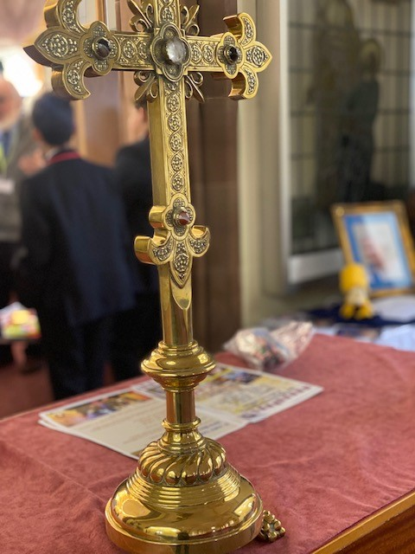
Year 11 Religious Education
Autumn Term 1 | Autumn Term 2 | Spring Term 1 | Spring Term 2 | Summer Term 1 | Summer Term 2
Relationships and Families  - Heterosexual and homosexual relationships.  - Human sexuality  - Contraception  - Marriage and cohabitation | Relationships and Families  - Different types of families  - Same sex parents and polygamy  - Divorce  - Assessment | Islam  - The nature of God  - Life and death  - Authorities—Adam, Ibrahim and Muhammed  - Holy Books  - Practice—5 pillars of Islam | Islam  - Salah and Shahadah  - Sawm, Zakah, Hajj and Jihad  - Islamic Festivals  - Assessment | Social Justice and Human Rights  - Prejudice and discrimination  - Human rights  - Social justice | Social Justice and Human Rights  - Prejudice and discrimination  - Human rights  - Social justice

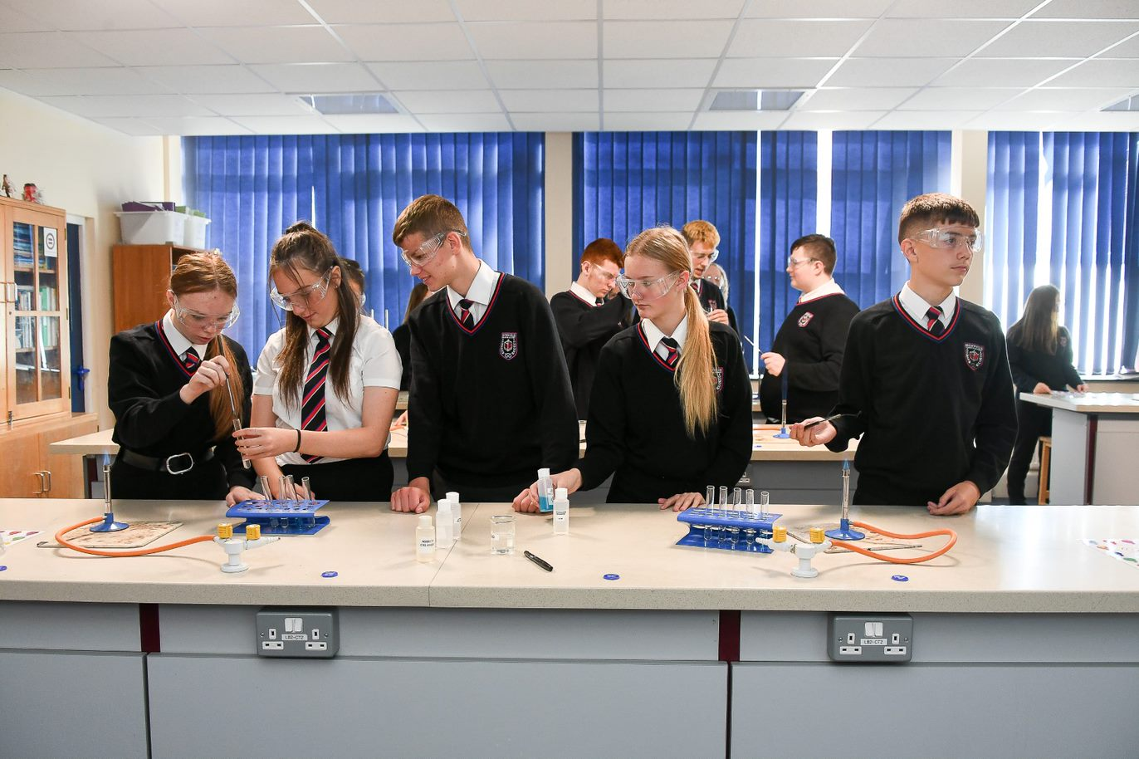
Year 11 Science (combined)

Year 11 Science (combined)
 | Autumn Term 1 |  |  | Autumn Term 2 |  |  | Spring Term 1 | Spring Term 2 |  | Summer Term 1 |  | Summer Term 2
➢  ➢  ➢  ➢  ➢  ➢  ➢ | Permanent magnets  Electromagnets  Motor effect  Flemmings left hand  rule  Uses for  electromagnets  Generators  Transformers | ➢ Mock 1 feedback and |  |  | ➢ |  | Energy | ➢ Atomic structure | ➢Revision |  | ➢ | Public examination
 |  | intervention |  |  |  | ➢ | Electricity | ➢ Mock 2 feedback and
 |  |  |  |  |  | ➢ | Particle model | intervention

Autumn Term 1 | Autumns Term 2 | Spring Term 1 | Spring Term 2 |  | Summer Term 1 | Summer term 2
➢Genetic modification  ➢Plant Hormones  ➢Food security and farming  ➢Pyramid of numbers  ➢Decay  ➢DNA  ➢Brain  ➢Mitosis | ➢cell structure and magnification  ➢Mitosis and meiosis  Mock feedback and intervention | ➢Transport in cells. Diffusion and Osmosis theory  Osmosis required practical  Therapeutic cloning using stem cells  Animal tissues, organs and organ systems | ➢Mock 2 feedback and intervention |  | ➢Revision | ➢ | Public examination

 | Autumn Term 1 |  | Autumn Term 2 |  | Spring Term 1 |  | Spring Term 2 | Summer Term 1 | Summer Term 2
➢ | Earth’s resources
 | Potable water and water treatment | ➢ Mock 1 feedback and |  | ➢ | Atomic structure and | ➢ | Chemical reactions | Revision | Public Examinations
➢ | Life cycle assessments |  | intervention |  | periodic table | ➢ | Energy changes
➢ | Identification of ions | ➢ |  | ➢ | Bonding
➢ | Hydrocarbons | ➢ | Titration calculations | ➢ | Quantitative chemistry | ➢ | Mock 2 feedback and
➢ | Alkenes | ➢ | Further quantitative |  |  |  | intervention
 |  |  | chemistry
➢
➢ | Polymers

Year 11 Textiles
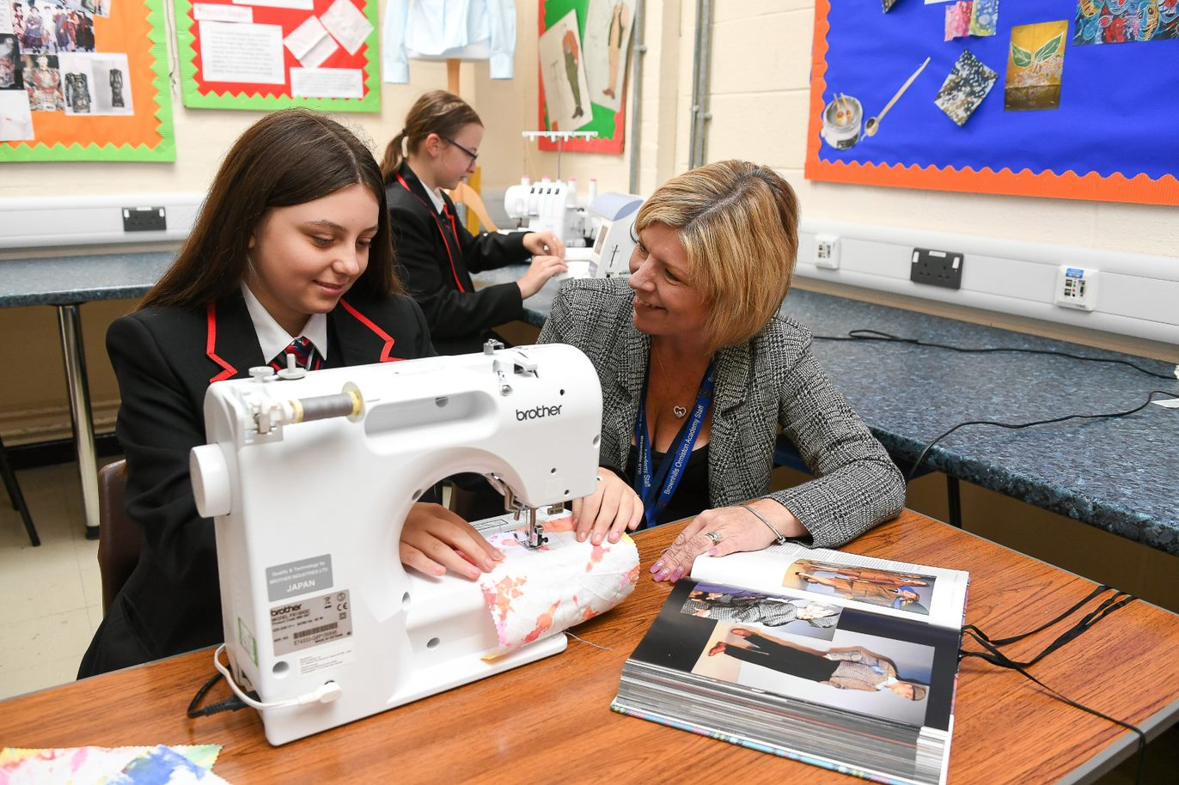

Year 11 Textiles
Autumn Term 1 | Autumn Term 2 | Spring Term 1 | Spring Term 2 | Summer Term 1 | Summer Term 2
Experimenting with appropriate media, materials and techniques  - Practice creating samples using a  - range of different techniques.  - Experiment and combine different  - techniques to see what effect they give.  - Print samples:  - Initial design ideas to show use of pattern samples.  - Record ideas, observations and insights relevant to intentions as work progresses  - Development of pattern samples experimenting with different decorative techniques.  - Combining different techniques together to produce further samples. | Present a personal and meaningful response that realises intentions and demonstrates understanding of visual language.  - Students sketch out final design planning for the use of decorative techniques.  - Record the step-by-step process of creating any  - developed sample final piece.  - Students produce final piece to include:  - A2 board of final design, coloured in and annotated. Blown up areas of detail included. Completed A4 decorative technique sample used in the garment design. | OCR COMPONENT 02 released 2nd January  (Externally set assignment)  The paper will give students a choice of five themes, each with a choice of written and/or visual starting points or stimuli. From this paper, they are expected to choose one option for which they will generate an appropriate personal response of one or more artefact(s)/product(s)/personal outcome(s) within a 10-hour supervised time period. The paper will also give the learner an opportunity to develop an extended response. | Realising intentions  Students will have up to 10 hours in which to independently realise their response(s) through the production of one or more artefact(s)/ product(s)/personal outcome(s). Within the 10-hour supervised time period, students are required to provide evidence of all assessment objectives in response to their chosen starting point or stimulus. The 10-hour supervised time period should be conducted under formal examination conditions. | Realising intentions  Students will have up to 10 hours in which to independently realise their response(s) through the production of one or more artefact(s)/ product(s)/personal outcome(s). Within the 10-hour supervised time period, learners are required to provide evidence of all assessment objectives in response to their chosen starting point or stimulus. The 10-hour supervised time period should be conducted under formal examination conditions.  Submission date 15th May.  Access practical skills:  Students' complete booklet practicing garment making finishing techniques; darts; pleating; smocking; collars; cuffs; waistbands | Public examinations

Year 11 PSHE
Autumn Term 1 | Autumn Term 2 | Spring Term 1 | Spring Term 2 | Summer Term 1 | Summer Term 2
Self-Regulation and success.  - Personal & Academic steps to success.  - Revision techniques.  - Financial literacy  - Understanding your payslip  - Your home (rent or buy?)  - Your monthly budget | Relationships and Sex Education  - Family conflict  - Long-term commitment  - Contraception  - Sexual health, fertility and parenthood  - Pregnancy  - Sexual harassment and stalking  - Sexual assault and date rape | Careers and aspirations  - Getting the basics right: Exercising, eating right & the dentist.  - More life skills: Self-examination, screening & immunisation  - Writing a good CV  - Practicing interview skills | Diversity and Equality  - Celebrating disability - explore the origins of the Paralympics  - Understanding the LGBTQ+ community and Pride  - Homophobia, Biphobia and Transphobia  - Diversity Role Models: Embracing Difference, Ending Bullying  - Brownhills TED Talk: 'Silence in the face of injustice is complicity with the oppressor' Should we be doing more? | Careers, the future and active revision | Public examinations

Year 11 Careers
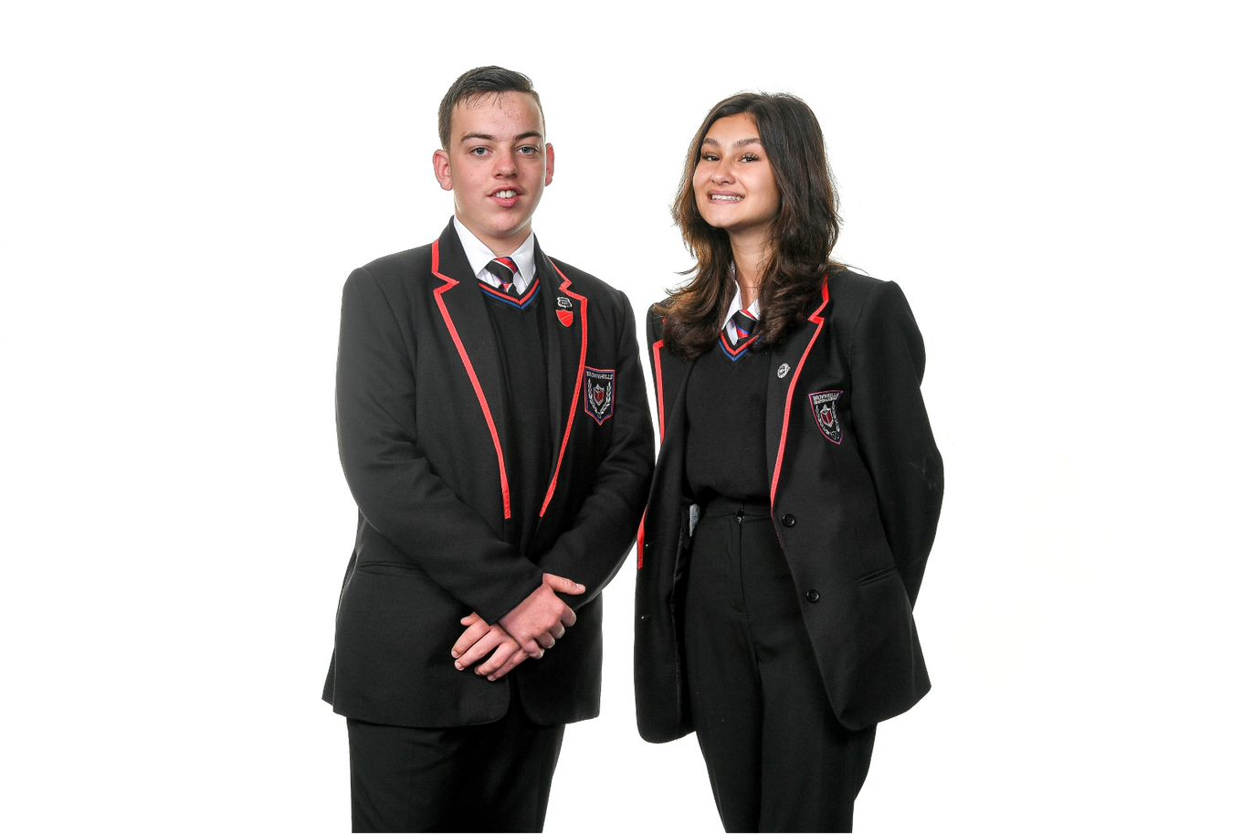
Year 11 Careers
Autumn Term 1 | Autumn Term 2 | Spring Term 1 | Spring Term 2 | Summer Term 1 | Summer Term 2
Form activity –  - Aspirations, what is your Future. Students look at former OAT students and focus on their dreams  - Your next move (post 16) (Moc)  - What is a T-Level (CB)  - What is an apprenticeship? (CB)  - Choosing Subjects (post 16) (MOC)  - Making your choice (post 16) (MOC)  1:1 Careers Guidance interviews | Careers Convention  pupils will be invited to our annual career’s convention. pupils will have the opportunity to speak with external delegates and receive bespoke advice and guidance. aspiring futures will also be present to offer impartial IAG  Form activity  - What skills are needed for different jobs? (2) (S)  - How to prepare for your interview (Afj)  - How to manage your emotions (SA)  - What is a CV? (Afj)  - How to write your CV (Afj)  - Finding opportunities to keep developing (SA)  Birmingham University Visit – 15 students  Aston Villa Football Academy talk.  1:1 Careers Guidance interviews | 6th Form Provider talks: ShireOak Academy & Aldridge School.  1:1 Careers Guidance interviews | - National Careers / Apprenticeship Weeks (March) – pupils will receive a special assembly,  - 1:1 Careers Guidance interviews | 1:1 Careers Guidance interviews | 1:1 Careers Guidance interviews

