Brownhills Ormiston Academy
Year 10 curriculum 2023-2024
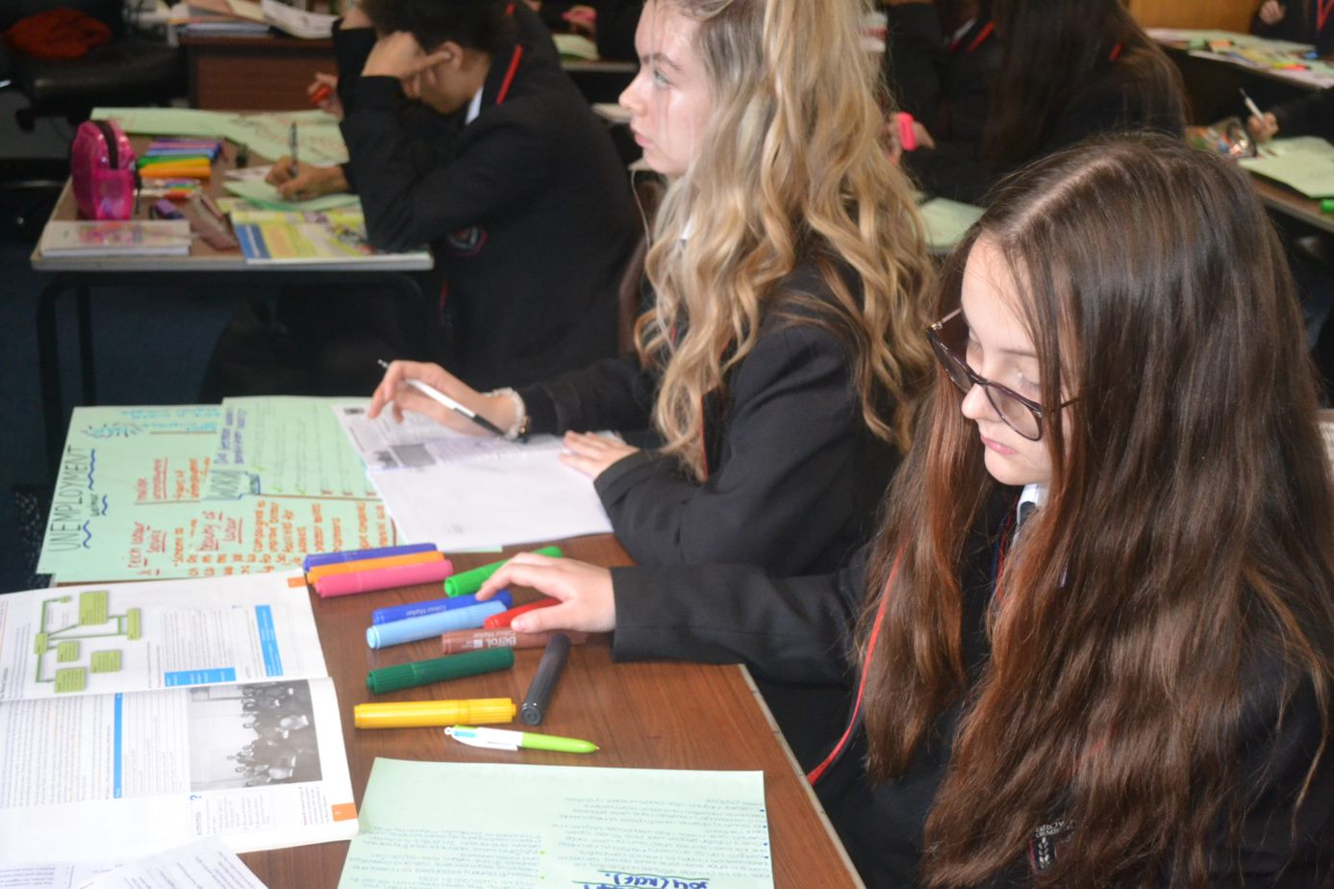

Year 10 Art

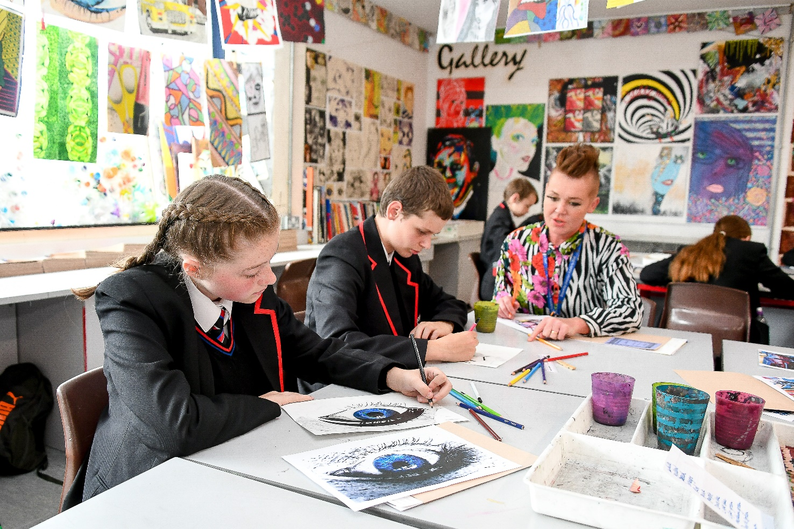
Year 10 Art
Autumn Term 1 | Autumn Term 2 | Spring Term 1 | Spring Term 2 | Summer Term 1 | Summer Term 2
OCR GCSE Art and design Fine art element.  - Portfolio work based under the project title City beach underground  - Contextual references  - Drawing  - Use of materials  - Independent skills | OCR GCSE Art and design Fine art element.  - Portfolio work based under the project title City beach underground  - Contextual references  - Drawing  - Use of materials  - Independent skills | OCR GCSE Art and design Fine art element.  - Portfolio work based under the project title City beach underground  - Contextual references  - Drawing  - Use of materials  - Independent skills | OCR GCSE Art and design Fine art element.  - Portfolio work based under the project title City beach underground  - Contextual references  - Drawing  - Use of materials  - Independent skills | OCR GCSE Art and design Fine art element.  - Portfolio work based under the project title City beach underground  - Contextual references  - Drawing  - Use of materials  - Independent skills | OCR GCSE Art and design Fine art element.  - Portfolio work based under the project title City beach underground  - Contextual references  - Drawing  - Use of materials  - Independent skills

Year 10 Information Technologies
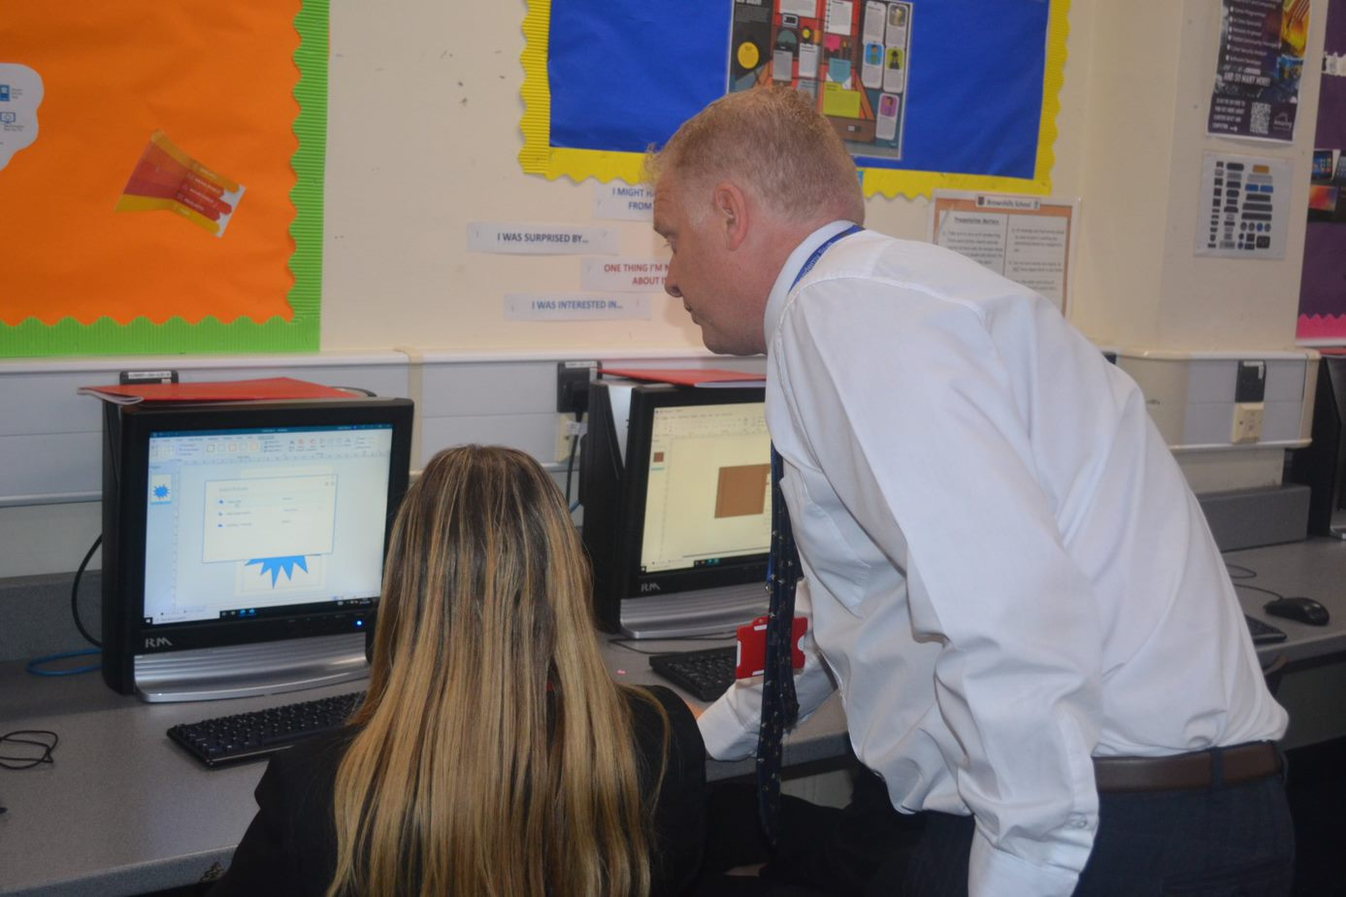
Year 10 Information Technologies

Autumn Term 1 | Autumn Term 2 | Spring Term 1 | Spring Term 2 | Summer Term 1 | Summer Term 2
WJEC Level 1/ 2 Tech Award  - Skills Audit and Recall  - Introduction to qualification  - Functionality of different hardware devices | WJEC Level 1/ 2 Tech Award  - Functionality of different software  - Databases skills and application in contexts | WJEC Level 1/ 2 Tech Award  - Use of ICT services  - Images skills and applications in contexts | WJEC Level 1/ 2 Tech Award  - Images skills and applications in contexts  - Spreadsheet skills and application in contexts | WJEC Level 1/ 2 Tech Award  - The How data and information is used and transferred | WJEC Level 1/ 2 Tech Award  - Legal, moral, ethical, cultural and environmental impacts of IT and the need for cyber security

Year 10 Business studies
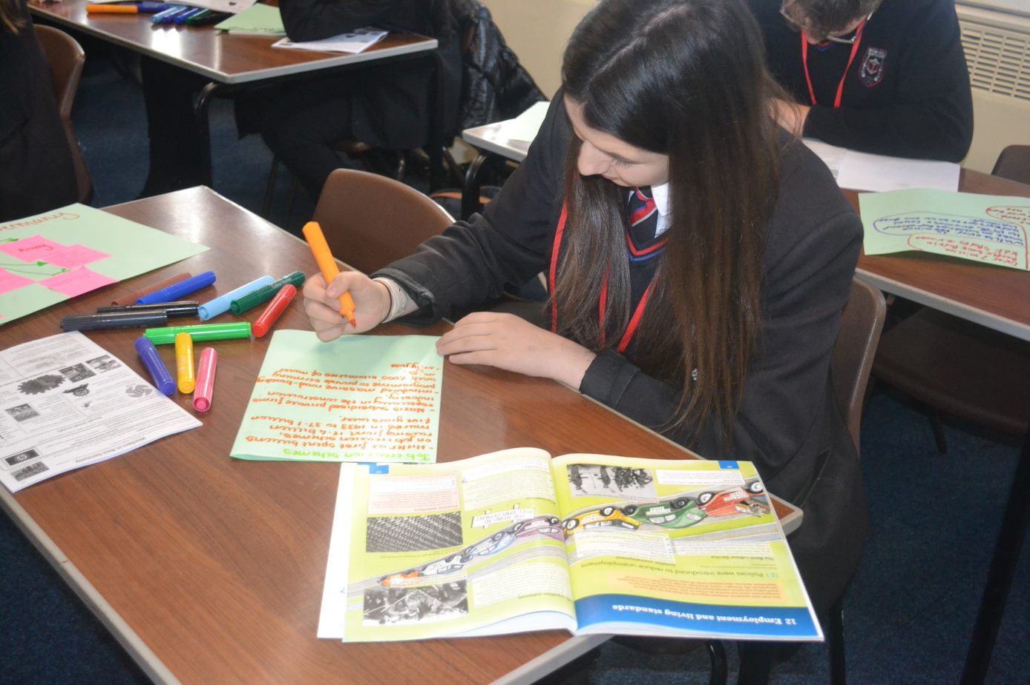
Year 10 Business Studies
Autumn Term 1 | Autumn Term 2 | Spring Term 1 | Spring Term 2 | Summer Term 1 | Summer Term 2
Cambridge National Enterprise and Marketing  R067 (TA2) Market Research to target a specific customer  R068 (TA1) Market Research  R068 (TA5)Review the likely success of the business proposal  Assessment:R067/8 | Cambridge National Enterprise and Marketing  R068 (TA2) How to identify a customer profile  R068 (TA3) Develop a product proposal  R068 (TA4) Review whether a business proposal is financially viable  R067 (TA3)What makes a product financially viable  Assessment: R067/8 | Cambridge National Enterprise and Marketing  R068 (NEA)Design a Business Proposal (Baslow Bags)  Students working independently applying knowledge from  R067: TA2, TA3  R068: TA1, TA2, TA3, TA4, TA5  Assessment: R067/8 | Cambridge National Enterprise and Marketing  R068 (NEA)Design a Business Proposal (Baslow Bags)  Students working independently applying knowledge from  R067: TA2, TA3  R068: TA1, TA2, TA3, TA4, TA5  Assessment: R067/8 | Cambridge National Enterprise and Marketing  R067 (TA4) Marketing Mix; advertising medium, promotion,  R069 (TA1) Branding; opportunities and threats  Assessment: R067 | Cambridge National Enterprise and Marketing  R067 (TA4) PR; Selling; product lifecycle; pricing and strategies  R069 (TA2) Promotional plan and materials  Assessment (R069): Students to complete Business Pitch Proposal

Year 10 English
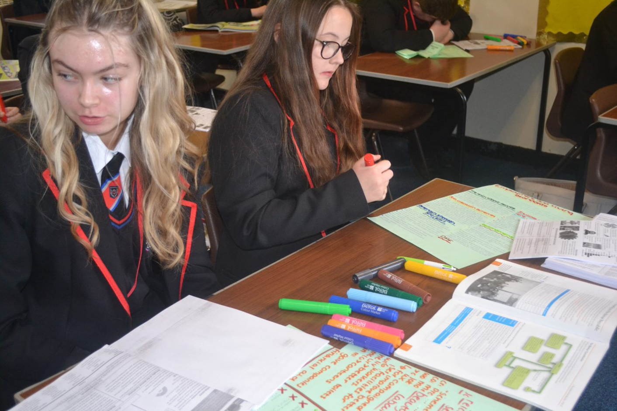
Year 10 English
Autumn Term 1 | Autumn Term 2 | Spring Term 1 | Spring Term 2 | Summer Term 1 | Summer Term 2
Transformation and Redemption:  Edexel Literature Paper 2 and AQA Language Paper 1  - Set text: A Christmas Carol by Charles Dickens  - Study will include close analysis off textual extracts as well as focussing on plot, character, themes and language.  - AQA English Language GCSE Paper 1 Explorations In Reading and Writing will be taught alongside the Literature text using practice texts | Continuation of study of Transformation and Redemption:  Edexel Literature Paper 2 and AQA Language Paper 1  - Set text: A Christmas Carol by Charles Dickens  - Study will include close analysis off textual extracts as well as focussing on plot, character, themes and language.  - AQA English Language GCSE Paper 1 will be taught alongside the Literature text using practice texts | Ambition and Guilt: Edexel Literature Paper 1 and AQA Language Paper 1 and 2  - Set text: Macbeth by William Shakespeare  - Study will include close analysis off textual extracts as well as focussing on plot, character, themes and language.  - AQA English Language Paper 1 and 2: Viewpoints and Perspectives- non-fiction texts | Continuation of study of Ambition and Guilt: Edexcel Literature Paper 1 and AQA Language Paper 2  - Set text: Macbeth by William Shakespeare  - Study of plot, character, themes, language and form.  - AQA English Language Paper 2: Viewpoints and Perspectives- non-fiction texts | Social Responsibility: Edexcel Literature Paper 1 and AQA Language Paper 2  - Set text: An Inspector Calls by J.B. Priestley  - Study will include close analysis off textual extracts as well as focussing on plot, character, themes and language.  - AQA English Language Paper 2: Viewpoints and Perspectives- non-fiction texts | Continuation of study Social Responsibility: Edexcel Literature Paper 1 and AQA Language Paper 2  - Set text: An Inspector Calls by J.B. Priestley  - Study of plot, character, themes, language and form.  - AQA English Language Paper 2: Viewpoints and Perspectives- non-fiction texts  English Speaking Exams  PPE1

Year 10 French
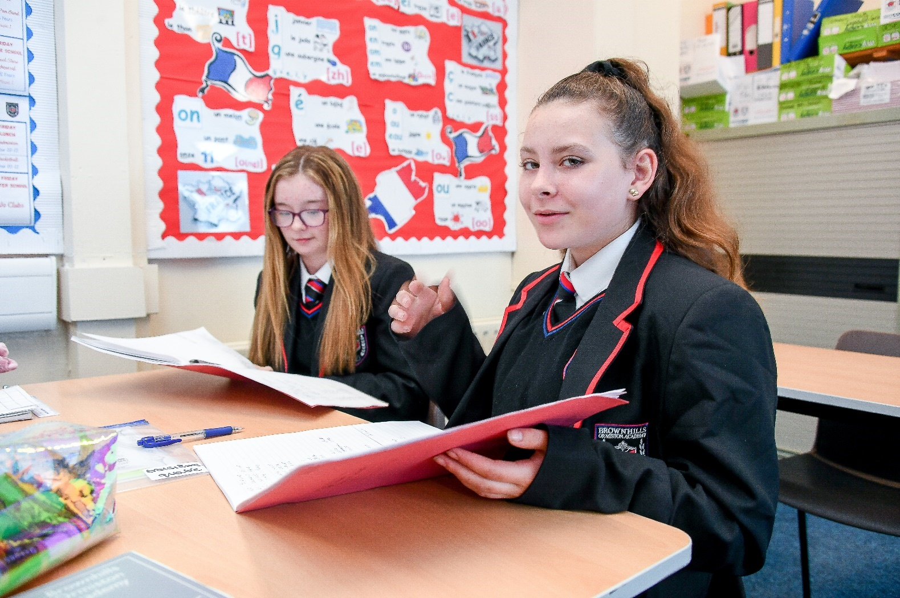
Year 10 French
Autumn term 1 | Autumn term 2 | Spring term 1 | Spring term 2 | Summer term 1 | Summer term 2
Moi, ma famille, mes amis et quand je fais la fête!  - Describing relationships  - Qualities of a best friend  - Food and festivals  Grammar, skills and phonics  - Comparison and superlative  - Exam skills  - Si clause  - Study of literary texts  - Idioms  - Listening for gist  - Photo card with P.A.L.M.O.J  - Reflexive verbs  - Writing with A.C.T.I.O.N. J.A.C  - Phonics:  Review on how to pronounce simple vowels  [a], SFE  [e] [é/er/ez] [è/ê/ai],open [o] [closed o/ô] [au/eau], [u] [ou] | Le temps des loisirs  - Talking about sports  - Opinions on TV programs  - Activities online  Grammar, skills and phonics  - Simple future tense with high frequency verbs (most common)  - Imperfect tense (whole paradigm)  - Literary texts  - Photo card with P.A.L.M.O.J  - Writing with A.C.T.I.O.N. J.A.C  - Depuis + present tense  - Idioms  - Exam skills  - Use of après avoir + past participle  - Use of impersonal structures  - Listening for gist  - Phonics:  Review [u] [ou]  [Closed eu] [open eu/œu], silent final [e], [i/y], è / ê /[u] [ou], silent final consonant(SFC), CaReFuL consonants | Ce qui m’intéresse quand je suis en vacances  - Holiday preferences  - accommodation  - Holiday activities, buying souvenirs and means of transport  - Big events on holiday  Grammar, skills and phonics  - Conditional tense (1st pers sing & plur)  - Reflexive in perfect tense (implicit)  - Combining all tenses  - Literary texts  - ‘en’ + present participle  - Use of triple verbs  - Using comparisons  - Photo card with P.A.L.M.O.J  - Writing with A.C.T.I.O.N. J.A.C  - Using idioms  - Listening for gist  - Phonics:  words ending with –ent,  [h muet] [h aspiré]  C, [j / soft g] [hard g] [gn], [ss / soft s] [hard s/z] | Des vacances de rêves ou cauchemar?  - A dreadful town  - Holiday disasters  - Weather phrases  - Eating out  - A dream holiday  Grammar, skills and phonics  - Avant de + infinitive  - après avoir/être + pp  - Expressions with avoir  - Pluperfect tense  - Literary texts  - Translating & identifying 5 tenses  - Role plays GCSE style  - Photo card with P.A.L.M.O.J  - Writing with A.C.T.I.O.N. J.A.C  - Simple future (common verbs)  - Phonics:  [r] [ch] [qu] [th],Liaisons  [oi] [oy], [ain/in/aim/im]  [en/an/em/am], [on/om] | Mon bahut et ce qui me préoccupe  - Your school and schools in France  - School rules (for & against)  - School activities and successes  - A recent outing with your school  - A cultural event  Grammar, skills and phonics  - Direct object pronouns  - imperative  Il faut/il est interdit + infinitive  - The conditional tense (whole paradigm)  - Photo card with P.A.L.M.O.J  - Dictations  - Writing with A.C.T.I.O.N. J.A.C  - Role play skills  - Literary texts analysis  - Giving detailed justifications & using idioms  - Phonics:  [un/um],[ien],[tion]  [-aill-/-ail],[-ill-/-ille],[-eill-/-eil],[-euill-/-euil/-ueill-/-ueil/-œill-/-œil]  Elision with [h] | Mon destin, mes plans  pour mon avenir  - Career choices and orientation  - Studying languages is an asset  - Future employment and community projects  Grammar, skills and phonics  - Using the subjunctive (implicitly)  - The conditional tense (whole paradigm)  - Combining all tenses  - Exam skills  - Literary texts analysis  - Using idioms and higher structures  - Photo card with P.A.L.M.O.J  - Writing with A.C.T.I.O.N. J.A.C  - Phonics:  [-ouill-/-ouil]  Reviewing SFC, SFE  au/eau, [th], [oi],  words ending with –ent  Syllables and stress

Year 10 Geography

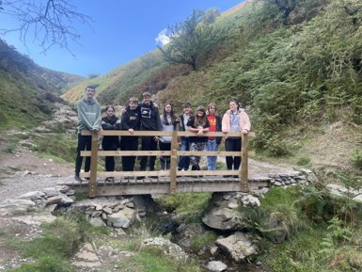
Autumn Term 1  Year 10 Geography | Autumn Term 2 | Spring Term 1 | Spring Term 2 | Summer Term 1 | Summer Term 2
Natural hazards/tectonic hazards:  - Global distribution of earthquakes and volcanic eruptions and their relationship to plate margins.  - Physical processes taking place at different types of plate margin (constructive, destructive and conservative) that lead to earthquakes and volcanic activity.  - Primary and secondary effects of a tectonic hazard.  - Immediate and long-term responses to a tectonic hazard.  - Use named examples to show how the effects and responses to a tectonic hazard vary between two areas of contrasting levels of wealth.  - Management can reduce the effects of a tectonic hazard.  - Reasons why people continue to live in areas at risk from a tectonic hazard.  - How monitoring, Prediction, protection and planning can reduce the risks from a tectonic hazard. | Weather hazards:  - Global distribution of tropical storms (hurricanes, cyclones, typhoons).  - An understanding of the relationship between tropical storms and general atmospheric circulation.  - Causes of tropical storms and the sequence of their formation and development.  - The structure and features of a tropical storm.  - How climate change might affect the distribution, frequency and intensity of tropical storms.  - Primary and secondary effects of tropical storms.  - Immediate and long-term responses to tropical storms.  - Use a named example of a tropical storm to show its effects and responses.  - How monitoring, prediction, protection and planning can reduce the impacts.  - An example of a recent extreme weather event in the UK to illustrate:  - causes  - social, economic and environmental impacts  - how management strategies can reduce risk.  - Evidence that weather is becoming more extreme in the UK.  - Evidence for climate change from the beginning of the Quaternary period to the present day.  - Possible causes of climate change:  - natural factors – orbital changes, volcanic activity and solar output  - human factors – use of fossil fuels, agriculture and deforestation.  - Overview of the effects of climate change on people and the environment. | - Changing economic world: Nigeria  - Different ways of classifying parts of the world according to their level of economic development and quality of life.  - Different economic and social measures of development: gross national income (GNI) per head, birth and death rates, infant mortality, life expectancy, people per doctor, literacy rates, access to safe water, Human Development Index (HDI).  - Limitations of economic and social measures.  - Link between stages of the Demographic Transition Model and the level of development.  - Causes of uneven development: physical, economic and historical.  - Consequences of uneven development: disparities in wealth and health, international migration.  - An overview of the strategies used to reduce the development gap: investment, industrial development and tourism, aid, using intermediate technology, fairtrade, debt relief, microfinance loans.  - An example of how the growth of tourism in an LIC or NEE helps to reduce the development gap.  - A case study of one LIC or NEE to illustrate:  - the location and importance of the country, regionally and globally  - the wider political, social, cultural and environmental context within which the country is placed  - the changing industrial structure. The balance between different sectors of the economy. How manufacturing industry can stimulate economic development  - the role of transnational corporations (TNCs) in relation to industrial development. Advantages and disadvantages of TNC(s) to the host country  - the changing political and trading relationships with the wider world  - international aid: types of aid, impacts of aid on the receiving country  - the environmental impacts of economic development  - the effects of economic development on quality of life for the population. | Changing UK Economy:  - Economic futures in the UK:  - causes of economic change: de-industrialisation and decline of traditional industrial base, globalisation and government policies  - moving towards a post-industrial economy: development of information technology, service industries, finance, research, science and business parks  - impacts of industry on the physical environment. An example of how modern industrial development can be more environmentally sustainable  - social and economic changes in the rural landscape in one area of population growth and one area of population decline  - improvements and new developments in road and rail infrastructure, port and airport capacity  - the north–south divide. Strategies used in an attempt to resolve regional differences th place of the UK in the wider world. Links through trade, culture, transport, and electronic communication. Economic and political links: the European Union (EU) and Commonwealth. | Rivers:  - The long profile and changing cross profile of a river and its valley.  - Fluvial processes: erosion – hydraulic action, abrasion, attrition, solution, vertical and lateral erosion. Transportation – traction, saltation, suspension and solution. Deposition – why rivers deposit sediment.  - Characteristics and formation of landforms resulting from erosion – interlocking spurs, waterfalls and gorges.  - Characteristics and formation of landforms resulting from erosion and deposition – meanders and ox-bow lakes.  - Characteristics and formation of landforms resulting from deposition – levées, flood plains and estuaries.  - An example of a river valley in the UK to identify its major landforms of erosion and deposition.  - How physical and human factors affect the flood risk – precipitation, geology, relief and land use.  - The use of hydrographs to show the relationship between precipitation and discharge.  - The costs and benefits of the following management strategies:  - hard engineering – dams and reservoirs, straightening, embankments, flood relief channels  - soft engineering – flood warnings and preparation, flood plain zoning, planting trees and river restoration.  - An example of a flood management scheme in the UK to show:  - why the scheme was required  - the management strategy  the social, economic and environmental issues. | Coasts:  - How geological structure and rock type influence coastal forms.  - Characteristics and formation of landforms resulting from erosion – headlands and bays, cliffs and wave cut platforms, caves, arches and stacks.  - Characteristics and formation of landforms resulting from deposition – beaches, sand dunes, spits and bars.  - An example of a section of coastline in the UK to identify its major landforms of erosion and deposition.  - The costs and benefits of the following management strategies:  - hard engineering –  - soft engineering – beach nourishment and reprofiling, dune regeneration  - managed retreat – coastal realignment.  - An example of a coastal management scheme in the UK to show:  - the reasons for management the management strategy  - the resulting effects and conflicts.

Year 10 History
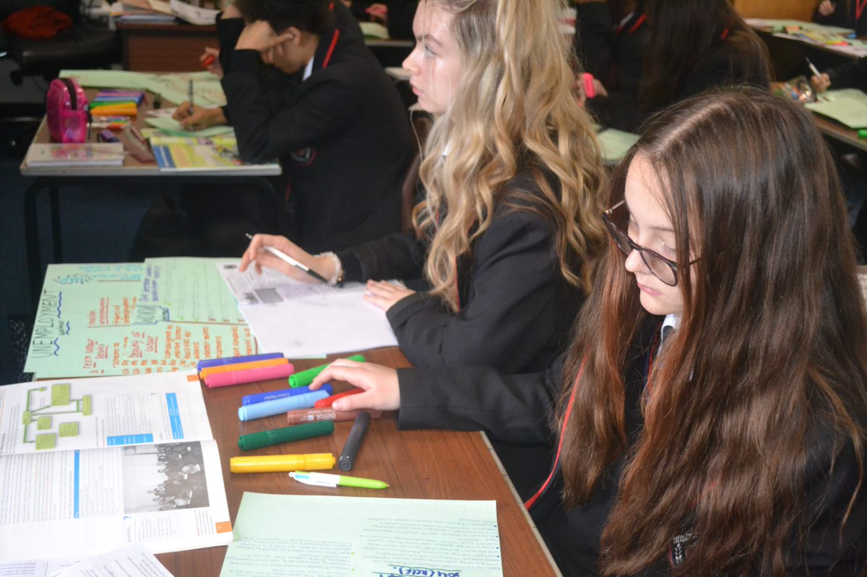
Year 10 History
Autumn Term 1 | Autumn Term 2 | Spring Term 1 | Spring Term 2 | Summer Term 1 | Summer Term 2
Crime and punishment c1750-present  - Whitechapel environment study  - Social conditions in Whitechapel between 1870 and 1900  - Poverty in Whitechapel  - What was Whitechapel like to live in?  - Whitechapel workhouse a d Casual ward  - The Peabody estate  - Victorians and the fear of crime in the East End  - Immigration problems  - Police force and how they were split in divisions  - The working of the Metropolitan Police  - Police commissioners and the Home Secretary  - The organisation of the police force in Whitechapel  - Difficulties in policing in Whitechapel  - High profile crimes that included the Jack the Ripper case | Crime and punishment c1750-present  - How did the press make it more difficult for the police to investigate the Ripper case?  - Did the city and Metropolitan police work well together?  - Modern crime and punishment  - Smuggling and drug offences  - Case study: Were conscientious objectors really “cowards and cads”  - What have been the biggest changes to policing since 1900?  - Have Prisons changed since 1900?  - How effectively do we deal with young offenders?  - Case study: Why is the Derek Bentley case remembered today?  - Why was death Penalty abolished in 1965?  - Skills and Concepts:  - Students will be assessed on their knowledge and understanding, with questions focusing on similarity and difference, and change and continuity. This may include turning points (significance), extent of, and causes or consequences of change  - The thematic studies require students to understand change and continuity across a long sweep of history, including the most significant characteristics of different ages from the medieval to modern periods. They include people, events and developments and reveal wider changes in aspects of society over the centuries and allow comparisons to be made between different periods of history | Early Elizabethan England 1558-88  - Elizabeth's situation  - Elizabeth's religious settlement  - Challenges to Elizabeth  - The situation on Elizabeth’s accession Elizabethan England in 1558: society and government.  - The Virgin Queen: the problem of her legitimacy, gender, marriage. Her character and strengths.  - Challenges at home and from abroad: the French threat, financial weaknesses.  - The ‘settlement’ of religion  - Religious divisions in England in 1558.  - Elizabeth’s religious settlement (1559): its features and impact.  - The Church of England: its role in society. 3 Challenge to the religious settlement  - The nature and extent of the Puritan challenge.  - The nature and extent of the Catholic challenge, including the role of the nobility, Papacy and foreign powers. 4 The problem of Mary, Queen of Scots  - Mary, Queen of Scots: her claim to the English throne, her arrival in England in 1568.  - Relations between Elizabeth and Mary, 1568–69.  - Concepts and Skills:  - require students to understand the complexity of a society or historical situation and the interplay of different aspects within it. Depending on the depth study chosen, these may include social, economic, political, religious and military aspects | Early Elizabethan England 1558-1588  - Relations with Spain  - Plots and revolts at home  - The reasons for, and significance of, the Revolt of the Northern Earls, 1569–70.  - The features and significance of the Ridolfi, Throckmorton and Babington plots. Walsingham and the use of spies.  - The reasons for, and significance of, Mary Queen of Scots’ execution in 1587. 2 Relations with Spain  - English direct involvement in the Netherlands, 1585–88. The role of Robert Dudley.  - Drake and the raid on Cadiz: ‘Singeing the King of Spain’s beard’. 4 The Armada  - Spanish invasion plans. Reasons why Philip used the Spanish Armada.  - Concepts and Skills:  - Students will be assessed on their knowledge and understanding. Questions will target key features and causation, and may also target other second order concepts (change, continuity, consequence, similarity, difference, significance) | Early Elizabethan England 1558-1588 and Cold War tension 1941-58  - The reasons for, and consequences of, the English victory.  - Political and religious rivalry.  - Education and the poor  - Raleigh and America  - Commercial rivalry. The New World, privateering and the significance of the activities of Drake. 3 Outbreak of war with Spain, 1585–88  - The Grand Alliance. The outcomes of the Tehran, Yalta and Potsdam conferences.  - The ideological differences between the superpowers and the attitudes of Stalin, Truman and Churchill. The impact on US-Soviet relations of the development of the atomic bomb, the Long and Novikov telegrams and the creation of Soviet satellite states in Eastern Europe. 2 The development of the Cold War  - The impact on US-Soviet relations of the Truman Doctrine and the Marshall Plan, 1947.  - The significance of Cominform (1947), Comecon (1949) and the formation of NATO (1949).  - Berlin: its division into zones. The Berlin Crisis (blockade and airlift) of 1948-49 and its impact. The formation of the Federal Republic of Germany and German Democratic Republic.  - The significance of the arms race. The formation of the Warsaw Pact.  - Events in 1956 leading to the Hungarian Uprising, and Khrushchev’s response.  - The international reaction to the Soviet invasion of Hungary | Cold War  1958-70  - The refugee problem in Berlin, Khrushchev’s Berlin ultimatum (1958), and the summit meetings of 1959–61. Soviet relations with Cuba, the Cuban Revolution and the refusal of the USA to recognise Castro’s government.  - The significance of the Bay of Pigs incident. Opposition in Czechoslovakia to Soviet control: the Prague Spring  - The construction of the Berlin Wall, 1961. The events of the Cuban Missile Crisis.  - The Brezhnev Doctrine and the re-establishment of Soviet control in Czechoslovakia.  - Impact of the construction of the Berlin Wall on US-Soviet relations. Kennedy’s visit to West Berlin in 1963. The consequences of the Cuban Missile Crisis, including the ‘hotline’. Attempts at arms control: the Limited Test Ban Treaty (1963); the Outer Space Treaty (1967); and the Nuclear Non-Proliferation Treaty (1968). International reaction to Soviet measures in Czechoslovakia  - The end of the cold war 1970-71  - Détente in the 1970s, SALT 1, Helsinki, and SALT 2.  - The significance of Reagan and Gorbachev’s changing attitudes.  - Gorbachev’s ‘new thinking’ and the Intermediate-Range Nuclear Force (INF) Treaty (1987).  - The significance of the Soviet invasion of Afghanistan, the Carter Doctrine and the Olympic boycotts.  - Reagan and the ‘Second Cold War’, the Strategic Defence Initiative The impact of Gorbachev’s ‘new thinking’ on Eastern Europe: the loosening Soviet grip on Eastern Europe.  - The significance of the fall of the Berlin Wall.  - The collapse of the Soviet Union and its significance in bringing about the end of the Warsaw Pact.

Year 10 Health and Social
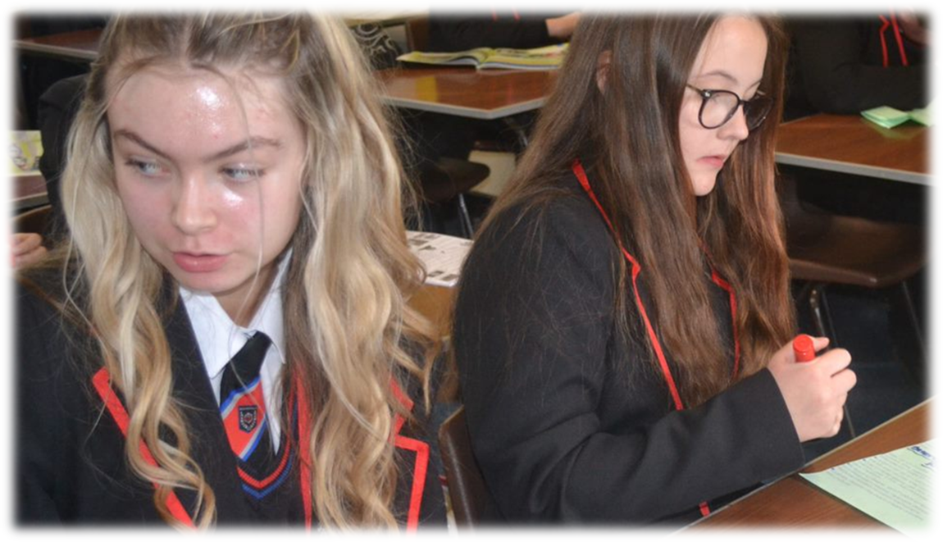
Year 10 Health and Social
Important Information: Component 1 and 2 Assignment Tasks are released by the exam board and are referred to as PSA (Pearson Set Assignments) Tasks throughout the document
 | Autumn 1 | Autumn 2 | Spring 1 | Spring 2 | Summer 1 | Summer 2
Year 1 | COMPONENT 1 - HUMAN LIFESPAN DEVELOPMENT  Focus on PSA Task 1Growth and development across the life stages using the physical, intellectual, emotional and social (PIES) classification.  - Life stages Infancy / early childhood / Adolescence / Adulthood  - Development Physical, Intellectual, emotional, and social development (PIES)  Component 1 Assignment Tasks  Assessments will take place at the end of this half term comparing growth and development across 2 life stages | COMPONENT 1 - HUMAN LIFESPAN DEVELOPMENT  Focus on PSA Task 2 (part 1)The different factors that can affect an individual’s growth and development.  - Physical, lifestyle, emotional, social, cultural, environmental, economic factors  Focus on PSA Task 2 (part 2)The impact of different factors on PIES growth and development through the life stages (order of this may vary depending on the exam board release information (PSA’s) and what factors have been chosen previously by them)  Component 1 Assignment Tasks Assessments will take place at the end of this half term looking at the impact of 1 factor on growth and development | COMPONENT 1 - HUMAN LIFESPAN DEVELOPMENT  (PSA released in January; completed by May; 5 tasks)  PSA Task 1 + 2 :  Controlled assessment conditions  (4 weeks)  PSA Task 1: growth and development across the life stages  PSA Task 2: The impact of different factors on PIES growth and development through the life stages  Resubmission opportunity given for each task  Focus on PSA Task 3+4  Preparation of class notes in readiness for assignment:  The impact of life events on PIES growth and development and how individuals adapt to life event  - Relationships (marriage, divorce, civil partnership, parenthood, bereavement, Life circumstances (Imprisonment, redundance, retirement, exclusion form school) | COMPONENT 1 - HUMAN LIFESPAN DEVELOPMENT  PSA Task 3 :  (PSA specific life event chosen by exam board)  Controlled assessment conditions;  (3 weeks)  PSA Task 3: The impact of 1 life event on PIES growth and development on 2 individuals Resubmission opportunity given  Focus on PSA Task 4a  How individuals adapt to life event  Preparation of class notes in readiness for PSA task 4a/b  - Coping and adapting to change  PSA Task 4a :  Controlled assessment conditions  PSA Task 4a: How 2 individuals cope and adapt to their life event  (3 weeks)  Resubmission opportunity given for each task | COMPONENT 1 - HUMAN LIFESPAN DEVELOPMENT  Focus on PSA Task 4b The impact of character traits (self esteem, emotional intelligence, disposition) and how individuals adapt to life events (preparation of class notes in readiness for PSA task 4b)  PSA Task 4b :Controlled assessment conditions The impact of character traits (self esteem, emotional intelligence, disposition on 2 persons ability to cope and adapt to their life event  (3 weeks) Resubmission opportunity given for each task Moderation sample May 1st  COMPONENT 2 - HEALTH & SOCIAL CARE SERVICES & VALUES : Health conditions and services for users to access  - Arthritis, CHD, COPD, Diabetes, Dementia, Obesity, Asthma  - Healthcare services:  Primary, secondary, tertiary care, allied health professions, multidisciplinary teams  - GP, Dentist, Opticians  - Social care services  Social worker, services for children and young people, services for adults or children with specific needs, informal care voluntary care | COMPONENT 2 - HEALTH & SOCIAL CARE SERVICES & VALUES  Barriers that can make it difficult to use these services and how these barriers can be overcome.  - Physical barriers, Social and cultural barriers, language barriers, geographical barriers, intellectual barriers  - Financial barriers  Values in health and social care that are required when planning and delivering care and the obstacles individuals may face.  - The 6C’s  Care, compassion, competence, communication, courage, commitment  - Obstacles  Emotional obstacles, work and family commitments, availability of resources, unachievable targets, lack of support, ability/disability, health conditions, addiction

Year 10 Hospitality
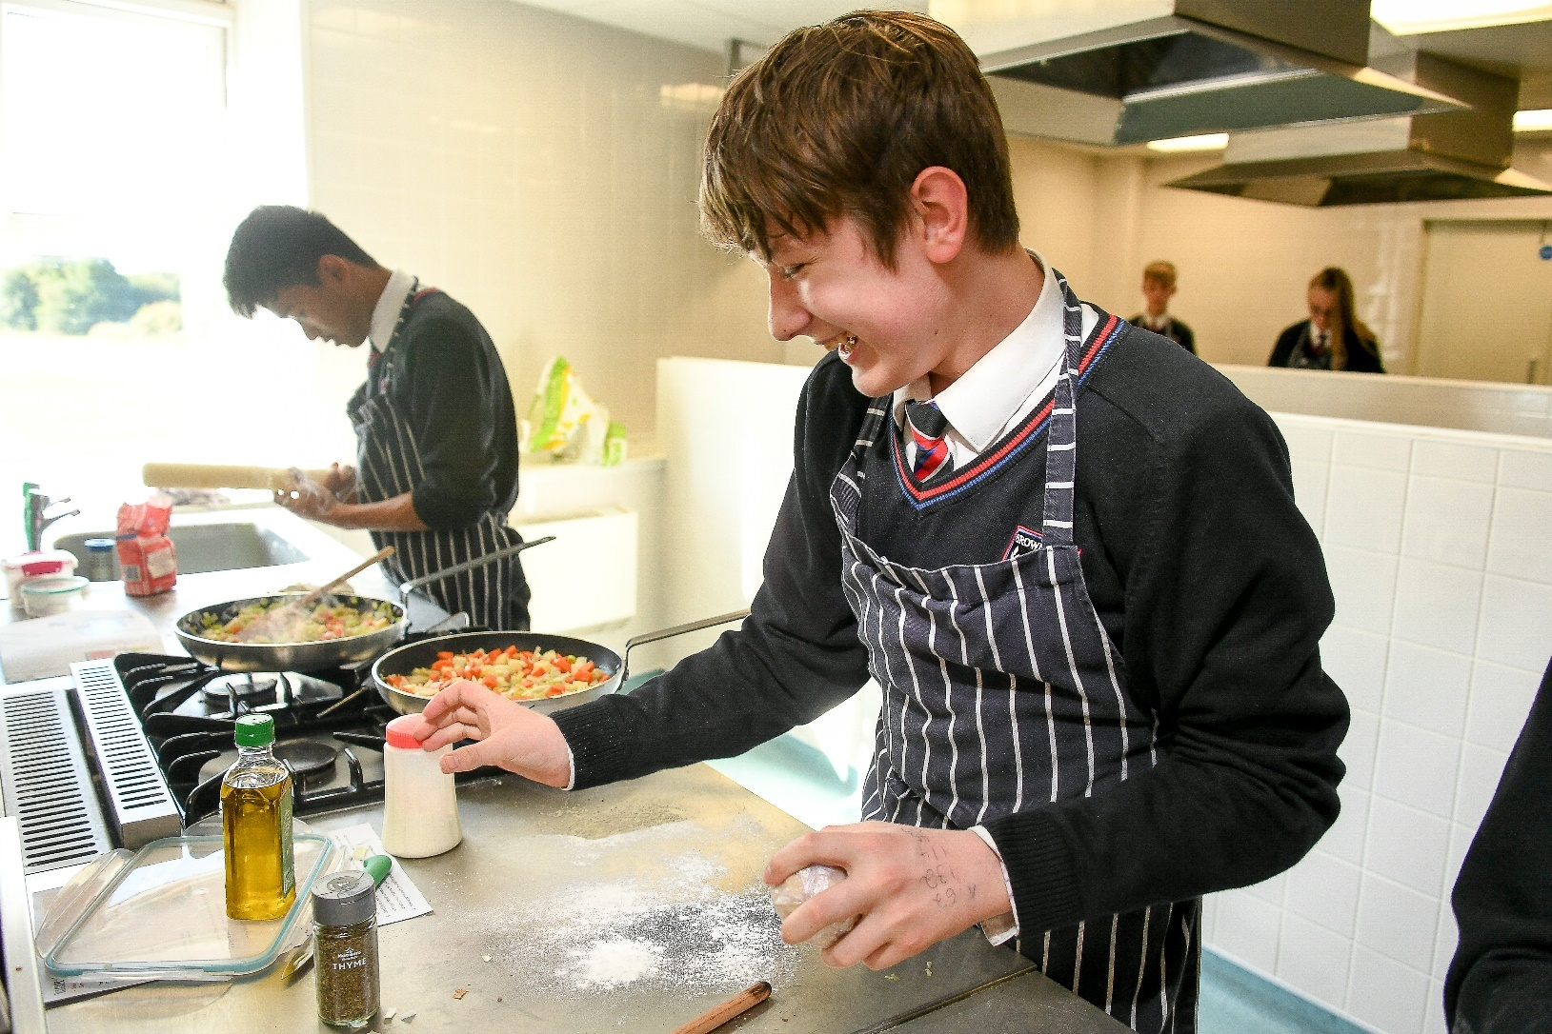
Year 10 Hospitality
Autumn Term 1 | Autumn Term 2 | Spring Term 1 | Spring Term 2 | Summer Term 1 | Summer Term 2
Unit: Food safety in the hospitality and catering industry  - Students study this topic first in order to build up a bank of fundamental food safety knowledge which will help them to apply safe working practises to all of their practical lessons.  Topics of study:  - Food related causes of ill health (including contamination such as bacteria, chemicals and also allergies and intolerances).  - The different types of food poisoning.  - Symptoms and signs of food-induced ill health (visible and non-visible)  - Control measures to prevent food-induced ill health.  Skills:  - Applying control measures in practical lessons (personal hygiene, correct storage, controlling cross contamination, temperature control etc)  Practical skills: Autumnal themed recipes  - The skills focused on are:  - Weighing and measuring  - Knife skills  - Pastry skills  - Confidence, independence and accuracy with using a range of equipment. | - Continuation of Food safety in the hospitality and catering industry unit:  Topics of study:  - Principles of Hazard Analysis and Critical Control Points (HACCP).  - Food safety legislation, including food labelling laws, food safety legislation food hygiene regulations  - The role of the Environmental Health Officer (EHO) and their responsibilities.  Skills  - Generating HACCP documents for establishments  - Applying control measures in practical lessons (personal hygiene, correct storage, controlling cross contamination, temperature control etc)  Practical skills: Autumnal themed recipes  - The skills focused on are:  - Weighing and measuring  - Knife skills  Pastry skills  - Confidence, independence and accuracy with using a range of equipment. | Unit: Hospitality and catering provision  - Students study this topic at this point as it helps to build on their understanding of terminology used when referring to the hospitality and catering industry. This helps them to access learning later on in the course of study and think more deeply about specific establishments and their setup.  Topics of study:  - Different types of hospitality and catering provision: commercial and non-commercial.  - Types of service in commercial and non-commercial provision: food services and residential services. (Including various types of food service, e.g. table service)  - Standards and rating systems used for hotels and restaurants.  - Job roles and responsibilities in the hospitality and catering industry.  - Dress codes in the hospitality industry.  Skills  - Being able to compare provision in different establishment types.  Practical skills: Spring themed recipes  - Ongoing: weighing and measuring/knife skills with focus on improving accuracy and confidence.  - Exploring differences between cooking methods  - Piping  - Laminating dough  - Mashing | Continuation of Hospitality and catering provision unit:  Topics of study:  - Personal attributes, qualifications and experience an employer would look for.  - Types of employment contracts and working hours: casual, full time permanent, part-time, temporary, seasonal, zero hours contract.  - Remuneration and benefits in the industry.  - Fluctuating needs of the industry, such as: supply and demand: staffing during peak times, large events, seasonal times and the location of the provision.  - Factors contributing to the success of hospitality and catering provision (costs, labour, environmental factors, technology, the media etc)  - Analysing and evaluating how factors such as the media can impact the success of an establishment.  - Comparing employment needs of various establishments.  Practical skills: Spring themed recipes  - Ongoing: weighing and measuring/knife skills with focus on improving accuracy and confidence.  - Exploring differences between cooking methods  - Piping  - Laminating dough  Mashing | Unit: How hospitality and catering provisions operate  Topics of study:  - The workflow of the front of house.  - The workflow of a catering kitchen.  - Equipment and materials used and managed within catering provision/kitchens including large and small equipment and utensils.  - •The documentation and administration requirements used in a catering kitchen.  - •How hospitality and catering establishments meet customer needs (including equality/disability)  - Skills  - •Describing what makes a successfully layout and the impact this has on workflow.  Practical skills: Summer themed recipes  - Ongoing: weighing and measuring/knife skills with focus on improving accuracy and confidence. Exploring different cooking methods.  - Shaping mixtures  - Portioning/deboning  - Emulsification/gelatinisation  - Unmoulding | Unit: Health and safety in hospitality and catering  Topics of study:  - The responsibility of employers and employees in relation to health and safety laws:  - COSHH  - HASAWA  - MHOR  - PPER  - RIDDOR.  - The level of risk.  - The importance of and be able to complete the following documentation: accident forms and risk assessments.  Skills  - Being able to suggest appropriate training/health and safety measures for specific circumstances relevant to industry.  Practical skills: Summer themed recipes  - Ongoing: weighing and measuring/knife skills with focus on improving accuracy and confidence. Exploring different cooking methods.  - Shaping mixtures  - Portioning/deboning  - Emulsification/gelatinisation  - Unmoulding

Year 10 Maths


Year 10 Maths
 | Autumn Term 1 |  | Autumn Term 2 |  | Spring Term 1 | Spring Term 2 |  |  |  | Summer Term 1 |  | Summer Term 2
 | Similarity |  | Developing Algebra |  | Geometry |  | Ratio & Probability |  |  | Delving into data |  | Using number
➢ | Congruence & | ➢ | Equations & | ➢ | Angles & Bearings |  |  |  | ➢ | Collecting, | ➢ | Non calculator
 | Similarity |  | inequalities | ➢ | Understand and use | ➢ | Ratios & Fractions |  |  | representing and |  | methods
➢ | Identify congruent | ➢ | Form and solve |  | bearings to solve | ➢ | Combine ratios |  |  | interpreting data | ➢ | Work with exact
 | and similar shapes |  | inequalities in a |  | problems | ➢ | Solve complex ratio |  | ➢ | Understand |  | answers
➢ | Use similarity to find |  | range of contexts | ➢ | Use bearings with |  | problems in a variety |  |  | sampling | ➢ | Evaluate
 | missing sides & | ➢ | Represent solutions |  | the trigonometric |  | of contexts |  | ➢ | Understand, |  | calculations
 | angles |  | graphically |  | formulae | ➢ | Percentages & |  |  | represent and | ➢ | Calculate with surds
➢ | Use similarity to | ➢ | Simultaneous | ➢ | Working with circles |  | Interest |  |  | interpret data in a | ➢ | Types of number &
 | investigate area and |  | Equations | ➢ | Find area, surface | ➢ | Solve percentage |  |  | range of charts and |  | sequences
 | volume | ➢ | Form and solve |  | area and volume of |  | change problems |  |  | tables | ➢ | Recognise and use
➢ | Trigonometry |  | simultaneous |  | cylinders, cones and |  | including reverse |  | ➢ | Compare |  | arithmetic, geometric
➢ | Use trigonometric |  | equations |  | spheres |  | percentages |  |  | distributions |  | and other
 | ratios with right- | ➢ | Solve simultaneous | ➢ | Use the circle | ➢ | Solve compound |  |  |  |  | sequences
 | angled triangles |  | graphically |  | theorems |  | interest and
➢ Use the sine rule, |  | ➢ Solve linear and |  | ➢ | Use the equation of |  |  | depreciation |  |  | ➢ | Find the nth term of
cosine rule and |  | quadratic |  |  | a circle |  |  | problems |  |  |  | a quadratic
other rules to find |  | simultaneous |  | ➢ | Vectors | ➢ |  | Evaluate exponential |  |  |  | sequence
area, missing sides |  | equations |  | ➢ | Use vector notation |  |  | change |  |  | ➢ | Indices & roots
and missing angles |  |  |  | ➢ | Solve vector | ➢ |  | Use iterative |  |  | ➢ | Work with powers,
in non-right-angled |  |  |  |  | arithmetic problems |  |  | methods |  |  |  | roots and the rules
triangles |  |  |  | ➢ | Construct geometric | ➢ |  | Probability |  |  |  | of indices
 |  |  |  |  | proofs with vectors | ➢ |  | Construct and |  |  | ➢ | Work with rational
 |  |  |  |  |  |  |  | interpret tree |  |  |  | and irrational
 |  |  |  |  |  |  |  | diagrams |  |  |  | numbers
 |  |  |  |  |  | ➢ |  | Find probabilities |  |  | ➢ | Work with limits of
 |  |  |  |  |  |  |  | from a range of |  |  |  | accuracy
 |  |  |  |  |  |  |  | charts and tables |  |  | ➢ | Calculate with
 |  |  |  |  |  |  |  |  |  |  |  | algebraic fractions
 |  |  |  |  |  |  |  |  |  |  | ➢ | Algebraic proof
Year 10 Media


Year 10 Media

Autumn Term 1 | Autumn Term 2 | Spring Term 1 | Spring Term 2 | Summer Term 1 | Summer Term 2
Exploring Media Products – Component 1  Develop understanding of how media products are created for specific audiences and purposes.  Explore the relationship between genre, narrative, and representation in media products,  Develop understanding of how products are interpreted by audiences. | Exploring Media Products – Component 1  Develop knowledge and understanding by deconstructing existing products in one of the three sectors:  audio/moving image  publishing  Interactive media.  Understand a range of theories on the structure of narratives  Explore how media production techniques are used to create different effects to communicate meaning to audiences. | Exploring Media Products – Component 1  Continue to explore how media production techniques are used to create different effects to communicate meaning to audiences.  Research, prepare and complete coursework Component 1 by comparing a range of media products over time and from different time periods and platforms that share a common theme  Exploring how genre, representation and practical production techniques are used in the selected products chosen for analysis | Developing Digital Media Production Skills – Component 2  Develop media production skills and techniques in one or more of the following media sectors:  -audio/moving image  -publishing and/or interactive media.  Participate in workshops to develop practical skills and techniques. | Developing Digital Media Production Skills – Component 2  Apply skills/techniques to relevant  pre-production, production, and post-production processes  Experimenting with reworking an existing media product/s. | Developing Digital Media Production Skills – Component 2  Continuing to refine editing skills/techniques relevant  pre-production, production, and post-production processes  Planning in preparation for component 2 coursework. Selecting and planning the reworking an existing media product.

Year 10 Music
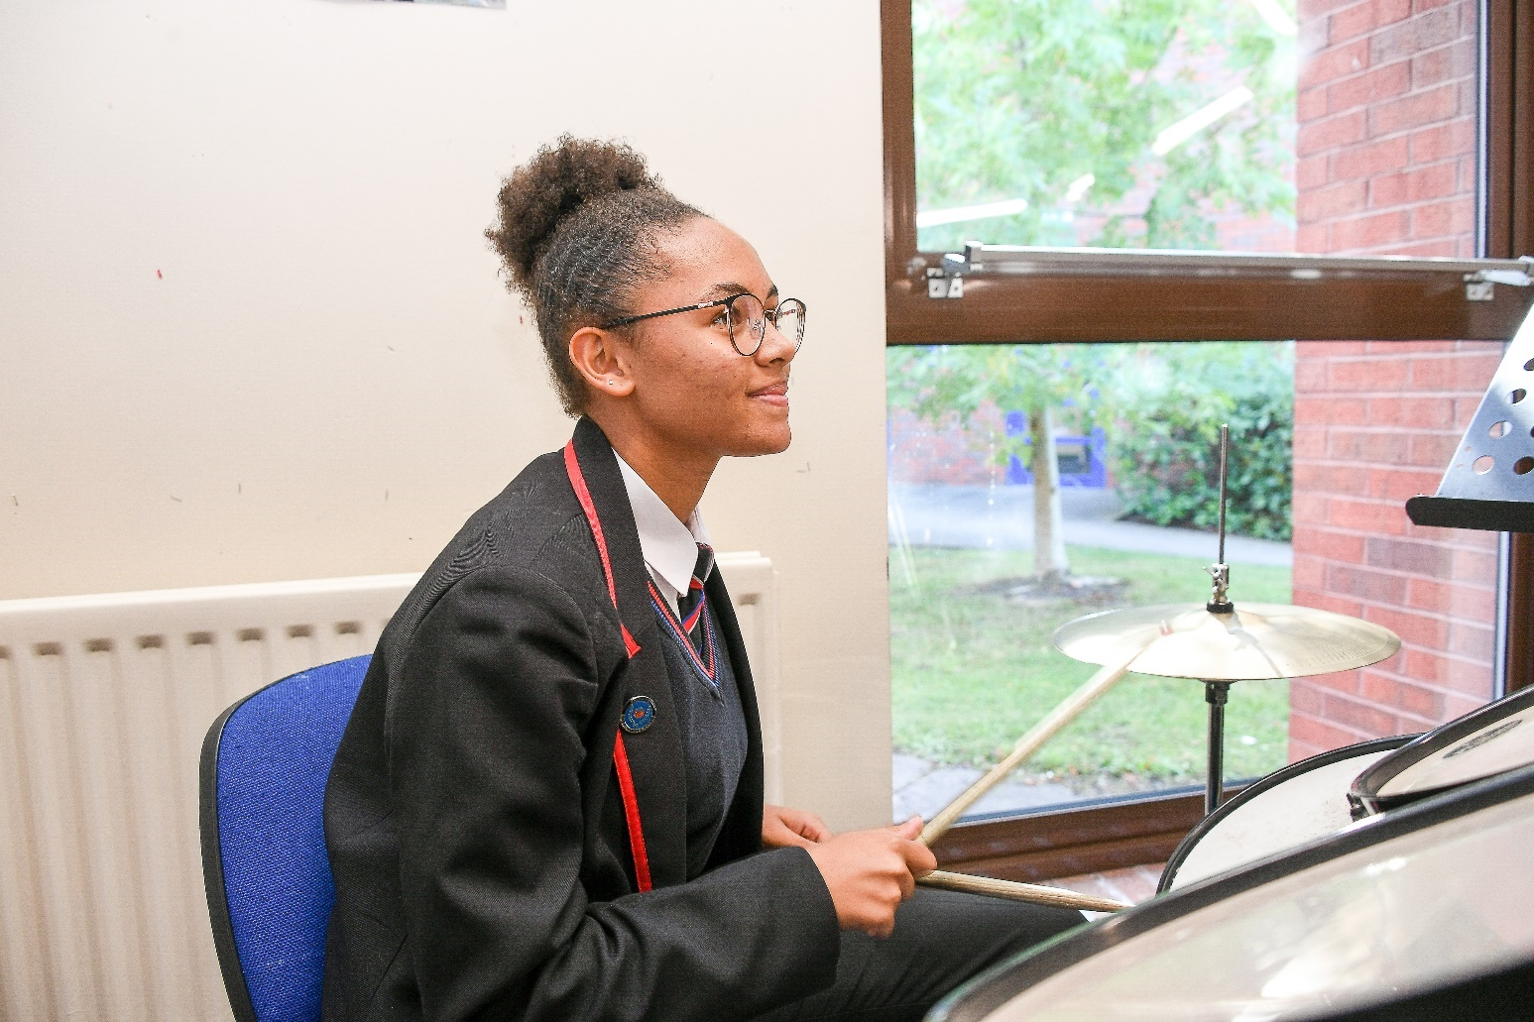
Year 10 Music

Theme 1 | Theme 2 | Theme 3 | Theme 4 | Theme 5 | Theme 6
Language of Music  Technical, Constructive & Expressive Progression:  Performing: Students develop ensemble skills and rehearsal etiquette through lass choir singing projects with opportunities for students to use their own instruments in rehearsals. Students use new knowledge using the language of music to aid musical conversation in rehearsal with other musicians.  Composing: Students learn about compositional devices and techniques and how they are applied to different musical contexts. Professional repertoire is used to model highly effective compositional practices.  Listening & Appraising: Students learn how to aurally identify state and name musical features linking to each element of music from a variety of different genres.  Knowledge Focus:  Dynamics  Rhythm & Tempo  Popular Structures  Melodic Shape  Pop Instrumentation  Orchestral Instruments  Texture  Harmony & Tonality | Working With Score  Technical, Constructive & Expressive Progression:  Performing: Students continue class choir rehearsals, now using score more effectively to identify musical features and translate notated music into accurate and expressive performances. Students continue to develop rehearsal practice and use work with score to aid independent rehearsals with other musicians.  Composing: Students refine notation skills, learning how to accurately notate music in different clefs, keys and time signatures. Students develop a better understanding of instrument range and techniques to allow them to compose idiomatically in future composition projects.  Listening & Appraising: Students learn how to use score combined with listening examples to identify and locate musical features accurately.  Knowledge Focus:  Time Signatures  Note Values  Intervals  Melodic Shape  Voice Types  Textural Devices  Key Signatures  Harmonic Devices  Cadences | Popular Music  Technical, Constructive & Expressive Progression:  Performing: Students practically explore Africa by Toto on their own instruments to thoroughly explore the musical features and practise translating features identified in musical analysis into a product that replicates that by Toto. Students learn to apply in-depth analysis skills to their own repertoire.  Composing: Students create their own brief in response to an Area of Study. Ideas for instrumentation are discussed in order to ensure that students can successfully meet their brief.  Listening & Appraising: Students focus their listening on the conventions of popular music and use score and aural skills to locate, name and describe features of pop music.  Knowledge Focus:  Rhythmic Devices  Popular Song Form  Word Setting  Pop Instrumentation  Music Technology  Chord Progressions  Bhangra | Music For Ensemble  Technical, Constructive & Expressive Progression:  Performing: Students explore rhythm sections, pop/rock groups and chamber ensembles practically depending on the instruments they play and consider the ways in which they interact with other instruments in ensembles. Students practically explore jazz, musical theatre and music for chamber ensemble.  Composing: Students complete research into similar compositions based on their brief to look for musical features to use as inspiration. Students begin to use trial and error with chord progressions and melodies.  Listening & Appraising: Students listen to jazz, blues, musical theatre and chamber music ensembles focusing on the use of texture and instrumentation in these genres of music.  Knowledge Focus:  Jazz/Blues Rhythms  Jazz/Blues Structure  Jazz/Blues Melodies  Jazz/Blues Harmony  Types of Ensemble  Texture & Instrumentation in Chamber Music. | Musical Forms & Devices  Technical, Constructive & Expressive Progression:  Performing: Students develop their understanding of structure to use musical language to aid rehearsals. Students explore melodic, harmonic, rhythmic and textural devices used in the history of music to inform their own playing and understanding of the music they are performing.  Composing: Students finalise ideas and begin to notate compositions using Notion. Students record chord progressions, melodic fragments and rhythmic ideas in order to support the notation process.  Listening & Appraising: Students can identify compositional devices and describe how the elements of music have been manipulated in Baroque, Classical and Romantic music to identify the era it is from.  Knowledge Focus:  Classical Structures  Melodic Devices  Harmonic Devices  Baroque Music  Classical Music  Romantic Music | Film Music  Technical, Constructive & Expressive Progression:  Performing: Students explore film music and more carefully consider the purpose of their performance pieces in order to improve expression and interpretation. Students reflect on the purpose and stylistic features of the music they are performing and consider how to communicate these musical features.  Composing: Students finalise compositions, adding other musical features, musical directions and checking for stylistic coherence throughout the composition. Students complete a composition log reviewing their process and the inspiration they have taken from other sources.  Listening & Appraising: Students consider the compositional intentions and purposes and analyse how a composer has harnessed the elements of music to meet the brief of the composition.  Knowledge Focus:  Features of Film Music  Compositional Devices  Musical Contrast
Year 10 Performing Arts

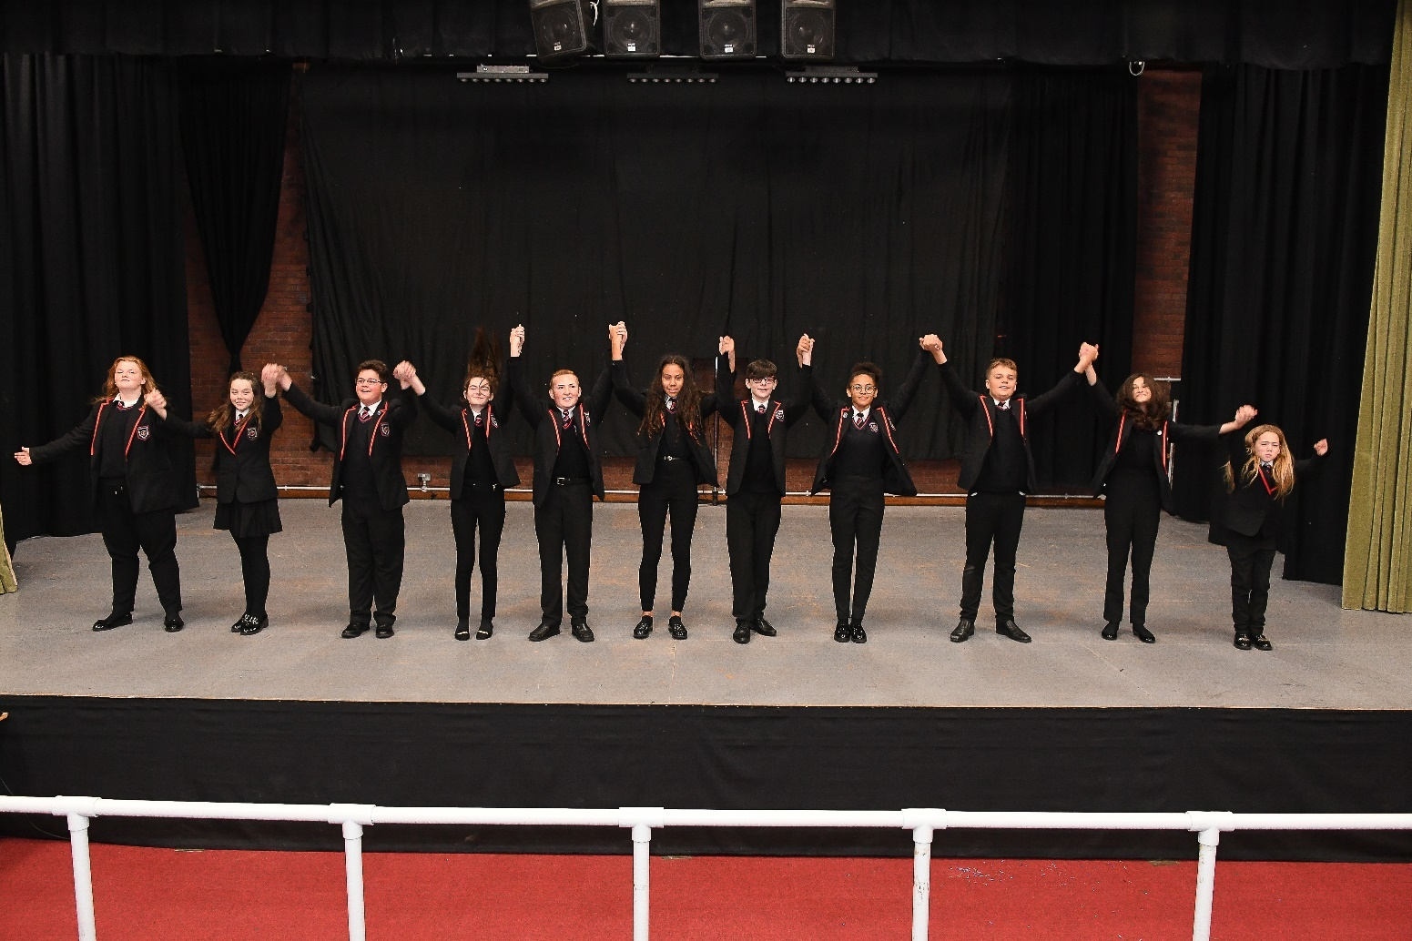
Year 10 Performing Arts
Autumn Term | Spring Term | Summer Term
Component 1  - Learning Aim A: Examine professional practitioners’ performance work. Students will study an existing piece of professional repertoire based on the brief provided by Pearson. Students will practically explore this piece and create a research log exploring the processes that took place to create the piece being studied.  - Learning Aim B: Explore the interrelationships between constituent features of existing performance material. Students will produce a piece of promotional material that explains to a festival audience the processes and individual responsibilities and skills required to create the piece. Students will link their own practical experience of the selected pieces to this research to show detailed understanding of the rehearsal process. | Being On Stage  - Engage with a range of stimuli to develop critical and creative thinking skills.  - AO2: Adopt a role.  - AO3: Take part in improvisation.  - AO5: Employ sign, symbol, metaphor and image.  - AO6: Engage in movement and/or dance.  - AO7: Experience live and recorded drama and respond to a variety of texts.  - AO8: Begin to develop an appreciation of theatre styles, genres and vocabulary.  - AO9: Explore characterisation through use of masks, costume, props, puppets and electronic media.  - AO10: Evaluate their own and others’ work.  - Lessons will be completed as filmed workshops and will require students to write up these workshops at home. | Devising Drama  - AO1: Engage with a range of stimuli to develop critical and creative thinking skills.  - AO2: Adopt a role.  - AO3: Take part in improvisation.  - AO4: Devise scripts and use drama forms and strategies effectively to explore and present ideas.  - AO5: Employ sign, symbol, metaphor and image.  - AO6: Engage in movement and/or dance.  - AO7: Experience live and recorded drama and respond to a variety of texts.  - AO8: Begin to develop an appreciation of theatre styles, genres and vocabulary.  - AO9: Explore characterisation through use of masks, costume, props, puppets and electronic media.  - AO10: Evaluate their own and others’ work.  - Lessons will be completed as filmed workshops and will require students to write up these workshops at home.

Year 10 PE

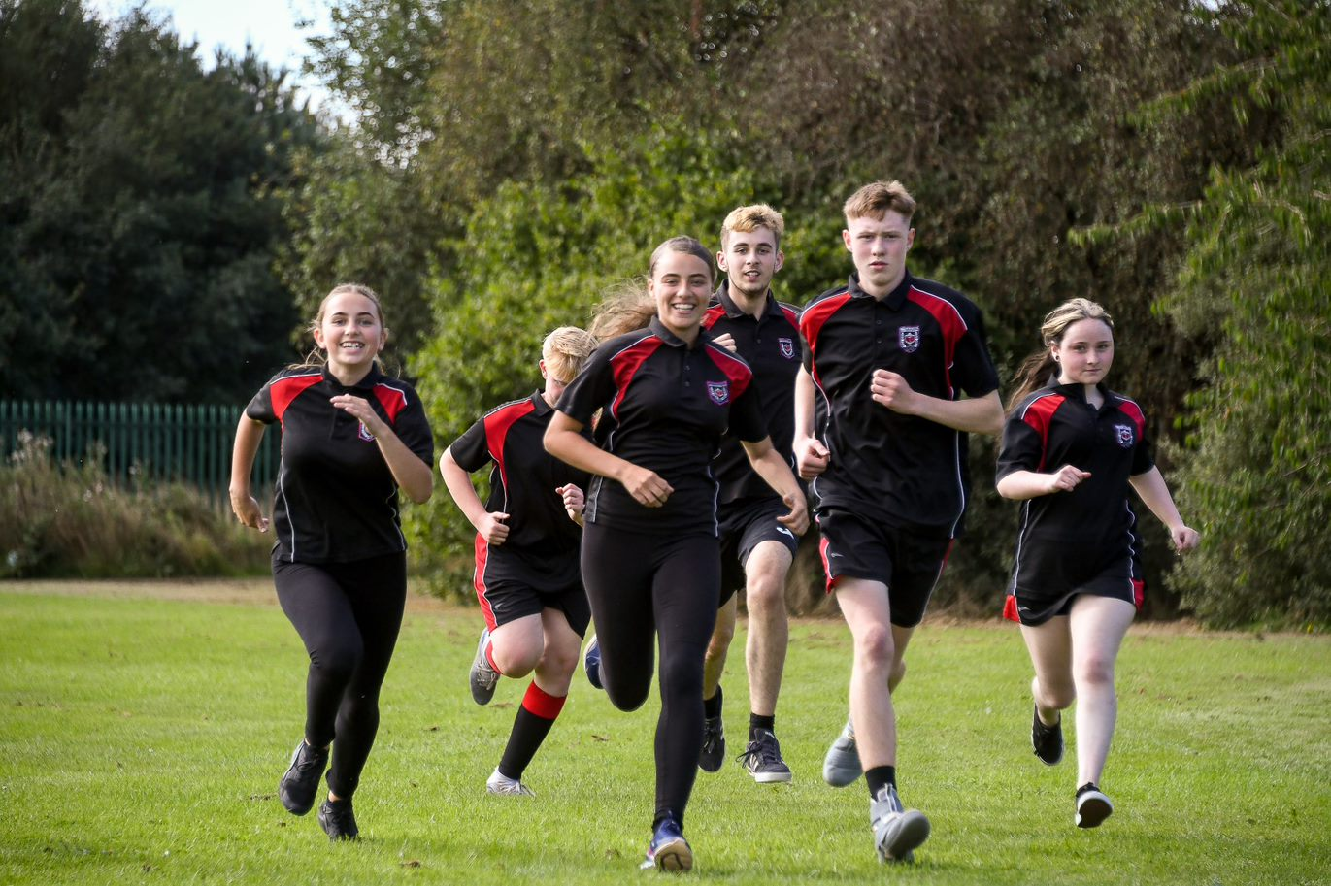
Year 10 PE
Autumn Term 1 | Autumn Term 2 | Spring Term 1 | Spring Term 2 | Summer Term 1 | Summer Term 2
Netball, Football, Rugby  - Developing own tactics and strategies through attacking and defensive play  - Understanding how to improve in different phases of play.  - Linking competitive sport to a healthy active lifestyle.  Application of rucking and mauling in rugby.  - Develop kicking techniques in rugby.  - Practical of application in competitive sport. | Basketball, Fitness, Badminton  - Attacking strategies in basketball, screens, blocks, and post play.  - Advanced shooting techniques- Jump shots and lay ups.  - The role of umpire and application of rules and regulations.  - Understanding how to create a training programme to suit individual needs.  - Participating in a personalised training programme to improve overall fitness | Handball, Table Tennis, Volleyball  - To replicate the dig, serve, set, and spike.  - Apply fundamentals consistently in a game.  - To be able to officiate a game of volleyball.  - To learn the basics of outwitting strategies in volleyball.  - To learn how to time and perform a block effectively  - To learn rules of new sports such as table tennis.  - The role of umpire and application of rules and regulations. | Table Tennis, Dodgeball, Futsal  - Developing own tactics and strategies through attacking and defensive play  - Linking competitive sport to a healthy active lifestyle.  - The role of umpire and application of rules and regulations. | Cricket, Rounders, Softball  - The role of umpire and application of rules and regulations.  - Apply fundamentals consistently in a game.  - Developing own tactics and strategies through attacking and defensive play  - Understand formations | Cricket, Rounders, Tennis  - The role of umpire and application of rules and regulations.  - Apply fundamentals consistently in a game.  - Developing own tactics and strategies through attacking and defensive play  - Understand formations
Year 10 PE (BTEC)
Autumn Term 1 | Autumn Term 1 | Autumn Term 2 | Autumn Term 2 | Spring Term 1 & 2 | Summer Term 1
Component A  - Types of sport and Physical activity.  - Benefits of taking part in sport  - Outdoor activities.  - Benefits of taking part in outdoor activities.  - Provision of sport  Characteristics of the sectors.  - Advantages and disadvantages of the provision of sport in each of the different sectors to the participant  - Types and needs of sport and physical activity participants  - Barriers to participation | Component C  - Be able to prepare participants to take part in physical activity  - Planning a warm-up  Types of activities in a pulse raiser  - Response of the cardiorespiratory system  Response of the musculoskeletal system.  - Types of activities in the mobiliser. | Component C  - Adapting a warm-up for different categories of participants and different types of physical activities.  - Delivering a warm-up to prepare participants for physical activity | Component B  Examine equipment and technology required for participants to use when taking part in sport.  - Different types of sport clothing and equipment required.  Component B  - Different types of technology and their benefits to improve sport.  - The limitations of using technology in sport. | Start of Component 2  Taking Part and Improving Participants Sporting  - Components of physical and skill fitness.  - Performing in own sport. | Component 2  Taking Part and Improving Participants Sporting  - Leading drills in own sport.  - Delivering drills to other participants.

Year 10 Religious Education


Autumn Term 1 | Autumn Term 2 | Spring Term 1 | Spring Term 2 | Summer Term 1 | Summer Term 2
Relationships and Families  - Heterosexual and homosexual relationships.  - Human sexuality  - Contraception  - Marriage and cohabitation | Relationships and Families  - Different types of families  - Same sex parents and polygamy  - Divorce  - Assessment | Islam  - The nature of God  - Life and death  - Authorities—Adam, Ibrahim and Muhammed  - Holy Books  - Practice—5 pillars of Islam | Islam  - Salah and Shahadah  - Sawm, Zakah, Hajj and Jihad  - Islamic Festivals  - Assessment | Social Justice and Human Rights  - Prejudice and discrimination  - Human rights  - Social justice | Social Justice and Human Rights  - Prejudice and discrimination  - Human rights  - Social justice
Year 10 Religious Education

Year 10 Science

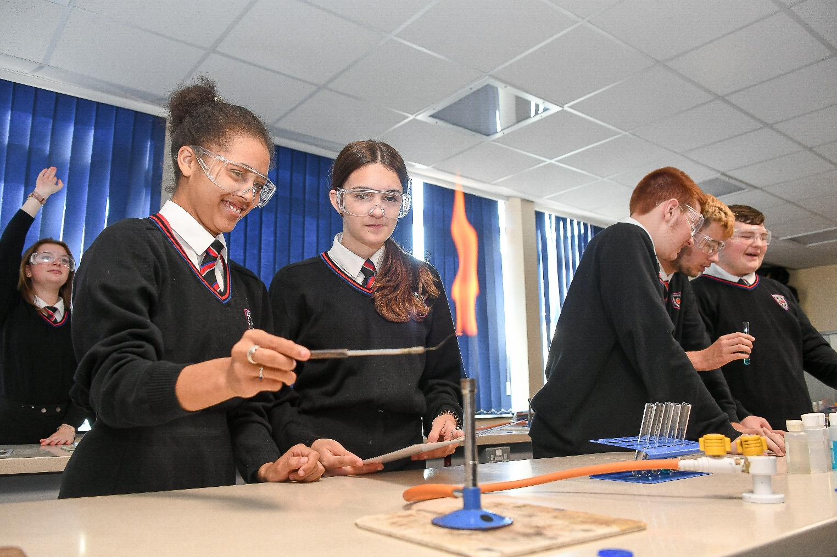

Year 10 Science
Autumn Term 1 | Autumn Term 2 | Spring Term 1 | Spring Term 2 | Summer Term 1 | Summer Term 2
Biology Ecology (taught as a separate topic) ➢Biotic factors ➢Adaptations ➢Food chains ➢Sampling required practical ➢Carbon and nitrogen cycles (Triple) Environmental decay ➢(Triple) Decay required practical ➢ Biodiversity and wast ➢Global warming ➢Deforestation and land use ➢Maintaining biodiversity
Biology  Enzymes and Digestion  ➢Enzymes and digestion  ➢Factors affecting enzymes  ➢Required amylase practical  ➢Food test required practical  Transport in plants and animals  Circulatory system  ➢Breathing and gas exchange  ➢Transport in plants  ➢Transpiration  Chemistry  Reactions of acids  ➢Strong and weak acids  ➢Neutralisation of acids  ➢Making salts  Energy changes  ➢Exothermic and endothermic reactions  ➢Investigating energy changes  ➢Reaction profiles  ➢Calculating energy changes in reactions  Physics  Force basics  ➢ Contact and non-contact  ➢ Resultant forces  ➢ Resolving forces  ➢ Work done  ➢ Hookes Law  ➢ Force multipliers  ➢ Moments  ➢ Pressure | Biology  Infection and response  ➢Pathogens and disease  ➢Growing bacteria required practical  ➢Defence against disease  Chemistry  Rates of reaction  ➢Collision theory  ➢Measuring rate of reaction  ➢Calculating rate of reaction  ➢Factors affecting rate of reaction  ➢Reversible reactions  ➢Le Chatelier’ principle  Physics  Energy  ➢ Stores and transfers  ➢Heat  ➢Energy calculations  ➢SHC required practical | Biology  Infection and response  ➢Vaccines  ➢Developing drugs  ➢Different drugs  Non-communicable diseases  ➢ Risk factors  ➢ Heart disease  ➢ Cancer  ➢ Plant deficiencies  Chemistry  Bonding and structure  ➢ Ionic, covalent and metallic bonding  ➢ Giant covalent structures  ➢ Polymers  Physics  Forces in action  ➢Velocity  ➢Acceleration  ➢Motion graphs  ➢Newtow’s laws | Biology  Bioenergetics  ➢ Respiration  ➢ Effect of exercise  ➢ Metabolsim  ➢ Photosynthesis  ➢ Factors affecting photosynthesis  Chemistry  Chemical changes 2  ➢Metal oxides  ➢Reactivity series  ➢Extraction of metals  ➢Redox reactions  ➢Electrolysis  Physics  Forces in action  ➢Investigating motion  ➢Stopping distances  ➢Reaction times  ➢Momentum | Biology  Homeostasis and response  ➢Homeostasis  ➢Nervous system  ➢Synapses and reflexes  ➢Investigating reaction times  ➢The endocrine system  ➢Control of blood glucose  Chemistry  Quantitative chemistry  ➢Balancing equations  ➢Conservation of mass  ➢RFM  ➢ Moles  ➢ Concentration  ➢Limiting reactants  Organic Chemistry  ➢Hydrocarbons  ➢Fractional distillation  ➢Combustion  ➢Cracking  Physics  Electricity  ➢Modelling circuits  ➢Current, voltage and resistance in series and parallel circuits | Biology  Homeostasis and response continued  ➢Hormones in reproduction  ➢Reproduction  ➢Contraception  ➢Infertility  ➢Negative feedback  Chemistry of the atmosphere  ➢Evolution of the atmosphere  ➢The greenhouse effect  ➢Climate change  ➢Pollutants  Physics  Electricity  ➢IV characteristics  ➢National grid  ➢Electrical equations  ➢(Triple) Static electricity

Careers
Autumn Term 1 | Autumn Term 2 | Spring Term 1 | Spring Term 2 | Summer Term 1 | Summer Term 2
Aspirations, What is your Future. Students look at former OAT students and focus on their dreams.  - What is a skill? (3) (S)  - An intro to different types of skills pt 1 (3) (S)  - An intro to different types of skills pt 2 (3) (S)  - Your interest & jobs (3) (SA)  - Your strengths & jobs pt1 (3) (SA)  - Your strengths & jobs pt2 (3) (SA)  1:1 Careers Guidance interviews | Form Activity  - What jobs do people do near you? (2) (LM)  - What will you get out of work experience? (WE)  - Why is work experience important? (WE)  Careers Convention - pupils will be invited to our annual careers convention. pupils will have the opportunity to speak with external delegates and receive bespoke advice and guidance. aspiring futures will also be present to offer impartial IAG  1:1 Careers Guidance interviews | PSHE Careers module  - The Next 18 Months: Post 16 options  - Writing and producing a successful CV  6th form Provider talks. From ShireOak Academy, Aldridge School  Form Activity  - Explore Industries in your area (2) (LM)  - Explore local jobs in demand (2) (LM)  - What skills do you have? (S)  - How can you develop your skills? (S)  - Explore local employers and what is important to them (2) (LM)  - What Skills are important to employers? (2) (LM)  - What is resilience? (SA)  - Why is feedback important?  DHL employability Workshop – 30 students  1:1 Careers Guidance interviews | - National Careers / Apprenticeship Weeks (March) – pupils will receive a special assembly, form time activities and also competitions will be launched. During National careers week departments will deliver a ‘Careers lesson’ in curriculum time. This will be used to inspire pupils and raise awareness of the variety of careers that are linked to their subject.  Form Activity  - Create your own development plan (SA)  - Using START to capture evidence (S)  - How can you evidence the skills you have? (S)  - What is a CV? (Afj)  - What is an interview (Afj)  DHL employability Workshop – 30 students  1:1 Careers Guidance interviews | Form activity -  - How do employers advertise jobs?  - Your subjects and jobs (CB)  - Explore jobs based on your interests (SA)  - Explore jobs based on your strengths (SA)  - Capturing evidence of your work experience (WE)  1:1 Careers Guidance interviews | - Work Experience for Y10: There will be 2 days out it local employers based on pupils careers survey. Reflections of visits to be typed up and recorded on pupils start profile locker. Risk assessments provided by employer.  - Mock interviews – all Y10 will have an interview with local employers.  Form activity  - What is a T-Level (CB)  - What is an apprenticeship? (CB)  - What is an A-level  - What is a university? (CB)  - What is the difference between a job and career? (CB)  1:1 Careers Guidance interviews

Year 10 PSHE
Autumn Term 1 | Autumn Term 2 | Spring Term 1 | Spring Term 2 | Summer Term 1 | Summer Term 2
Resilience  - Emotional Awareness and Self-Regulation  - Impulse control  - Optimism and empathy  - Flexible thinking  - Self-Efficacy | Relationships & Sex Education  - Role of intimacy and pleasure  - Impact of pornography  - Pressure, persuasion and coercion  - Contraception  - Parental responsibilities  - Addressing relationship abuse  - FGM | Study skills, Relaxation & Aspirations  - Why habits matter  - How positive habits can help us stay healthy  - The Next 18 Months: Post 16 options  - Writing and producing a successful CV | Diversity and Equality  - Disability: Dealing with and fighting discrimination in the world of work and the wider community. To describe the different types of disability.  - Race & Religion: Dealing with and fighting discrimination in the world of work and the wider community.  - Gender: Dealing with discrimination in the world of work and the wider community.  - LGBTQ+: Dealing with discrimination in the world of work and the wider community.  - LGBT+ inclusion in sport: Rainbow Laces | Drugs, Alcohol & Healthy Living  - Substance use, assessing risk and managing influence.  - Drugs, the law and managing risks  - Addiction dependency (including prescription drugs) and seeking help.  - Drugs and their effects, alcohol and cannabis  - Vaping: The consequences and influences  - Gambling – managing the risks | Crime & Criminality  - What is crime? The difference between criminal and civil law.  - Justice system in the UK: The courts, being arrested and prosecution.  - Honour-based Violence. What is it and how it is being tackled around the world.  - Comparative study: Law in the UK and law in the USA.  - Brownhills TED talk: The truth behind carrying a knife - It only makes you more vulnerable.

