Brownhills Ormiston Academy

ADMISSIONS
PACK
2023/2024

TABLE OF CONTENT
SECTION | PAGE
Section 1: Administration Record | 2 - 5
Section 2: Biometric Information | 6 - 7
Section 3: School Trips & Off-Site Activities | 8
Section 4: Use of Images | 9
Section 5: School Uniform | 10 - 12
ADDITIONAL FORMS
i: Home Academy Agreement
ii: Request for Locker Key

Brownhills Ormiston Academy  Deakin Avenue  Walsall  WS8 7QG | ( 01543 452886  8 www.brownhillsoa.co.uk  @ postbox@brownhillsoa.co.uk

Brownhills Ormiston Academy
SECTION 1: ADMINISTRATION RECORD
The information, which is requested in this document, may be stored on a computer and, if so, it is subject to the GDPR Legislation. This legislation requires that all information is strictly confidential and may only be assessed by those with a legal right to see it, e.g., if there is a child protection enquiry. The information will not be given to anyone else without your written consent.
You have a right to examine, at any reasonable time, information about you or your child which is kept on a computer. You have a right to correct any information which you feel is wrong or misleading. Please contact the Principal if you wish to examine the information about you or your child which is kept on computer.
1a Basic Details of Child
Legal Surname:

Legal Forenames:

Preferred Name (if different from above):

Date of Birth: | Gender (Male/Female):
Address:

Postcode: | Home Telephone:
Main Home Email Address:

Name of Present School (If Any):

1b Details of Parents/Carers/Contacts in case of Emergency
These are very important to us. If your child becomes ill during the day, we need to be able to contact you, or someone acting for you, who is able to collect your child AT ALL TIMES. Please give at least three emergency contacts. We suggest the telephone number of any place of work and one other emergency contact, perhaps a grandparent if they live close by. If you have no relatives in the area, then ask a friend, neighbour, or child-minder if they would be willing to act as an emergency contact. The people who you give as emergency contact details may have to act on your behalf and you should be happy for this to happen.
PERSON 1 Contact Priority in Case of Emergency (please circle): 1 2 3 4 5 6
Full Name:

Relationship to Child: | Parental Responsibility (Yes/No):
Mobile Telephone: | Work Telephone:
Email Address:

Home Address including postcode (please complete if different from child’s)

PERSON 2 Contact Priority in Case of Emergency (please circle): 1 2 3 4 5 6
Full Name:

Relationship to Child: | Parental Responsibility (Yes/No):
Mobile Telephone: | Work Telephone:
Email Address:

Home Address including postcode (please complete if different from child’s)

PERSON 3 Contact Priority in Case of Emergency (please circle): 1 2 3 4 5 6
Full Name:

Relationship to Child: | Parental Responsibility (Yes/No):
Mobile Telephone: | Work Telephone:
Email Address:

Home Address including postcode (please complete if different from child’s)

PERSON 4 Contact Priority in Case of Emergency (please circle): 1 2 3 4 5 6
Full Name:

Relationship to Child: | Parental Responsibility (Yes/No):
Mobile Telephone: | Work Telephone:
Email Address:

Home Address including postcode (please complete if different from child’s)

1c Medical Details
Does your child have any medical conditions if so what (including details of regular medication and dietary requirements). This is especially important for asthma, allergies, and diabetes

Does your child require regular medication in school? Yes / No

If at any time your child does need a course of antibiotics or any other medication whilst in school, this must be brought to the academy by and adult and signed in with a member of staff from student services who can discuss the arrangement for taking the medication.
1d SEN Details
Is your child on the SEN register Yes / No
Has your child an EHCP Yes / No
Does your child wear a hearing aid? Yes / No
If yes, what are your child’s needs

1e Cultural Details
CODE | ETHNICITY
WHB | White British |  | CODE | RELIGION |  | CODE | LANGUAGE
WHR | White Irish |  | ANG | Anglican |  | BEN | Bengali
WHT | Traveller – Irish Heritage. |  | BPT | Baptist |  | CAN | Cantonese
WHA | Any other White background. |  | CHR | Christian |  | ENG | English
WRO | Gypsy/Roma |  | HIN | Hindu |  | GRE | Greek
MWB | White/Black Caribbean |  | JEW | Jewish |  | GUD | Guajarati
MBA | White/Black African |  | MTH | Methodist |  | HIN | Hindi
MWA | White/Asian |  | MUS | Muslim |  | ITA | Italian
MOT | Any other Mixed Background |  | NON | No Religion |  | OTH | Other
AIN | Indian |  | OTH | Other |  | PAN | Panjabi
APK | Pakistani |  | ROC | Roman Catholic |  | PRO | Portuguese
ABA | Bangladeshi |  | SKH | Sikh |  | SPA | Spanish
AAO | Any other Asian Background |  | URC | United Reformed Church |  | TUR | Turkish
BLB | Black Caribbean |  |  |  |  | URD | Urdu
BLF | Black African
BLG | Any other Black Background
CHE | Chinese
OEO | Any other Ethnic Group
REF | Refused
NOT | Information Not Obtained.
Please insert code from list above.
 | ETHNICITY |  |  | RELIGION |  |  | LANGUAGE
Is English as an additional language Yes / No
Once your child has joined Brownhills Ormiston Academy, an electronic link will be sent to you to allow you to access the details we hold. This will enable you to make changes if, and when, necessary for example: change of address, contact details etc.
1f Additional Information
LUNCHTIME ARRANGEMENTS I wish my child to (please circle):
Have an academy meal Yes / No
My child is currently entitled to claim Free School Meals
(please see parent section of the website or contact the academy for more information) Yes / No
Eat sandwiches in the academy Yes / No
TRANSPORT
How does your child travel to the academy (please circle)? | Walk Bus (please state No.) __________ Academy Coach Car
I give my permission for my child to travel in a car belonging to a member of staff at Brownhills Academy in the event of an emergency or at other times when the academy feels it necessary. |  | Yes / No

Signature ……………………………………………………………………

SECTION 2: BIOMETRIC INFORMATION

Biometric information is information about a person’s physical or behavioural characteristics that can be used to identify them, for example and as we are proposing in this system, information from their fingerprint.

Each individual’s finger and thumbprints are unique. The Biometric cashless system stores only a section of the print as a unique number and not as an image.

Each child has a unique number stored on a central server. This is done by scanning the finger or thumb with a non-evasive electronic scanner, which passes light over the finger or thumb. The same scanner is installed at the tills where they get their food. The system will take measurements of your child’s fingerprint and convert these measurements into a template to be stored on the system. An image of your child’s fingerprint is not stored. The template (i.e., measurements taken from your child’s fingerprint) is what will be used to permit your child to buy food from the dining room. The information is held in a secure database on the server. Access to this database is given only by the academy and then only to those who are required to administer the system.

You should note that the law places specific requirements on us when using personal information, such as the biometric information, about pupils for the purposes of an automated biometric recognition system:

- The academy cannot use the information for any other purpose other than for those for which it was originally obtained and made known to parents.
- The academy must ensure that the information is stored securely.
- We must tell you what we intend to do with the information.
- Unless the law allows it, we cannot disclose personal information to another body.

Providing your consent / objecting to the use of biometric data
Under the Protection of Freedoms Act 2012, we are required to notify each parent of a child and obtain the written consent of at least one parent before being able to use a child’s biometric information for an automated system.
Consent given by one parent will be overridden if the other parent objects in writing to the use of their child’s biometric information. Similarly, if your child objects to the use of their biometric information, the academy cannot collect or use the information for inclusion on the automated recognition system.
You can also object to the proposed processing of your child’s biometric information at any time or withdraw any consent you have previously given.
Please note that you must make any consent, withdrawal of consent or objection in writing.
Even if you have given your consent, your child can object or refuse at any time to their biometric information being collected and used
If your child objects they do not need to do this in writing. We would appreciate if you could discuss this with your child and explain to them that they can object if they want to.
The academy is happy to answer any questions you or your child may have by contacting Mrs Harriman or Miss Richards with any questions you may have.
If you do not wish for your child’s biometric information to be used by the academy, or your child objects to such processing, the academy will provide reasonable alternative arrangements for pupils who are not going to use the automated system to pay for academy meals / coaches / Trips or other Ad hoc items.
Please note that, when your child leaves the academy or ceases to use the biometric system, their biometric information will be securely erased in line with the academy’s Record Retention policy.
Please complete the form below to confirm if you do or do not consent to the collection and use of your child’s biometric information and return it to the academy office by date.
If you wish to withdraw your consent at any time, this must be done so in writing and sent to the academy at the following address: Principal, Brownhills Ormiston Academy, Deakin Avenue, Brownhills, Walsall. WS8 7QG

Consent for the Use of Biometric Information in School

I give consent to the school for the biometrics of my child: to be used by
Brownhills Ormiston Academy for use as part of a recognition system as described above.

I understand that I can withdraw this consent at any time in writing.

Name of pupil________________________________________________________

Name of parent:______________________________________________________

Signature: ___________________________________________________________

Date:_____________________________

SECTION 3: ACADEMY TRIPS & OFF-SITE ACTIVITIES
The trips and activities covered by this consent include:
- All local, non-residential, and non-hazardous visits that take place inside and outside of the academy.
- Off-site sporting fixtures inside and outside of academy hours.
- The academy will send information about each trip or activity before it takes place.
- You can, if you wish, tell the academy that you do not want your child to take part in any specific academy trip or activity.
In circling yes, you are giving permission for your child to:
- Take part in academy trips and other activities that take place off academy premises.
- Be given first aid or urgent medical treatment during any academy trip or activity.
If permission is not given for the above, your child will not be able to attend academy trips.
I give consent for my child to take part in academy trips and off-site activities (please circle): | Yes / No
I understand that the emergency contact details used for these trips will be taken from the academy’s administration system provided on initial admissions form or any subsequent data collection sheet sent to you that you have returned (please circle). | Yes / No
I understand that it is my responsibility to ensure that the academy is notified of any changes to these contact details or medical conditions (please circle). | Yes / No

Signature ……………………………………………………………………

Behaviour – Child MUST read
You must maintain the high standard of public behaviour expected in the academy and do nothing which could harm the reputation of Brownhills Ormiston Academy. Good manners, respect and politeness are expected at all times. The academy behaviour policy will continue to apply.
Students should meet the expectations below at all times:
- Follow the instructions and obey all requests from members of academy staff and staff at the area/venue you are visiting.
- Be punctual and ensure you are present for any agreed meeting points.
- Follow all the codes of conduct at the places of visit.
- Dress appropriately as advised by trip leaders. If wearing uniform, normal academy rules regarding this apply.
- Respect the environment (e.g., not dropping litter, vandalising property, or trespassing).
- Accept full responsibility for your own possessions.
- No smoking, no consumption of alcohol, and no use of illegal substances.
- You must not be in possession of any dangerous or threatening items/weapons.
- You must not engage in intimidation, harassment, or bullying, including fighting or violent behaviour.
- You must follow the guidance given by the trip leader on mobile phone use.
- If the visit involves unsupervised time, in the event of an emergency, students are to inform the group leader immediately using the contact numbers provided and follow any instructions and advice as given by the group leader.
- You must ensure that safety regulations at any venue visited are followed at all times.
In addition, on any residential trips:
- You must follow instructions regarding bedtime curfews.
Signature of Child: | Date:
Name (BLOCK CAPITALS) of Child: | Date:

Parent/Carer
I have read and accept the above guidelines which apply to all academy trips, offsite visits, and sporting activities until such time as my child leaves Brownhills Ormiston Academy or these guidelines are updated (please circle):  Signature …………………………………………………………………… | Yes / No
In addition, I understand that any serious misbehaviour or illness will result in my child having to be collected. Any costs incurred by the academy in getting them back safely will be charged to Parents/Carers (please circle):  Signature …………………………………………………………………… | Yes / No
SECTION 4: USE OF IMAGES
From time to time, photographs and video footage may be taken of your child for celebrating achievement such as news letter, website, etc.
I agree to photographs being taken of my child to be used for Celebrating Achievement purposes internally & externally (please circle):  Signature …………………………………………………………………… | Yes / No

I agree to videos being taken of my child to be used for Celebrating Achievement purposes internally and externally (please circle):  Signature …………………………………………………………………… | Yes / No

I agree to my child’s name to be published when used for Celebrating Achievement purposes internally and externally (please circle):  Signature …………………………………………………………………… | Yes / No

PARENT/CARER SIGNATURE
I confirm that the information given in this form is true, complete and accurate (pages 2-7).
Signature of Parent/Carer: | Date:
Name (BLOCK CAPITALS) of Parent/Carer: | Date:

SECTION 5: ACADEMY UNIFORM
Our academy rules state that pupils must aim to create a good impression of themselves and the academy in their dress and personal appearance. This means wearing academy uniform and aiming to look smart and presentable at all times.
Our Academy Uniform - Years 7, 8, 9, 10 & 11
- Plain black shoes (no logos or decoration). No boots
- Black trousers/skirt
  - Trousers should be plain black. Jeans/jean style, tight fitting legging type trousers are NOT acceptable
  - Skirts must fully cover the knee of the wearer in terms of length and should be made from plain cotton and polyester material. Tight fitting, short, lycra styled skirts are not allowed
- White academy shirt with a top button (not polo type)
- Academy tie
- V-neck jumper in black plain-knit with red and blue stripe at V neck with academy badge. This should not be tucked into trousers or skirt
- Black blazer with red trim and academy badge. Blazer sleeves should not be rolled up.
- Plain belts worn around trousers may only be worn if they are black and no wider than 3cm.
- Shoes MUST cover the full foot and be of a sturdy leather type material for health and safety reasons. Slip on style shoes/sandals or trainer style canvas shoes are NOT allowed. No coloured flashes, trims or logos are allowed.
SUMMER TERM UNIFORM
Students can wear an academy polo shirt in the summer term only in place of their shirt, tie, and academy jumper. All other items of uniform remain the same for the summer term if students choose to wear the polo shirt. The Brownhills Ormiston Academy Polo shirt is royal blue with the academy badge on it and can be purchased from all of our uniform suppliers.
For Sport & PE

Compulsory Wear
- Falcon Encore unisex polo shirt with standard academy badge on left breast
- Falcon Encore shorts (no badge)
- Falcon skort to match top (no badge)
- Black socks with solid red top
- Appropriate footwear
- One-piece swimsuit

- Students have the option to choose skort or shorts, either is acceptable
Optional Outer Wear (with logo)
- Falcon Spirit ¼ zipped fleece top academy badge to left breast
- Plain black tracksuit trousers (no logo)
- Plain black sports leggings – thick style (no logos)
Jewellery:
For reasons of safety and security jewellery should not be worn in the academy except for a watch, one plain signet ring and plain small stud type earrings. One earring in each ear lobe is permissible. Earrings should not be worn in other parts of the ear. Wristwatches, if worn, should have your child’s name on. The academy has no liability if jewellery is stolen when brought into academy. The academy has a policy of banning “facial and body piercing” on the grounds of health and safety. All jewellery must be removed for PE/games. Please be aware that it is illegal for anyone to have a tattoo under 18 even with parental consent.
Hairstyles/Makeup:
Extreme hairstyles are not acceptable. This includes patterns or tramlines cut into hair and hair colouring other than natural colours. Extreme hair bows and ribbon should not be worn. Nail varnish/nail extensions are not acceptable. Make up should not be worn. All of the above are at the discretion of the Principal whose decision will be final.
All items of academy uniform, including the PE kit, can be purchased from Uniforms Plus, Burntwood & Lichfield stores, Clive Mark – Saddlers Shopping Centre, Walsall and Crested Academy-wear, Walsall. Other stockists of your choice may stock non-logo uniform items.
(PARENT COPY)
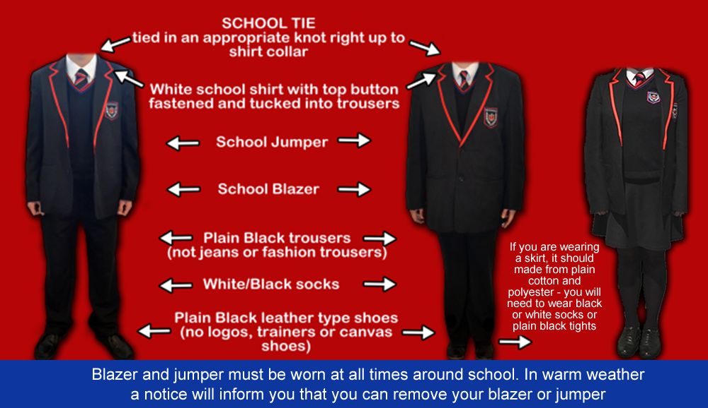
HOW TO WEAR THE BROWNHILLS ORMISTON ACADEMY UNIFORM
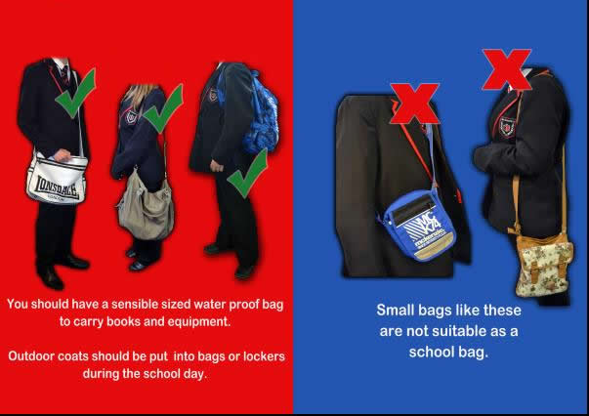

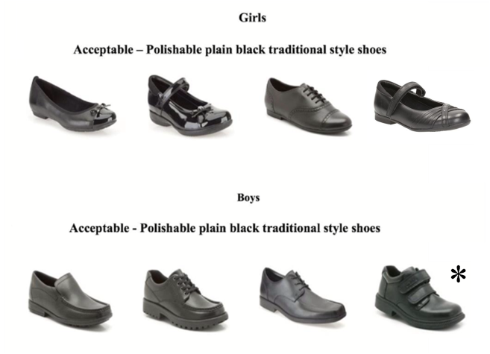

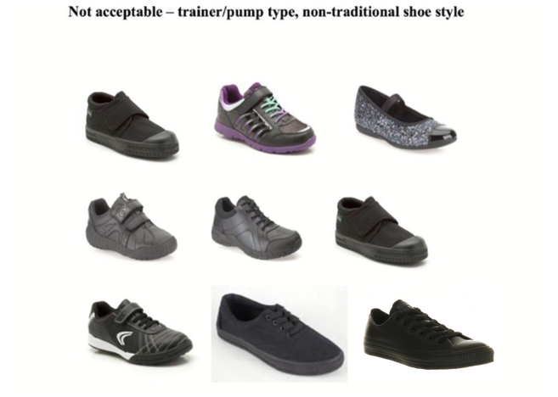

HOME-ACADEMY CONTRACT
Education is very much a partnership between students, their parents, and the academy. For this partnership to work effectively, it is vital that we all support each other in the work which has to be done. This agreement sets out the undertakings which we all need to make to ensure that each student gains the most from their secondary education and for this reason is renewed on an annual basis.
BROWNHILLS ORMISTON ACADEMY UNDERTAKES TO….
- Provide a safe, well ordered, and caring environment.
- Have clear aims and learning objectives for all students.
- Ensure that parents are informed of any concerns or problems that affect their child’s work or behaviour.
- Ensure we are available, by prior arrangement, to discuss any matter relating to a student’s education.
- Have a clearly stated, published Behaviour Policy detailing expectations, rewards, and sanctions.
- Send home regular assessments of students’ progress and provide opportunities to review these.
- Keep parents informed about academy activities through regular letters home, news sheets and notices about special events.
- Set and assess homework.
- Inform parents of both academy and external examination timetables.
- Provide opportunities for educational advancement outside the classroom.
SIGNED ON BEHALF OF ACADEMY: Principal 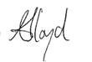
AS PARENT(S)/CARER(S), I/WE WILL….
- Ensure that my/our child attends the academy every working day, is punctual and equipped with a sensible bag, pencil case, pens, pencils, ruler, and planner.
- Inform the academy if my/our child is ill and unable to attend the academy.
- Inform the academy of any concerns or problems that might affect my/our child’s learning or behaviour.
- Attend Parents’ Evenings and respond to any reasonable request to discuss my child’s education.
- Communicate with all staff at Brownhills Ormiston Academy in a respectful manner. I/we will adhere to the Academy Visitors Policy, and I/we understand that academy staff may take up to 2 working days to respond to any queries.
- Support the academy’s policies and guidelines for behaviour.
- Support and respect the professional decisions of staff at the academy regarding my child’s behaviour and progress
- Work together with staff members for the benefit of my/our child and to resolve any issues of concern.
- Will, where appropriate, clarify my/our child’s version of events with the school to bring about a peaceful solution to any issue
- Support and offer guidance to my/our child to participate in restorative conversations (R&R’s) where necessary with other students or staff. In the academy we call this an ‘R & R’ which means repair and reconnect.
- Encourage my/our child to complete homework and coursework and meet the required deadlines and sign student planner on a weekly basis.
- Support my/our child in homework and other opportunities for learning outside of the academy, including extracurricular activities that take place at lunch time and/or after the academy day.
- Ensure my/our child follows the academy’s uniform and personal appearance code (including makeup/jewellery).
- Ensure that my/our child does not take out, use, or turn on a mobile phone on the academy site. Understand that if a mobile phone is seen or heard by a member of staff, the Personal Electronic Devices Policy will be put into operation. I/we understand that there will be occasions where my/our child's phone will be confiscated and kept in the academy safe overnight.
- Ensure that my/our child does not bring a SMART watch to the academy and, if they do, the Personal Electronic Devices Policy will be put into operation.
- Ensure that my/our child uses ICT systems and social media appropriately, supporting the academy in dealing with any incident of misuse.
- Ensure that my/our child does not carry any banned or prohibited items as list in the Academy Behaviour Policy. This includes drugs or weapons. A weapon is any article that is intended or adapted to be used to harm another being.
- Support the academy’s use of searches where necessary to determine whether my child has a prohibited item in line the Searching, Screening and Confiscation Policy.
- Ensure that my/our child does not use or have in their possession illegal substances, alcohol, cigarettes, tobacco, vapes, e-cigarettes, matches, lighters or any equipment linked to these or any banned item.
- Ensure my/our child conducts themselves sensibly and in a respectful manner in the academy, to and from the academy and on public/academy transport.
- Understand that my/our child will have to attend detentions at the end of the academy day if they fail to follow the academy’s Behaviour Policy, even if they travel on the academy coach. I/we understand that it is my/our responsibility to arrange transport for my child to get home following an after-school detentions.
- understand that I/we will be informed by text message or phone call of if my/our child has an after-school detention and that detentions can only be re-arranged in rare and exceptional circumstances.
- Support and reflect the school’s ethos and values through my/our behaviour. I/we will set a good example to pupils through my/our behaviour and the way I/we interact with staff, pupils and other adults.
- Treat all governors, staff members, pupils, other parents and any members of the school community with dignity and respect.
- Follow the academy’s car parking rules and procedures for dropping-off and collecting pupils from the academy. This means: not blocking the academy’s driveway or carpark, not blocking residents' driveways, not waiting or dropping off on single yellow lines or academy entrances, and following staff directions if asked to relocate.
I confirm that I understand and accept the academy policies without question.
I confirm that my signature indicates my support for the academies’ policies for the duration of time that my child attends the academy.

SIGNATURE OF PARENT(S_/CARER(S): _ ______________ DATE: _____________

1 of 2
AS A STUDENT, I WILL….
- Follow the Academy values of Ready, Respect, Safe, at all times.
- Attend the academy every day wearing the correct uniform and follow the personal appearance code. I understand that if I do not meet the personal appearance code or I have incorrect uniform that I may not be allowed to attend my normal lessons until this is rectified.
- Arrive at the academy and each lesson at the correct time and with the correct equipment. E.g., pens, pencil, pencil case, ruler, and planner in a sensible bag.
- Always conduct myself sensibly, including travelling to and from the academy and on public/academy transport.
- Show respect for other people’s points of view, race, gender, religion, sexuality and personal circumstances.
- Work to the best of my ability, both in class and at home.
- Speak to other students, to staff and to visitors in a polite manner.
- Make sure that my mobile phone is not used or taken out of my bag on the academy site. I understand that if a mobile phone is seen or heard by a member of staff, the Personal Electronic Device Policy will be put into operation. I understand that this means that the academy can confiscate my mobile phone overnight until a meeting is arranged with my parents.
- Make sure I don’t bring a SMART watch to the academy and, if I do, understand that the Mobile Phone/SMART Watch Policy will be put into operation.
- Make it as easy as possible for myself and others to learn in class.
- Move in a safe and orderly manner around the academy buildings and site.
- Use ICT systems appropriately, only using computers for academic work and homework.
- Use social media appropriately so it does not create issues in the academy.
- Not carry a weapon, which is any article that is intended or adapted to be used to harm another person.
- Not to use or have in my possession illegal substances, alcohol, cigarettes, tobacco, vapes, e-cigarettes, matches, lighters or any equipment linked to these or any banned item.
- Not to bring any type of aerosol into the academy and not to use any type of aerosol on the academy site (supporting individuals who have allergies)
- Comply with the academy Searching, Screening and Confiscation Policy.
- Help to keep the academy a pleasant and comfortable environment in which to work, keeping the academy free from damage, litter, and graffiti.
- As a student I will attend detentions at the end of the academy day if I fail to follow the academy’s Behaviour Policy, even if I travel on the academy coach. I understand that my parents will receive a text about any after school detentions and that it is my responsibility to ensure that I attend.
- I understand that if I am late to the Academy or lessons my parents/Carer will be contacted for me to complete this time. This will be at the end of the Academy day at an agreed day and time.

PRINT NAME: ____________ _____________________ __

SIGNATURE OF STUDENT: ____________ _____________________ __

DATE: ___________________________

School Policies are available on our website:
www.brownhillsoa.co.uk
Brownhills Ormiston Academy, Deakin Avenue, Brownhills, Walsall, WS8 7QG
Tel: 01543 452886 Fax: 01543 370105

2 of 2
LOCKER KEY REQUEST

Dear Parent/Carer,

When your child starts at Brownhills Ormiston Academy, we would encourage them to have a locker. This will provide them with a secure space in the academy in which they can store their belongings, rather than carry them around all day.

In order to secure a locker, please complete the attached form.

The cost of a locker is a £5 which will be payable by Parent Pay only.

We will advise when payments can be made.

On receipt of payment, a key will be issued.

--------------------------------------------------------------------------------------------------------------------------

NAME OF STUDENT....................................................................

I agree to pay by Parent Pay the sum of £5 when advised

Signed ....................................................................................... (Parent/Carer)

Date ............................................................

